UCF Senior Design
Photonic Targeting Acquisition and ideNtification Knowledge Systems
(Photo-TANKS)
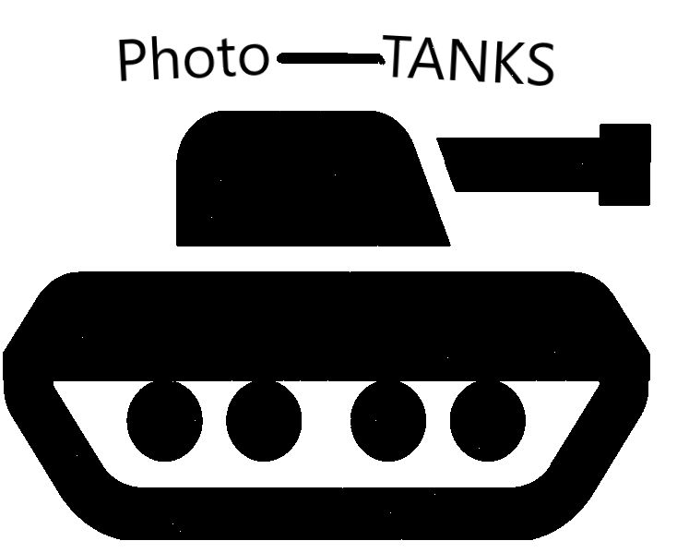
College of Optics and Photonics (CREOL), Department of Electrical Engineering and Computer Science
University of Central Florida
Dr. Lei Wei

Group 1
Dylan Perkowski Photonics Engineer
Joshua Walton Photonics Engineer
Skyler Burns Electrical Engineer
Joshua Frazer Computer Engineer

Contents
1 Executive Summary 1
2 Product Description 3
2.1 Motivation 3
2.2 Project Goals and Objectives 6
2.3 Requirements Specifications 9
2.3.1 Main Tank: 9
2.3.2 Controller: 11
2.4 House of Quality Diagram 12
2.5 Hardware Illustration 14
2.6 Hardware Block Diagram 16
2.6.1 MCU 17
2.6.2 Power 17
2.6.3 Motors 17
2.6.4 Peripherals 17
2.6.5 RF Transceiver 18
2.6.6 Laser 18
2.7 Software Illustration 19
2.8 Existing Products and Relevant Technologies 20
2.8.1 Military Targeting Acquisition Process 20
2.8.2 RC Tanks 21
2.8.3 Laser Designator 22
2.8.4 Battlefield Combat Identification System 23
2.8.5 Aircraft Registration/Hull Number/Combat Identification Panels 25
2.8.6 Aided/Automatic Target Recognition 27
3 Research and Part Selection 29
3.1 Technology Comparison 29
3.1.1 Tank Treads/Continuous Track (Tank Chassis) 29
3.1.1.1 B08P49VLPS 29
3.1.1.2 B096DKCCBT 30
3.1.1.3 B08QZB5MFR 30
3.1.2 Batteries 31
3.1.2.1 Non-Rechargeable Batteries/Primary Cell 32
3.1.2.2 Rechargeable Batteries/Secondary Cell 32
3.1.2.2.1 INIU Power Bank 34
3.1.3 Motors 34
3.1.3.1 Chassis DC Geared, Brushed Motors 35
3.1.3.1.1 MG16B-06-0-AB-00 36
3.1.3.1.2 1271-12-21 37
3.1.3.1.3 25mm Geared Motor 38
3.1.3.2 Turret Continuous Rotation Servo Motors 38
3.1.3.2.1 FS5103R 39
3.1.3.2.2 900-00360 39
3.1.3.2.3 DF15RSMG 40
3.1.3.3 Barrel Elevation Servo Motors 41
3.1.3.3.1 HXT900 42
3.1.3.3.2 HD-1440A 43
3.1.3.3.3 MG90D 43
3.1.4 Laser Diode 44
3.1.4.1 L635P5 45
3.1.4.2 HL6320G 45
3.1.4.3 HL6322G 45
3.1.4.4 HL63163DG 45
3.1.5 Laser Diode Evaluation Board 46
3.1.6 Constant Current Laser Diode Driver 46
3.1.7 Lens 46
3.1.7.1 The Bi-Convex Lenses 47
3.1.7.2 The Plano-Convex Lenses 47
3.1.8 Optical Sensors 48
3.1.8.1 The Phototransistors 48
3.1.8.2 The Photodiodes 49
3.1.9 Multi-Color LED 49
3.1.9.1 1528-2761-ND 50
3.1.9.2 BL-HBGR32L-3-TRB-8 50
3.1.10 Wiring 50
3.1.10.1 Standard Slip Ring 51
3.1.10.2 Pancake Slip Ring 52
3.1.10.3 Mercury Dipped Slip Ring 52
3.1.10.4 Wireless Slip Ring 53
3.1.11 RF Transceiver and Antenna 53
3.1.11.1 Bluetooth Protocol 54
3.1.11.2 Bluetooth Transceiver Comparison 54
3.1.11.2.1 BGM220PC22WGA2R 54
3.1.11.2.2 BMD-350-A-R 55
3.1.11.2.3 ENW-89854A3KF 56
3.1.11.3 Bluetooth Transceiver Selection 57
3.1.12 Graphics Processor Units 58
3.1.12.1 Jetson Nano Part Description 58
3.1.12.2 Jetson Nano Competitors 58
3.1.12.2.1 Raspberry Pi 59
3.1.12.2.2 Google Coral 60
3.1.12.2.3 Intel Up Squared AI Vision X Developer Kit 61
3.1.13 Cameras Overview 63
3.1.13.1 360 Degree Camera 64
3.1.13.2 Barrel Camera 66
3.1.13.2.1 Barrel Camera Options 67
3.1.13.2.2 Raspberry Pi Camera Module 2 68
3.1.13.2.3 IMX219-77 8MP Camera with 77° FOV 68
3.1.13.2.4 Arducam NoIR IMX219-AF Programmable/Auto Focus IR Sensitive Camera Module 69
3.1.13.3 Top Mounted Camera Orientation / Setup 70
3.1.13.3.1 Single Camera Dual Fisheye Lenses 70
3.1.13.3.2 Double Wide Angle Camera Setup 71
3.1.13.3.3 Triple Camera Setup 73
3.1.13.4 Camera Comparison 74
3.1.13.4.1 Waveshare IMX219-200 74
3.1.13.4.2 Waveshare IMX219-170 74
3.1.13.4.3 Arducam Mini HQ 12.3 MP IMX477 75
3.1.14 Sound Card and Speakers 76
3.1.14.1 BFAB B098R78XSY Sound Card 77
3.1.14.2 Magnetic Cone Speakers 78
3.1.14.3 Standard Flat Panel Speakers (Planar Speakers) 79
3.1.14.4 Multi-Cell Flat Panel Speakers 80
3.1.14.5 Speaker Selection 80
3.1.15 Speakers Input Type 84
3.1.15.1 Bluetooth Speakers 84
3.1.15.2 Auxiliary Speakers 84
3.1.16 Audio Interface Computer Connectors 84
3.1.16.1 USB 85
3.1.16.2 FireWire 85
3.1.16.3 PCIe 85
3.1.16.4 Thunderbolt 86
3.1.17 Audio Output Options 86
3.1.17.1 Sabrent USB External Stereo Sound Adapter 87
3.1.17.2 USB to Audio Adapter 87
3.1.17.3 USB Audio Codec for Jetson Nano Soundcard 88
4 Design Constraints and Standards 89
4.1 Constraints 89
4.1.1 Economic Constraints 89
4.1.2 Social Constraints 89
4.1.3 Environmental Constraints 89
4.1.4 Manufacturing Constraints 90
4.1.5 Health & Safety Constraints 90
4.1.6 Sustainability Constraints 90
4.1.7 Time Constraints 91
4.1.8 Ethical Constraints 91
4.1.9 Political Constraints 91
4.2 Standards 91
4.2.1 Optical Standards 91
4.2.1.1 Laser Diode Standards 91
4.2.1.2 Laser Safety Standards 92
4.2.1.3 Lens Handling and Cleaning Standards 92
4.2.2 Electrical Standards 93
4.2.2.1 Power Supply Standard 93
4.2.2.2 IPC Standards 94
4.2.2.3 Soldering Standards 94
4.2.2.4 Soldering Safety Standards 95
4.2.2.5 IEEE 802.15.1 Standard 95
4.2.2.6 Bluetooth Range 95
4.2.2.7 Bluetooth Frequency 96
4.2.2.8 Testing of Plastic Materials Standard 96
5 System Design 98
5.1 Software Design Details 98
5.1.1 MIT Application Inventor 98
5.1.2 Controller Application – Photo-TANKS’s Controller 99
5.1.3 Peripherals 102
5.1.4 Jetson Nano Software Implementation 103
5.1.5 Software Languages for Jetson Nano 104
5.1.5.1 C++ 104
5.1.5.2 Python 104
5.1.6 Jetson Nano Supported Frameworks 105
5.1.7 Different types of AI Video Processing 106
5.1.7.1 Object Detection 106
5.1.7.2 Image Processing 106
5.1.7.3 Image Recognition 107
5.1.7.4 Segmentation 107
5.1.7.4.1 Semantic Segmentation 108
5.1.7.4.2 Instance Segmentation 108
5.1.7.4.3 Panoptic Segmentation 109
5.1.8 Convolutional Neural Networks 109
5.1.9 CNN Models 110
5.1.9.1 Performance of Reliable Models on Jetson Nano 110
5.1.9.2 ResNet 111
5.1.9.3 MobileNet 112
5.1.9.4 TinyYOLO V3 112
5.1.9.5 Single Shot Detector 113
5.1.10 Autonomous Feature 113
5.2 Hardware Design Details 114
5.2.1 Power Flow Diagram 114
5.2.2 Webench Power Designer 115
5.2.3 DC - DC Conversion 115
5.2.3.1 TPS55288 115
6 Testing 119
6.1 Phototransistor Testing with ADC converter on a MSP430FR6989 119
6.1.1 MSP430FR6989 Schematic 120
6.1.2 Code for Testing 120
6.2 Laser Diode and Lens Testing 120
6.3 Target Identification and Hit Detection Testing 122
7 Administration 124
7.1 Estimated Project Budget 125
7.2 Work Distribution 126
7.3 Project Milestones 127
7.4 Progress 128
7.5 Owner’s Manual 129
8 Conclusion 129
Appendix A: References 1
AA1: Main Tank Specifications 1
Table AA 1: Main Tank Specifications 3
AA2: Controller Specifications 4
AA3: Prototype Identification and Hit Code 6
6
AA4: DC-DC Circuit BOM and Parameters 9
Appendix B: Permissions 1
Appendix C: Citations 1

1 Executive Summary
Today, the United States military targeting acquisition process is met with a myriad of limitations and challenges. Beginning with limitations of the unaided eye, or even aided with optics, a crew’s observations are restricted to only what they can see. A crew’s ability to visually identify targets are not only limited by the available field of view of their vehicle, but additionally visual identification rapidly decreases as engagement ranges increase, camouflage techniques become more effective, and battlefield obscuration increases [1]. Reduced visual conditions such as nighttime, poor weather conditions, or mirage effects can also impede a crew’s ability to locate and acquire potential targets. Furthermore, there is always the presence of human error. Even the most well-trained soldiers can mistakenly overlook a potential target, or a potential target could enter a crew member’s sector of observation while his/her line of sight is displaced and focused on something else. Lastly, the nature of war is naturally chaotic so, at times, the amount of incoming visual information that a crew would need to intake and analyze in order to maintain 360° of security coverage can be overwhelming.

With these problems in mind, in this project we develop a target acquisition and identification system that can either be operated via user-control or via artificial intelligence (AI) decision making and capabilities. The vehicle chassis decided to demonstrate the system was selected to be a tank due to their naturally limited field of view, this decision is further inquired in the Motivation section. The aim of this project is to provide a proof-of-concept to help remedy the aforementioned limitations and challenges by developing a system to aid and provide an improved version of military methods of rapid target acquisition and identification.

Beginning with the aspect of rapid target identification, in this project, free-space optical transmittance and sensing is utilized to trigger a signal containing unique identification codes to be relayed back and received by the crew’s vehicle. In this setup, a laser diode operating within the visible spectrum at 635 nm, is mounted within the tanks barrel and is the light source used to trigger the identification signals. To account for and minimize dispersion, a lens is mounted within the barrel following the laser diode with a far focal length in order to maintain the collimation of the laser light emitted from the diode. Silicon phototransistors with a high response in the 635 nm region will be used for the means of detection. These phototransistors will be mounted around the hull and turret canopy of the tank, representing strategic strong and weak points of modern tanks’ armor. Upon receiving the unique identification code by the crew’s vehicle, the code is referenced against a database and determined if it matches allied specifications to identify the potential target as friendly or hostile. These codes will also have the capabilities to be reprogrammable. Therefore, the ability to perform fleet-wide routine updates for security reasons is available. Additionally, given the scenario where an allied vehicle is compromised and taken into the possession of hostile forces, the entire allied fleet can be selectively reprogrammed excluding the originally lost vehicle which would now transmit hostile identifications.

The aspect of target acquisition is handled by AI implementation, utilizing mounted wide-angle cameras to the turret in combination with the camera mounted to the barrel to continuously monitor and scan the surrounding environment around the vehicle for potential targets. With the use of machine learning, the AI can be taught how to recognize and differentiate civilians versus armed hostiles, hostile vehicles, and hostile military equipment. Expanding, the AI can also be taught the specific identifications of friendly and hostile vehicles such as vehicle type and how to classify them appropriately to the vehicle crew’s engagement priorities. By being used in tandem with a crew’s standard procedures of observation, an enormous amount of visual information surrounding the crew’s vehicle could be analyzed all at one time for potential targets. As it would be possible to use AI, to detect, locate, identify, and classify within one step with that information being relayed to the crew. Further, the vehicle’s crew will be capable of allowing the AI to take full autonomous control over the vehicle where AI decisions determined by information obtained from the cameras is used to operate the vehicle.

All system information is displayed to the crew via their heads-up-displays (HUDs) by being overlaid onto their external camera feed perspective of the tank. System information includes information determined by direct optical free-space identification code verification, displayed as hostile or friendly to the crew. Additionally, information determined by the AI about the location of potential targets represented in orientation to the tank by degrees, the identification of potential targets such as friendly or hostile and vehicle type, and the classification of the potential target based on threat level. While the system is continuously scanning around the crew’s vehicle it will assess for immediate threats to the crew such as a hostile tank taking aim. Targets with the classification of being an immediate threat, or most dangerous, to the crew are differentiated on the HUD by color and shown in red. By having the system information displayed onto the crew’s HUD, a quick mean of intelligence gathering can be achieved by eliminating the potential delays that could arise through radio communications.

Due to budget constraints and not having access to a real tank, the prototype of the system is demonstrated in the form of a remote control tank and the effective range for the AI targeting system is limited due to technological constraints. Because of these limitations, the system demonstrated in this project would not meet the optimal requirements for real world military applications. Further, given the nature that remote control vehicles are considered toys, some entertainment features such as a health bar displayed on the crew’s HUD and sound effects from an onboard speaker are implemented into the prototype’s design. However, the equipment used in this project meet our requirement specifications for the prototype to accurately demonstrate the proof-of-concept and usability of a target acquisition and identification system in a simulated combat environment.

2 Product Description
This section serves to provide the motivation that inspired our team to develop a target acquisition and identification system for military application and a brief history of other motivations that guided the evolution of our project. Furthermore, this section provides explanations and details pertaining to our project’s goals and objectives. Lastly, the requirement specifications of the project are presented to obtain the proposed goals and objectives.

2.1 Motivation
From the beginning, there were a handful of different motivations that drove the conceptualization and evolution of this project. At first, the idea that sparked the endeavour of this project was simply the interesting idea of creating remote controlled tank laser-tag. A rather rudimentary idea and upon research, was found to be already existing all over the market. Being an idea lacking a considerable amount of originality, an investigation of the products already on the market found that they operated using quite basic technology, harnessing infrared LEDs and photodiodes for ‘point-and-shoot’ light emission and detection of ‘hits’. Rather, we thought of furthering the complexity of the tank to create a more advanced design with the implementation of on board first-person cameras for the operator of the tank to watch on a live broadcast displayed on the controller and improvements of the optical components from a ‘point-and-shoot’ infrared design to directed fire controlled laser diode precisely where the gunner’s reticle is aimed. We felt that all aspects of offense were attended to, but we wanted to give the tank user a better way to defend oneself. To achieve this, the laser diode was decided to operate in two modes, one being a low intensity continuous beam, and the second being a high intensity pulse. The low intensity continuous beam would function as a means to help assist the user with aiming the reticle, however the low intensity light would be detected by the phototransistors and provide an aim detection warning on the HUD for the user operating the tank that is being aimed at. This aim detection warning would provide the user with the brief information to defend themselves and take evasive maneuvers. The high intensity pulse would act as the tank’s projectile and the detection of this light by the phototransistors would be registered as a ‘hit’ and do subsequent ‘damage’ to the affected operator’s tank, reducing the health of the tank by one.

The thought of splitting the roles of operation of the tank into a driver role and a gunner role was also speculated. This idea was considered to make the simulation of operating a tank more realistic for the remote control operators, now in essence a crew, therefore creating an environment that required teamwork and communication to control and maneuver the tank effectively, locate and acquire targets, proceed to engagement, and come out victorious against a hostile tank in the laser-tag battlefield. We felt that this would provide a very entertaining and exciting aspect to the experience, giving a great sense of achievement when you and your teammate work together successfully. However, we ended up having to scrap this idea due to concerns of complexity and time constraints.

Alternatively, we shifted our attention towards AI implementations, and taking a page out of the self-driving car industry and applying it to our remote control tanks, we thought about the possibility of the tank operating itself. This idea was appeasing because the added challenges we would have to solve in order to achieve self-automation were rather solvable. Immediately we knew that the AI would need a dedicated device to receive visual information in order to know its surroundings and make decisive decisions to maneuver the tank and operate its turret. Machine learning would be used to teach the AI how to recognize other tanks and targets while observing the battlefield and therefore be capable of rotating the turret and aiming the cannon at the acquired targets and engaging in battle. Methods of target tracking would be implemented for the instance of on-the-move battle conditions and once locked, the AI would continuously aim the turret at the hostile tank. Further, the idea of aim detection could be implemented for the AI to make decisions on when to take evasive actions and defend itself.

Even at this level of complexity, we still felt that the entire scope of the project was unsatisfactory, being that a self-driving tank wasn’t necessarily demonstrating any new technology given that we commonly see self-driving cars on the road now. As a team, we wanted to develop a system that solved a real world issue or could be used as an alternative assistive approach that could be applied to a real world issue. Coincidently during this period of brainstorming, the world’s attention was focused on the developing collapse of the Afghan government and the country’s seizure by the Taliban. Following the wake of these events, reports began to flood the news outlets about weaponry, vehicles, and equipment that was left behind during the withdrawal of United States and NATO military presence in Afghanistan and was now in the possession of the Taliban. Reportedly, the military left behind about 100 armored vehicles including 27 Humvees and as many as 70 MRAPs, as well as 73 aircraft including the world famous Blackhawk helicopter and Russian Mi-17s [2, 3]. Additionally, these figures do not include the unknown amount of armored vehicles the Afghan National Army lost to the Taliban, which could be up to thousands of United States made Humvees and M-117s; as well as nearly 200 MRAPs [7]. Although no immediate threat is imminent of the situation as of now; and United States officials claim that no threat of the situation will ever arise, it has been demonstrated the possibility of United States equipment falling into the wrong hands.

The United States is the world’s leading arms exporter, generating $175 billion in forgein trade in 2020 and controlling a 37% global market share in international arms exports, delivering arms such as weaponry, land vehicles and aircraft, and military equipment to 96 countries over 2016-2020 [4, 5]. During the same five-year period, 47% of all United States arms exports went towards the Middle East, seeing a 28% increase from the previous 2011-2015 five year period [5]. Accounting for 24% of all United States arms exports over 2016-2020, Saudi Arabia is the largest recipient at an export value of $2.151 billion in 2020 [5, 6]. Countries such as Qatar, Afghanistan, and the United Arab Emirates are the United States’s tenth, eleventh, and thirteenth largest recipients of arms, seeing export values of $300 million, $227 million, and $149 million in 2020, respectively [6]. Even with the highly selective processes the United States government takes as to who they make international arms deals with and exactly what and what not the Department of Defense will allow to be sold, there always poses a risk that any United States made military equipment that is not in the active possession of the United States military, could be used against us. The questions that had to be asked were, what if the United States goes to war against a country that also utilizes our military equipment and technology? And, how would we be able to differentiate between friendly vehicles and aircraft, and hostile counterparts if the battlefield is composed of two sides utilizing the same equipment?

These two questions provided a problem that could be addressed and the motivation that our team needed to shape our project into what is presented here today. We quickly realized that practically all of our ideas that had been previously drafted could be adapted into a system that could be used to detect, acquire, and identify potential targets. We felt a system of this design would be of high beneficial value for military applications, providing a vehicle’s crew with a tool to be used for smart, active and passive, high speed observation and analysis. First, the proposal to create a method for quick, direct identification of a potential target was conceptualized, feeling that for a tank’s crew, or any vehicle, it is a necessity to be able to rapidly identify a potential threat as friendly or foe. Given that times of war can be extremely stressful of an environment for any soldier, the ability to rely on an integrated system to get identification confirmations could help alleviate the possibility of preventable life-threatening mistakes such as friendly fire scenarios. Starting with the idea of using a laser diode as the tank’s means of ‘weaponry’, it was refashioned to still remain as the tank’s primary weapon, but to also carry out the means of free-space vehicle identification transmittance. Following, we felt that the original plan for AI implementation having the ability to operate the tank, recognize other tanks, and perform target tracking, was a well suited foundation for our newly found motivation. However, we knew that the AI would have to be expanded upon, making it more intricate and ‘smarter’ for a lack of better description.

The decision was made that a suitable complement to our idea of free-space target identification would be a form of target acquisition, wanting the AI implementation to also operate as a form of ‘active radar’ monitoring the surroundings of the vehicle. Driven by the limitations of the naturally restricted field of view of tanks, we wanted to give a tank’s crew the ability to have full awareness of potential targets and immediate threats around them. We felt that a design of this functionality would prove to be very useful in applications for armored vehicles, especially tanks, giving our soldiers the advantage of AI powered situational monitoring and analysis. Vehicle crews would be able to shift their attention to other tasks, and when they are distracted, say in a firefight, everyone has a job to do and the current task at hand is not necessarily observation. By having a system continuously monitoring the surroundings of a vehicle, when a crew’s attention is elsewhere, their vulnerable perimeters are still remaining under observation and if a target is acquired within this range, a notification to the crew would make them aware of the situation. It was decided to further the intricacy of our idea of the AI being capable of recognizing other tanks, to being able to locate, identify, and classify potential targets, as well as search for immediate threats. All information that would be displayed to a vehicle’s crew.

With these ideas in mind, we felt as a team that we had the blueprints for a project that could be used to sufficiently demonstrate our engineering expertise in our respective fields. Satisfied that we established a real-world problem that could be addressed, we formed a mission statement for us to stand behind: to create a cost-effective, easy-to-use, and intelligent system that could be uncomplicatedly implemented onto currently deployed military armored vehicles for the purpose of target acquisition and identification. Now with the shape of the project taking its final evolution, we coined it as the Photonic Targeting Acquisition and ideNtification Knowledge Systems technology, or Photo-TANKS.

2.2 Project Goals and Objectives
During our team’s conception of Photo-TANKS, our focus was gathered on best answering the questions we proposed to ourselves. Given the scenario where war erupts between two opposing forces who utilize the same military equipment, how would the allied force be able to differentiate between friendly vehicles versus their hostile counterparts? And, if allied vehicles somehow fall into the wrong hands, how would the allied forces know that vehicle is hostile? To construct a solution to this problem, our team’s goal is to develop a proof-of-concept of an easily integratable technology system that serves the purpose of aiding troops with rapid target acquisition and identification, and in doing so, helping prevent potential occurrences of avoidable fratricide. In order to achieve this goal, we separated its components into a series of objectives.

Starting with the matter of rapid target identification, our objective of focus is to provide a vehicle’s crew with a means of direct target identification. In order to do so, we plan to demonstrate this task with Photo-TANKS utilizing a laser diode as the trigger source for an unique identification code of the potential target to be transmitted and received by the investigating tank. While visual investigations at close ranges are rather feasible, the difficulty to accurately positively identify a potential target quickly begins to increase as engagement ranges increase. Meanwhile light doesn’t necessarily care about distance. The process of detecting this light in order for Photo-TANKS microcontroller to know when to broadcast the identification signal is done by using phototransistors. By referencing the unique identification code received against a database of known allied identifications, Photo-TANKS can quickly determine the identity of a potential target as friendly or hostile and immediately return that information to the tank’s crew. Since this process is carried out as a means of direct target identification, the tank’s weapon will already be trained onto the potential target. In the instance where the identification signal returns back ‘hostile’, the tank’s cannon is already aimed and prepared to engage with the target. Oppositely, if the identification signal were to have returned back ‘friendly’, then the tank’s crew are very quickly presented with the information to stand down and not potentially jeopardize the lives of their fellow soldiers.

Our team’s objective regarding target acquisition is aimed at boosting the combat effectiveness of a vehicle’s crew by providing 360° observational monitoring for potential targets around the vehicle and aiding in the military’s standard target acquisition process. To achieve the task of continuously monitoring the surroundings of the vehicle, our project makes use of multiple wide angle cameras to provide for 360° of visual coverage, as the input informational feed of the encompassing environment. Artificial intelligence is then used to continuously process this incoming visual information, scanning for the detection of a potential target and relaying that information back to the crew. Our team wanted Photo-TANKS to not only assist its operators when they are actively observing for potential targets, but when their attention is on other matters as well. In nearly every situation, layers of redundancy are always beneficial and in war, a simple mistake can be the matters between life and death. Our objective with Photo-TANKS was to create that layer of redundancy by providing a vehicle’s crew with another set of ‘eyes’ that can look out for something a soldier might mistakenly overlook, or maybe are too busy to see. At times, they might not even be able to see. As stated in the Motivation section of this report, a large inspiration for our team’s project was the naturally restricted field of view accompanied with tanks. Situational awareness is a key factor in the battlefield, and by having a system that is always monitoring for potential threats, a vehicle’s crew can always be aware of what is around them.

With all this incoming information, our team made it an objective to compile everything into a format that would generate the greatest ease of use for Photo-TANKS operators. Since all information was planned to be displayed on the HUD that is used to control our tank, we felt the need to make sure that the display did not get overcrowded and possibly distracting. Categorization of a potential target as friendly or hostile utilizing Photo-TANKS direct free-space optical identification system was planned to be displayed as unambiguously as possible, only reading whether the potential target is in fact friendly or hostile. In order to maintain our objective of simplicity for the AI target acquisition system, we focused our attention to make sure that the information presented to the operators is minimalistic, yet most important. Therefore, if the target acquisition system detects a potential target that is not currently being observed by a crew member, the vehicle’s crew can still make a full picture of the situation. To accomplish this task, our team decided that the vital information a crew would require from Photo-TANKS target acquisition system is the potential target's location in orientation to the current direction the tank’s turret is facing, identification, and classification. Further, since Photo-TANKS is equipped with being able to detect if the user’s tank is being hit with a laser, a simple aim detection warning is presented to the user to notify them that their vehicle is under investigation and decide if evasive actions need to take place.

A secondary goal for our project stems from the method of which our team plans to demonstrate Photo-TANKS. Rooted with the initial idea that sparked this entire project, being tank laser tag, we wanted to ensure that our project not only had functional value in the target acquisition and identification systems, but also possessed a degree of entertainment value. Since Photo-TANKS is only a proof-of-concept and the approach our team is using to demonstrate the system is in the form of first person perspective remote control tanks, we wanted to make sure that the experience for the user of Photo-TANKS would be enjoyable while also informative about how beneficial a system as such could be to our armed forces. Building off of that, considering that our team is building two tanks to demonstrate our project, we plan on donating one, if not both, to UCF to be used in demonstrations and played with by the younger generations in the hopes of inspiring them to pursue an education in a STEM field. To describe how our team plans to reach this goal, we divided it into a group of objectives.

First, because we had to keep in mind our intentions of younger students being able to use our project without any confusion, we had to make sure that the ease of use was set very high. This objective worked well in conjunction with our primary goal of military application, because if a twelve year old can use it, then a trained soldier should not have a difficulty in understanding how the system operates without ever being introduced to it. We wanted Photo-TANKS to feel no different to any other remote control toy; however, simulating the experience of actually operating a tank. Even more so, we wanted the target acquisition and identification functionality of Photo-TANKS to be easy enough for a twelve year old to understand.

Another objective we made to accomplish this goal was based on the question we asked ourselves: How can we make the demonstration of Photo-TANKS fun, yet remain professional? Going back to the demonstration resembling a far more advanced version of tank laser tag, our team decided to integrate the tanks with a health feature. This of which would be displayed on the user’s HUD and indicated by multi-color LEDs mounted onto the tank’s exterior to give it a little more life. Adding to that, our team felt that Photo-TANKS would also need to have some sound effects. Dr. Peter Delfyett of UCF’s CREOL is known amongst us students as making some incredible sound effects in class, most notably his “BOOM!”. Without question our team felt he would be the perfect candidate to be the voice of Photo-TANKS sounds, thinking how comical it would be to hear Dr. Delfyett yell “BOOM!” each time the tank's cannon was fired. With that, our team organized a small series of stretch features we felt we could implement given the chance; however, with these objectives listed, we felt that we had enough to meet our secondary goal.

2.3 Requirements Specifications
The requirements specifications of our project can be broken down into two categories. The first category covers the main body of the tank, which houses all the target acquisition and information systems. The second category covers the tank’s controller, which acts as the direct means to operate the tank as well as the heads-up-display that exhibits all the information gathered by the tank’s intelligence systems.

2.3.1 Main Tank:
Given that Photo-TANKS intended primary consumer would be the United States military, the necessary requirements specifications to meet standards set by the military would be rather impossible to obtain with the magnitude of our team’s budget, allotted time for project completion, safety standards we have to abide to, manufacturing capabilities, availability and obtainability of parts, and unavailability of classified military information for related technologies. For these reasons, the leading purpose of Photo-TANKS is to serve as a proof-of-concept for a system that utilizes a combination of direct observation identification through free-space identification code transmission and AI determined surrounding target acquisition and identification to provide situational information to the crew operating the vehicle implemented with our system. This would be demonstrated by the functionality of Photo-TANKS in its scaled-down simulated battlefield environment, rather than the system’s total capabilities. Accordingly, our team created our own set of requirements specifications that we felt would justify and represent the specifications possibly set by the United States military. The supplementary purpose of Photo-TANKS pertains to the means of which the intelligence gathering systems are demonstrated, being simplified down to taking place within a game of tank laser tag. As previously stated, one of the objectives of this project was to create a device that had entertainment value for the purpose of inspiring younger generations to pursue higher-learning educations in STEM fields. Because of this, some design elements of our project were decided to meet requirements for functional ease of use. Comprehensively, our requirements specifications for the main body of the tank can be divided into six categories including performance, functionality, economic, energy, health and safety, and useability. Below, a summarized specification table can be seen. A fully detailed specification sheet can be found in Appendix AA1.

Main Tank Specifications
Component(s) | Parameter | Specification
Turret | Rotation Speed | 30° per second
Barrel | Elevation Adjustment | ± 30°
Laser Diode | Output Wavelength | 635 nm
Laser Beam | Dispersion | Minimal dispersion up to 10 m
Phototransistor(s) | Relative Spectral Sensitivity | > 90%
Multi-color LED(s) | Spectral Range | 380 nm – 750 nm
Plano-Convex Lens | Far Focal Plane | > 1 m
Operator Camera | Image Delay | < 100 ms
Turret Cameras (360° coverage) | Image Delay | < 100 ms
Bluetooth Transceiver | Transmission Accuracy | < 10% Noise
Jetson Nano 2GB AI Kit | Image Processing & Decisions | AI performs image processing and decision making to provide crew with information determined by the acquisition system
Table 1a: Main Tank Specification Sheet

2.3.2 Controller:
The counterpart to our intelligence gathering system is the matter of how the information ascertained is presented to the operator. As a team, we felt that the means utilized to present this information required the utmost level of simplicity for maximized ease-of-use; however, still communicate the details a military crew would find necessary. All information displayed would have to be trustworthy and accurate, only leaving a crew with the step of confirmation. Further, any information displayed would have to be noticeable and legible, yet not impede the operator's vision. Since Photo-TANKS is being demonstrated on the platform of a remote control tank, the HUD also doubles as the controller for the tank, likely to the conditions of full scale tanks except the operator of our project assumes the role of the entire crew.

Controller Specifications
Component(s) | Parameter | Specification
User Input | Input Delay | < 1 ms
Display | Image Delay | < 1 ms
Connection | Range | > 10 m
Direction Control | Controllable Function | Can use controller to control the tank and move it via the treads
Aim Detection | Defensive Feature | Controller will display a warning message when the tank is being lased by an unknown source
Acquired Potential Target | Target Acquisition | Controller will display the location of a potential target detected by the target acquisition system in reference to the tanks forward direction by degrees
‘Fire’ Control Lock | Fratricide Prevention | Controller will ‘lock’ the fire button when a potential target is identified as friendly
Table 2a: Controller Specification Sheet
Update: We changed some of the specifications and changed the ones that we wanted to show off, so here is the updated tables:
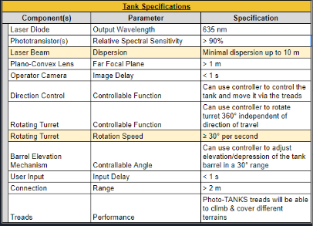
Table 1b: Final Tank Specification Sheet
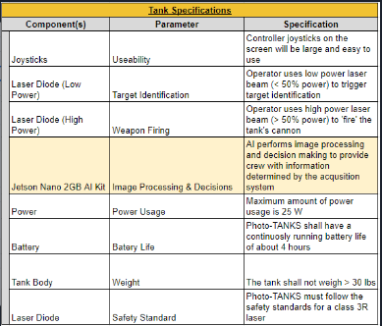
Table 2b: Final Controller Specification Sheet

2.4 House of Quality Diagram
The house of quality (HoQ) in Figure 1 below, is a design tool to help show and visualize the engineering requirements that can link with marketing requirements for Photo-TANKS. Within the diagram our core engineering and marketing requirements are listed, as well as our targets for the engineering requirements. For each engineering and marketing requirement, a positive or negative correlation is assigned between the two. Similarly, a polarity is assigned to each requirement to dignify how that requirement relates to our project. Within the roof of the HoQ, a positive or negative polarity is assigned relating two engineering requirements with one another.
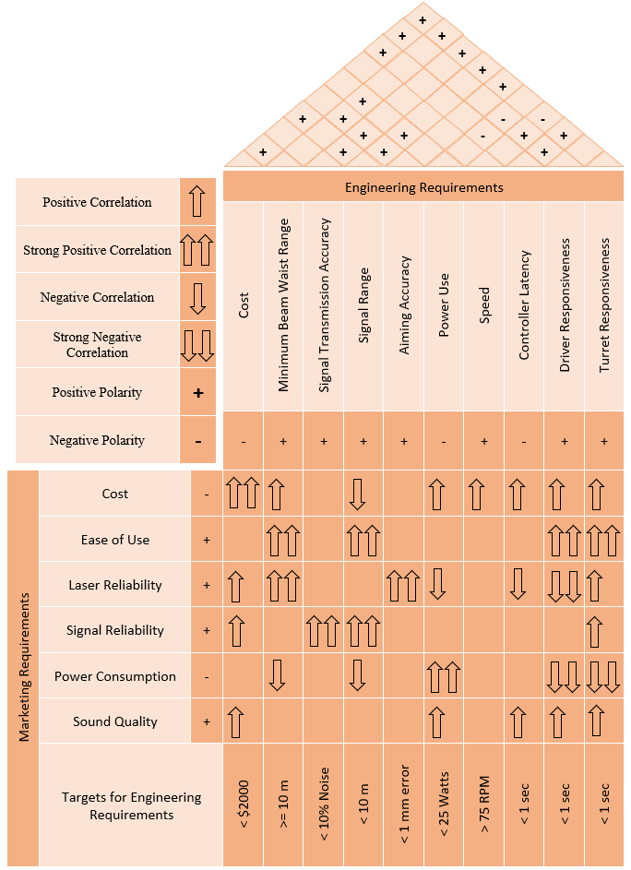
Figure 1: House of Quality Diagram

2.5 Hardware Illustration
The hardware illustrations below are a rough concept created to provide a visual aid for the main platform of the tank. Imaged with the hull opaque and transparent, the primary components of the hardware are labeled. Exterior features such as the phototransistors and cameras are hidden in the transparent hull images to provide a clearer view of the internals. It should be noted that the locations of some of the internal components may change come the final design of our project, as well as more components like circuit boards may need to be added.

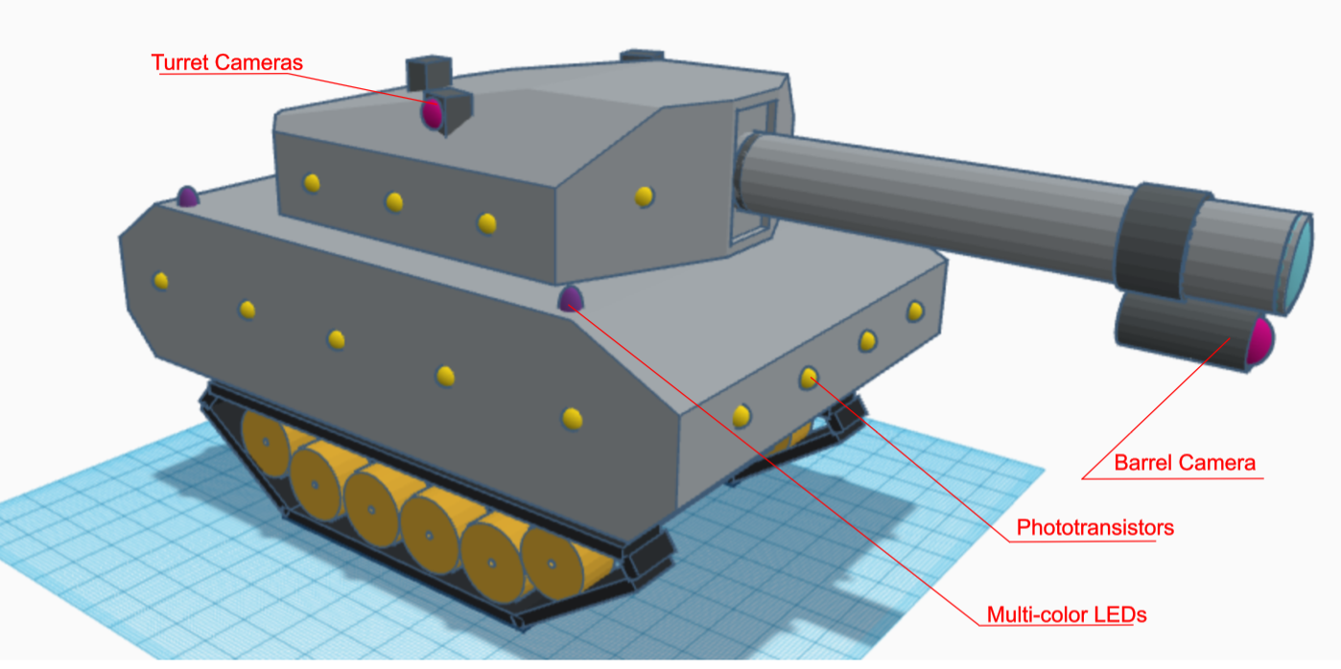
Figure 2a: Front/Side Exterior View of the Tank

In Figure 2a above, labeled are the turret and barrel cameras, the phototransistors, and multi-color LEDs. Beginning with the turret cameras, our team plans to mount three wide angle cameras onto the turret that would provide for a combined coverage up to 340° around the peripherals of the tank. The barrel camera, serving as the eyes for Photo-TANKS operator, also serves the purpose to enclose the 360° viewing circle around the tank that the AI software utilizes for target acquisition. The phototransistors are displayed in a format that our team plans to arrange and install them; however, more will most likely be installed on the final assembly of the project since the phototransistors are quite small compared to the conceptualized size of the tank. The phototransistors serve the very important purpose of target identification, as well as detecting if the user’s tank has been hit. Therefore, having an abundance of them on the exterior of the tank would be beneficial. Still our team’s intent is to maintain the amount of phototransistors on the tank to be at a near minimum of the amount necessary for smooth and consistent performance. Displayed in purple are the multi-color LEDs. Four of these will be mounted onto the tank with one in each corner. These serve the purpose of providing Photo-TANKS operator another way of visualizing the health of their tank. Shining with green light when the tank is at full health, yellow light when the tank is at medium health, and red light when the tank is at low health.

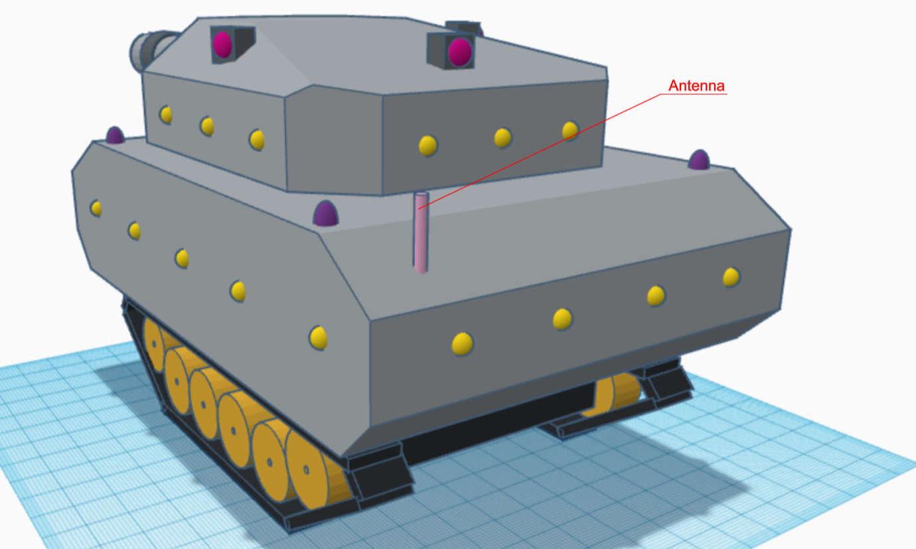
Figure 2b: Rear Exterior View of the Tank

Figure 2b above serves to provide a visual image of the rear view of the tank. Similar to the front, an array of phototransistors are also mounted onto the rear. Labeled is the tank’s antenna, used for its communications with the user’s controller and for the transceiver to transmit and receive identification code signals. While being shown as being mounted to the hull of the platform, there is the chance that our team would have to relocate this onto the turret to avoid the possibility of the antenna impeding the barrel’s travel.

Figure 2c below displays and labels most of the internals of Photo-TANKS. Starting with the laser diode, our team plans to mount this as visualized near the start of the barrel. The plano-convex lens is shown mounted at the end of the barrel. This is where it was placed for the purpose of this visualization; however, our team will likely end up relocating this to the most optimal location within the barrel to focus and collimate the laser diode’s beam. Displayed in red is the tank’s microcontroller. The chassis our team selected for our project comes with a raised platform which our team intends to utilize for this component. The turret rotation servo will be mounted on the roof of the tank’s hull, connecting its gears with a larger gear that will be fitted around the ring of the turret. That larger gear is not visualized in this model. The slip ring will be fitted between the turret - hull connection and serve the purpose of making sure the wires connecting components do not get twisted while the turret rotates. The component for Photo-TANKS artificial intelligence, the Jetson Nano AI Kit is visualized in green being mounted on the floorboard of the tank’s hull. Towards the rear of the tank is the PCB, shown with some circuit components connected such as the transceiver module and the power conversion module.

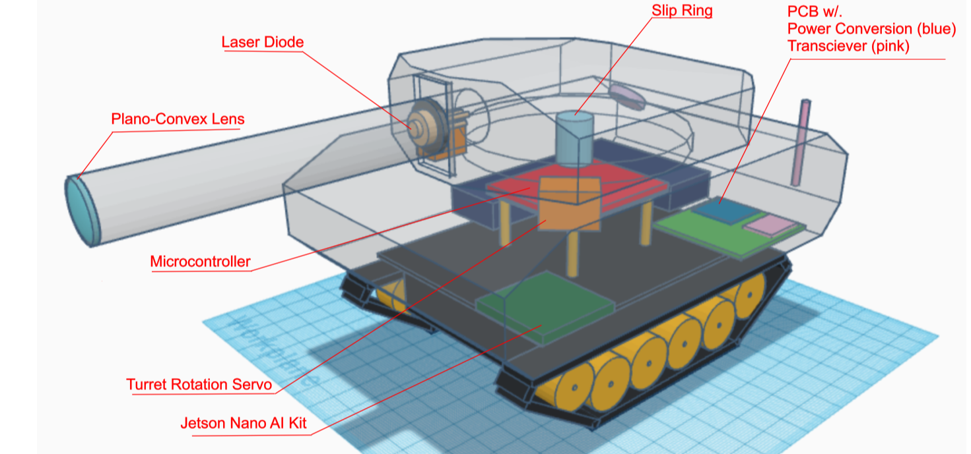
Figure 2c: Front/Side Interior View of the Tank

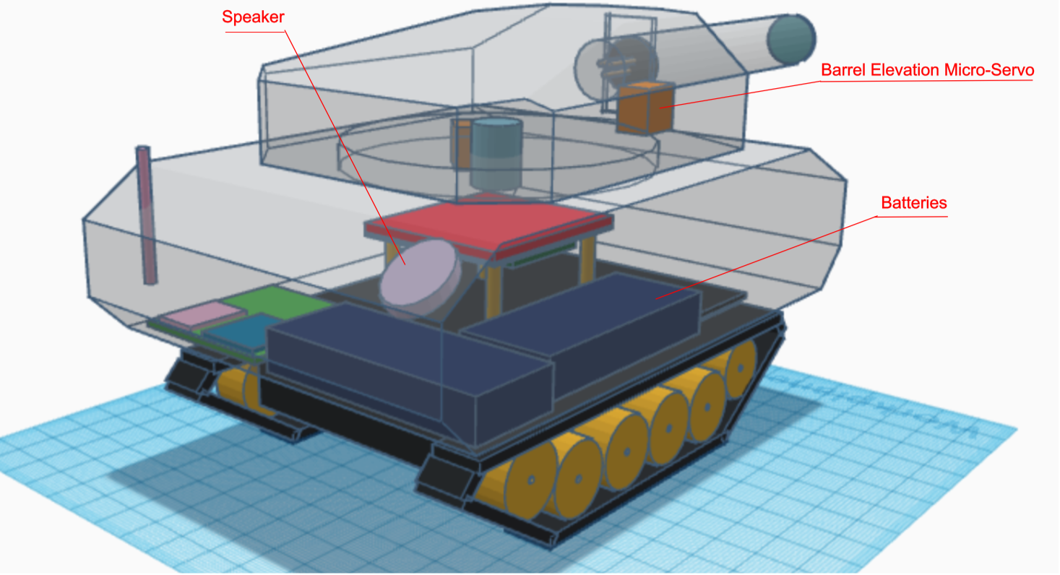
Figure 2d: Rear Interior View of the Tank

Lastly, Figure 2d is provided to give a visualization of the interior of the tank viewed from the rear as well as label components that were obscured in the previous image. Starting with the speaker, its purpose is only to provide sound effects when operating the tank. In the model, our team located the speaker towards the rear of the tank, however it can be located anywhere best fit. Below the speaker are the visual representation of the battery bricks that will be used to provide power for every component on the tank. The barrel elevation micro-servo can be seen located within the turret adjacent to the barrel. Not modeled is the angled track that the barrel will follow when adjusting elevation or the method of which our team will connect the micro-servo to the barrel.

2.6 Hardware Block Diagram
The diagram below consists of a single PCB named TANK divided into various functions. The functions are listed and described below.
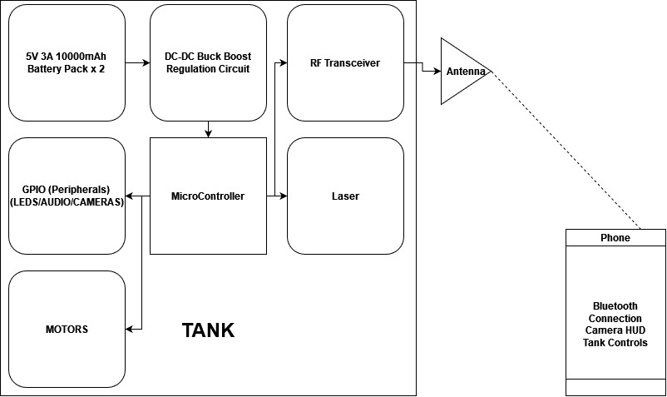
Figure 3: Hardware Block Diagram

2.6.1 MCU
The Microcontroller unit function consists of the primary controller. This function is in charge of executing the code and operating the various other functions. The microcontroller will be in charge of any calculations and or analysis that needs to be done.

2.6.2 Power
This function consists of power components that will regulate the voltage and current to operate each device. The tank will be powered by a battery. The battery power will be regulated and routed into the microcontroller where it will then be distributed to the various functions. The peripherals connected to the board will be powered by the board itself. The power that is fed in the board is controlled and routed to GPIO and other various pins that we designate. This will result in an accurate and consistent power supply for each component. The battery mentioned will be interchangeable. This means that if we are operating the tank and the power bank becomes fully depleted, we can replace the battery with a charged secondary battery and resume operations.

2.6.3 Motors
The motor function consists of various motors that will power the tracks and tank barrel. The tank motor for the barrel will need to be able to move the barrel in a vertical manner. The portion of the tank that the barrel is mounted on will be moved in a 360° fashion.

2.6.4 Peripherals
The peripheral function will consist of the speakers, cameras and LEDS. The speaker will output audio during various operations of the tank. The camera will be mounted to the gun barrel and a secondary camera will be mounted above the turret. The barrel camera will give the controller the ability to see what they are aiming at on the wireless device. The overhead camera will be able to detect enemies within a 360° radius around the tank. The last peripheral would be the LEDs. The LEDs will provide a physical representation of the tanks health as well as an indication that the tank has been hit by a shot. The LEDs will also be programmed to emit a certain color when the tank is powered on.This will give us the opportunity to display other factors such as battery life.

2.6.5 RF Transceiver
The RF Transceiver will be in charge of connecting the tank's microcontroller to the designated controller. The RF Transceiver will need to have bluetooth capabilities. This connection will enable the phone to control the tank as well as the turret. Depending on the protocol of the Bluetooth transceiver. We may be able to transmit signals as far as two hundred meters outdoors and forty meters indoors. This is the current limitation of Bluetooth in the current market. The range available from the most recent protocol is well within the planned operational range. The RF transceivers can come in low and ultra low power configurations. These configurations ensure that the component can operate with small power requirements. This will result in less overall battery consumption thus resulting in a longer battery life.

2.6.6 Laser
The laser diode and phototransistor function is in charge of sending and detecting various wavelengths. The photodiode will be able to detect low and high frequency signals and send the information to the MCU. More specifically, the low power signal is detected, then a small current is sent to the microcontroller alerting the tank that it has been aimed at. When the high power signal is detected by the photodiode, the tank will receive damage which will be reflected on the heads up display. The laser diode will be tasked with sending the low constant signal and high pulse signals towards the target. This signal can be varied by changing the amount of current sent into the laser diode. We will assign each of these signals a fixed intensity so that we can easily differentiate between them when they are received by the photodiode.

2.7 Software Illustration
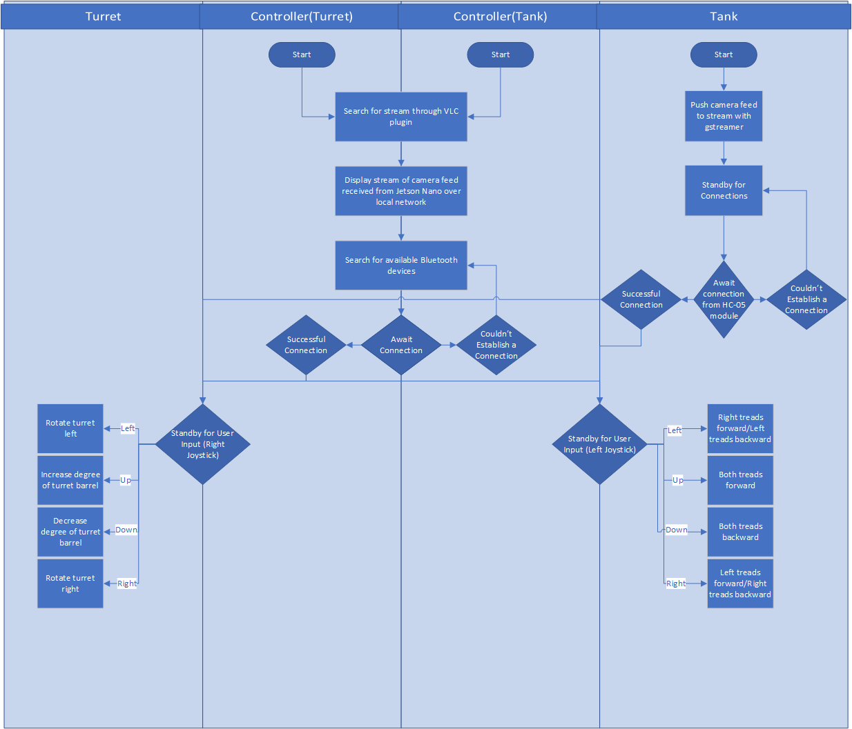
The image below shows off what a potential software diagram might look like.
Figure 4: Software Flow Chart

2.8 Existing Products and Relevant Technologies
With how technology exists and expands everyday, it would not be surprising to see something like this on the market. However, that is not the case, since there is no signal transmitter/receiver within a tank. As such, instead of comparing the tank with similar products of this caliber, some of the tank’s mechanics will be compared to existing products.

2.8.1 Military Targeting Acquisition Process
By definition, targeting is the process of systematically analyzing and prioritizing objects or installations and complimenting appropriate lethal and nonlethal actions to those targets. Similarly, the act of target acquisition includes the timely detection, location, and identification of targets with enough detail to make decisive decisions on which to carry out to attack the target accurately. Currently, the standard means our military uses today for target acquisition and identification are still rooted into methods used and developed during World War 2 and evolved upon slightly during the Vietnam War. The target acquisition process is a series of progressive and interdependent actions involving crew search, detection, location, identification, classification, and confirmation, by which the crew acquires targets [1].

The action of crew search or observation is the act where a vehicle’s crew members use the unaided eye, as well as the use of optics, to scan predetermined sectors of observation to maintain 360° security coverage around the vehicle to acquire targets. There are a plethora of different techniques the military uses to conduct crew search. Ranging from different methods of a rapid and slow visual scanning, different approaches in different terrains, and sometimes even utilizing dismounted observers which can be very risky to the lives of those soldiers. The discovery of any target or object such as personnel, vehicles, and equipment on the battlefield during the crew’s sector observations is classified as a target detection. These target detections can be further aided through the use of target signatures which are unique indicators or clues such as exhaust smoke or the reports of weapon fire for example. Information of which the crew members can use to help in the process of target detection. Upon the detection of a potential target, its location on the battlefield is determined and the target’s location information is relayed among all crew personnel. Following, the identification of a target involves recognizing a potential military target as being of a particular target type. At a minimum, a crew is required to know what to engage and what not to engage and identification must determine the target as friendly, foe, or neutral. Crews must be able to identify potential targets quickly to have the advantage of engaging first when necessary [1]. However, crews are limited by the fact that the only method of positive vehicle identification is visual [1]. Once a potential target is identified, it is then categorized by threat level they represent and classified from most dangerous to least dangerous based on the engagement priorities of a vehicle crew’s unit. Target confirmation is the verification of the initial target identification where the vehicle crew commander makes the final evaluation of the potential target, confirming the identification and hostility level, and determining the following process of engagement.

This entire process, while proven effective, still has its drawbacks and at times can be very lengthy. Added are the challenges that can be presented to the target acquisition process like reduced visibility situations and challenges that would prevent a crew member from the visual detection of a potential target. These challenges include instances where the potential target is outside the crew member's peripheral line of vision, camouflage, natural terrain obstacles, and mirage effects.

2.8.2 RC Tanks
The remote control tank itself is not that uncommon in today’s market. This is not the first, nor the last time, a tank-laser-tag idea will occur. As such, we are going to compare our tank design and functions to Amazon’s 2nd best seller RC tank: B08LHDBTY8, or “RC Tank for Boys, with Smoke Effects, Lights, and Realistic Sounds”.
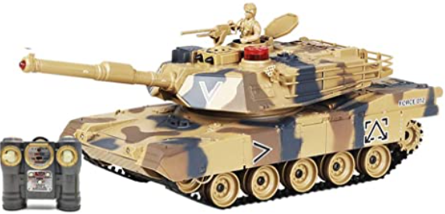
Figure 5: B08LHDBTY8
This RC tank is quite different from what we plan on building for our project. Firstly, it uses a classic controller one would see for traditional remote control toys to control the tank. This was a method which our team considered using. But, instead of using a controller with a specific frequency, we swapped it for a bluetooth connection, opting for our project to be able to be controlled from a phone connected through a bluetooth transceiver. Secondly, the RC tank uses infrared light to shoot and hit a target. Since those tanks do not use any sort of lens, the light does not get collimated and diverges everywhere. As such, if there is a target near said tank shooting, and gets hit at a specific area, by any of the infrared light, then it counts as a ‘hit’, losing a point of ‘health’. While most RC tanks do that, Photo-TANKS will use a collimated beam, with a lens of a specific focal length. Therefore, Photo-TANKS will be able to accurately aim exactly where the operator desires to ‘fire’ the tank’s cannon.

2.8.3 Laser Designator
Next, the laser designator is a device that is used to optically designate a target for a laser guided munition. Although Photo-TANK's purpose is not to carry out laser designation, this product can be related to our project. Since one of the capabilities of Photo-TANKS is to perform optical free space target identification, a directable lasing device is necessary. Because our project is only a proof of concept, our team can execute this with a simple laser diode. However, for a real world military application, laser designators are already widely used and equipped on most military vehicles. If Photo-TANKS were something to be developed onto the market, the identification system could be adapted to be responsive to the wavelength used by most deployed laser designators. Therefore, we are going to compare the idea of laser designation with Photo-TANKS, and compare it to two different laser designators: B00WME0OKS, a green laser light designator from Amazon, and the AN/PED-1 Lightweight Target Designator Rangefinder that is used in the military.
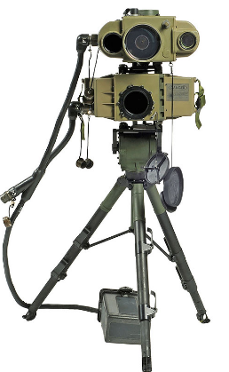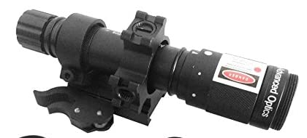
Figure 6: AN/PED-1 (left) and B00WME0OKS (right)
Comparing the two devices, the AN/PED-1 is used in the traditional military aspects of a laser designator one would expect. Being mounted onto various pieces of military equipment such as aircraft, tanks, and naval vessels. Where, its purpose is to guide various types of bombs/projectiles to a distance away, depending on if it is in its ‘moving’ mode or its ‘stationary’ mode. In the ‘moving’ mode, the AN/PED-1 can target an object from three kilometers to five kilometers away, day or night. And, in the ‘stationary’ mode, it can target an object from five kilometers to ten kilometers away during the day, and four kilometers to five kilometers at night. Comparatively, the B00WME0OKS can only designate a target from about one kilometer away. This is largely due to the fact that the B00WME0OKS is designed to be either handheld or mounted onto any type of small arm weapon. Considerably though, both designators provide a vast amount of range at which a target identification system could be carried out using lasers and photonics in a real world military environment.
While having an optical target identification system with a range of one kilometer or greater is outside the scope of our project, our team wants Photo-TANKS to be able to lase potential targets from as far as we can. Not only that, but for when Photo-TANKS is switched to operate autonomously by the AI, we need a method for the tank to lock onto its potential target. From gaining a lock by lasing the phototransistors, Photo-TANKS is essentially performing a laser designation until it receives the signal identifying whether the potential target is friendly or hostile. Then, since the tank is already locked onto the potential target, it can immediately carry out an engagement if the potential target returns back as hostile.

2.8.4 Battlefield Combat Identification System
The Battlefield Combat Identification System (BCIS) was developed following the 1991 Gulf War, governed by the Joint Chiefs of Staff to address the issue of direct fire fratricide [9]. By the conclusion of Operation Desert Storm, the Army reported fifteen total incidents of fratricide, from which, direct fire engagements accounted for twelve of those incidents. Eleven out of twelve of these incidents were reported to have occurred at night, while nearly all of them were characterized by reduced visibility [8]. Additionally, Army reports state that twenty-three Abrams tanks were either damaged or destroyed; while of the nine tanks that were destroyed, seven were caused by friendly fire and the other two were intentionally destroyed after becoming disabled in order to prevent enemy seizure of the weapon platform [14]. And of the twenty-eight Bradley IFV that were damaged or destroyed, twenty were caused by friendly fire [14]. Of the total 615 soldiers either wounded or killed in action during the Gulf War, 107 or 17% of casualties were a direct consequence of friendly fire [8]. Further breaking down the stated 107 casualties into its components, thirty-five soldiers lost their lives and seventy-two were wounded due to one friendly vehicle engaging with another friendly [8]. The Army’s Training and Doctrine Command (TRADOC) and the Army Materiel Command (AMC) conducted a joint study to identify causes of fratricide and possible solutions to the issue. From their study, the TRADOC-AMC task force identified two leading factors for the cause of fratricide. The first being the lack of situational awareness of one’s own location and the locations of friendly, enemy, and noncombatant elements. The second being the shortfall of positive target identification.
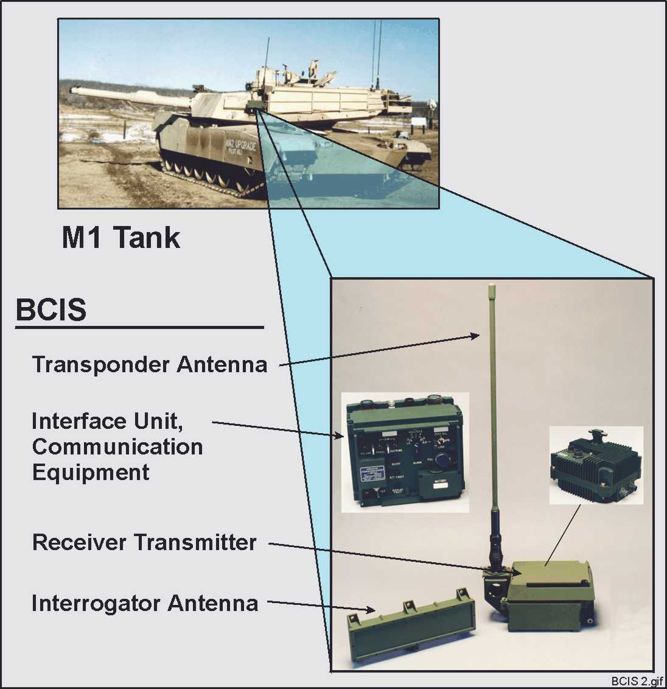
Figure 7: Battlefield Combat Identification System [BCIS]
A proposed solution for these selected causing factors was the BCIS, designed to be integrated into a platform’s fire control system, a vehicle’s crew would be equipped to immediately identify potential targets as friendly, hostile, or neutral. After the gunner aligns the weapon’s sights on a potential target, BCIS is activated in M1A1 Abrams tanks by the gunner using the vehicle’s laser rangefinder, or in M2A2 Bradleys by pressing an interrogation switch mounted below the vehicle’s trigger. Utilizing a 38 GHz electronic millimeter wave pulse, a potential target is queried, and if the potential target is also equipped with BCIS, it responds with a signal of its own. To maximize accuracy, each interrogation is the sum of three queries, where the system issues three separate pulses in under one second and analyzes the response of each before displaying the identification status of a potential target to the gunner. By doing so, BCIS was able to achieve an accuracy rate of above 97% [8].

Designed for use in all visibility conditions, BCIS was effective from a minimum range of 150 meters up to 5500 meters in optimal weather conditions or fog. In dusty conditions, the maximum effective range was reduced to 5000 meters; 4000 meters for radiation fog conditions, and 3000 meters for steady rain conditions [8].

BCIS given to Task Force XXI, or the Army’s experimental force (EXFOR), came with an added feature outfitted to provide accurate situational awareness information in the form of a digital data link (DDL). Upon the interrogation of one BCIS/DDL equipped platform to another BCIS/DDL platform, the target platform responds automatically by transmitting a signal from its omni-directional antenna containing the target vehicle’s GPS coordinates and unique identification code. This information is then added to the interrogating platform’s display computer screen showing a digitized map and graphics with icons indicating the location of friendlies. A composite signal would then be transmitted that shows the GPS location of all known BCIS/DDL platforms within the area. Received by any other BCIS/DDL platform within a one kilometer radius, these platforms would then update their displays and retransmit their own composite signal. By having multiple platforms intercommunicating position and identification information in parallel, situational awareness could spread rapidly across the battlefield, including to systems not directly involved in the interrogation sequence.

From EXFOR testing, BCIS was determined to have performed adequately and as advertised. Furthermore, Captain Mark Grabski ran offensive and defensive combat tank simulations to identify if BCIS improves combat effectiveness, defined as increased lethality and reduction in fratricide [9]. From his simulations, he was able to conclude that BCIS could positively supplement the combat effectiveness of a tank company, allowing our forces to move and react more quickly, apply dominant maneuvers, and perform precise engagement [9]. Results from Captain Grabski’s offensive ‘Movement to Contact’ simulation can be seen below in Table 3.

Despite demonstrating satisfactory results from EXFOR testing as well as Captain Grabski’s simulations showing increased combat effectiveness for units equipped with BCIS technologies, BCIS was still met with challenges. In order to integrate BCIS onto every Army/United States military vehicle would prove to be rather difficult and tremendously expensive. At a cost estimate of $100,000 per installation, the Army discontinued efforts into the program and abandoned the idea in 2003 [11].

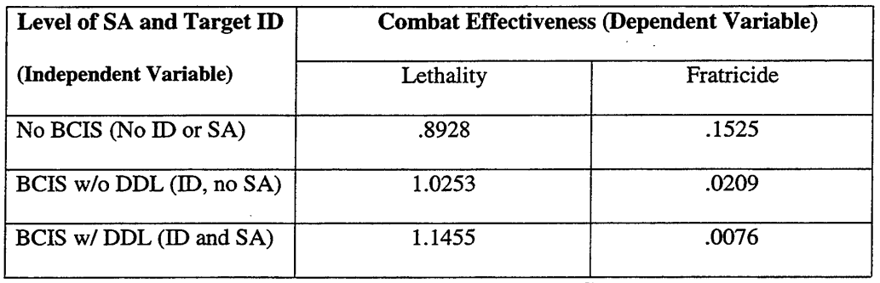
Table 3: Combat Effectiveness of BCIS

2.8.5 Aircraft Registration/Hull Number/Combat Identification Panels
A more-or-less idea we had for Photo-TANKS would be that each tank would have a symbol/number on them for an alternative method to identify allied/enemy vehicles. But, unsurprisingly, aircraft and naval vessels also have some sort of identifying mark for allied vehicles. With each having either numbers or an allied symbol on each.
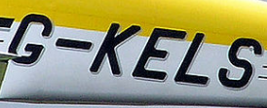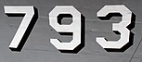
Figure 8: Aircraft Number (left) [Wiki], Ship Hull Number (right) [Wiki0]
There are a few ways that we can use these for Photo-TANKS: we could use a numbers that would be near the back of the tank (by reference of aircraft registration), we could have the numbers be at the front near the wheels of the tank (in reference to hull numbers), or we can reference old WWII tank symbols (in reference to military vehicle markings). The best idea is to use military vehicle markings, where a symbol of what affiliation was used, at the front of the tank, in between the grounded vehicle’s wheels.
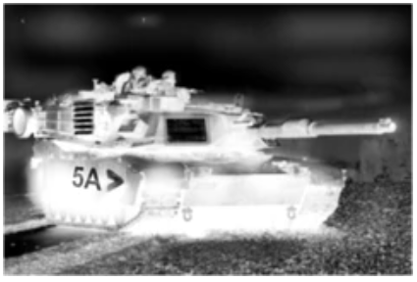
Figure 9: Combat Identification Panel [CIP]
Likely to the BCIS, combat identification panels (CIPs) were swiftly developed following the Gulf War to address the issue of direct fire fratricide. However, comparatively these identification panels operated at a far lower level of complexity than that of the BCIS. Stemming from an idea conceptualized by Captain David Jessup, 4th Infantry Division (Mechanized), he suggested the application of thermal tape onto armored vehicles to be utilized for combat identification. After technical and field testing met the satisfactory requirements, the United States military developed a thermal tape/panel design that could be implemented for each weapon platform. Each of which provided performance out to the maximum effective range of then-currently fielded direct fire weapons [13].

Still in use today during the modern age of warfare, CIPs are the primary means of ground-to-ground identification for armored and non-armored vehicles. Consisting of only one principal component, CIPs are typically found as 24 inch x 30 inch flat or venetian styled panels painted with a chemical agent resistant coating and covered with low emissive, high reflectivity, thermal tape. These panels are then fitted to rest flat against the exterior shell of the vehicle either by hook-and-loop fasteners (commonly referred to as velcro) or mounted inside a bracket designed to hang on the vehicle’s exterior.

When viewed through thermal sensors such as FLIR optics, CIPs appear as cold spots that contrast against the hot target image making them clearly pronounced to distinguish and easily identifiable. Platform dependent, CIPs would normally be arranged in sets of three or five panels mounted to provide for all aspect coverage of the vehicle. For a gunner carrying out the engagement process, he/she could quickly determine the friendly or unknown identity of a potential target by observing for these standardized cold spots.
Like any other technology, CIPs also had some shortcomings, although rather minor. Terrain features, such as trees and other vegetation, proper defilade firing positions, and other obstacles have the potential to break up or obscure the thermal picture of any vehicle [13]. This means that even if a vehicle is fitted with CIPs, there is still the chance that any direct line of sight a gunner would have on the panels could be concealed making the identification of the vehicle indeterminate. In desert conditions, it was found that fine dust particulates embedded themselves into the chemical agent resistant paint and no amount of washing or brushing could fully clean the surfaces of the CIPs. This caused a reduction in their overall reflectivity; however, it did not render them non-operable, it just limited the maximum range of which they were visible from five kilometers to about two and one half kilometers. Nevertheless, this was reported to not be a large problem due to the normal engagement ranges of tanks being shorter than two and one half kilometers [10].

Another technology to mention are thermal identification panels (TIPs) which are the air-to-ground equivalent of CIPs for target identification. TIPs have the same operational functions as CIPs, to appear as a cold spot against the hot vehicle, but are instead fabricated from soft cloth and cut to the dimensions of four feet x four feet.

2.8.6 Aided/Automatic Target Recognition
Aided/Automatic Target Recognition (Ai/ATR) is a generic term to describe automated processing functions performed on data obtained from input imaging sensors to conduct procedures ranging from notifying a human observer for their attention of a matter to complex, fully autonomous object acquisition and identification [12]. Imaging sensors used to collect the data to be processed by the Ai/ATR system include visible and electro-optics-infrared (EO/IR), 3D LADAR, and imaging radar such as synthetic aperture radar (SAR), each of which are platform centric [12]. ATR is fully autonomous, harnessing no need for human involvement, where all decision making processes are handled by artificial intelligence. An example for a system with ATR capabilities could be likened to that of a heat-seeking missile. Contrarilly, AiTR processing still requires the presence of a human observer to make the final decisions on verifying the importance and accuracy of informational image annotations displayed and the actions that will follow. An example for such a system could be compared to our team's proposed AI determined target acquisition functionality, where the information compiled is displayed to the tank's operator via the HUD to decide what actions should follow suit.

Ai/ATR systems have been a large focus of development for the United States military, viewed as a critical technology for modern combat. Similar to the BCIS, systems with Ai/ATR capabilities have enhanced combat effectiveness; increasing the lethality and survivability of the platform implemented, while reducing the engagement timeline regarding detection, location, and identification for target acquisition. Applications of such systems branch across an entire hierarchy of possible tasks that the Army, Navy, and Air Force are putting efforts into research and development for Ai/ATR platforms to perform such tasks like reconnaissance, intelligence, surveillance, target acquisition, fire control, wide-area search and track, countermine, and sensor fusion [12].

One would idealize that with the monstrous budget and highly advanced capabilities of the United States military, Ai/ATR would already be widely integrated into every platform imaginable. However, this is not the case. Having yet to realize full tactical promise, the current level of performance for Ai/ATR systems that are available are predominantly unreliable and deficient compared to their requirements. These challenges can be attributed to two reasons. The first is due to the lofty difficulty of acquiring targets in realistic environments. The topic of most concern for target acquisition is the difficulties for an ATR system to be able to decipher the detection of vehicles and personnel from image clutter. While ATR systems have shown to perform at an acceptable performance metric for low clutter scenarios, the capacity of these systems begins to steeply diminish for medium and high clutter backgrounds. In these cases, the capabilities for ATR target recognition and identification discrimination are significantly degraded compared to capabilities of target detection. Higher levels of background clutter leads to a higher false alarm rate by the ATR system due to an increased amount of input visual information where objects can be confused as targets. This limitation is further exacerbated by sensors such as thermal imaging, that have an inferior level of resolution to that of visual imaging counterparts [12]. Compoundingly, higher false alarm rates in realistic environments can be attributed to factors including camouflage, concealment, and deception; as well as target variability under different environmental, operational, and background conditions that can produce different signatures. The second reason why Ai/ATR systems have so far not met full tactical promise is the disconnect of communication between government labs, defense industries, and the academic community. A limitation that can be accredited to the unavailability of distribution of classified information. This even impacted our team's ability to conduct research into platforms capitalizing the use of Ai/ATR systems, with all public resources only pertaining to the challenges of Ai/ATR systems and the methods that could be employed to make improvements to further advance the technology.

3 Research and Part Selection

3.1 Technology Comparison
To construct Photo-TANKS, there are a plentiful amount of parts that we need. In general, these parts were fairly non-challenging to identify, knowing most of the parts our team would need in order to accomplish our goals for Photo-TANKS. However, sometimes identifying the best suited part for our project came with a challenge and even at times entire ideas for our project had to be redesigned in order to accommodate for what was available on the market and what was within our proposed budget.

3.1.1 Tank Treads/Continuous Track (Tank Chassis)
Arguably the most important part of the design of Photo-TANKS. The tank chassis we get will give us the dimensions of the tank, allow the tank to be all-terrain if possible, and will give us the load capacity. With these three important aspects of the tank chassis, we are looking for: a low cost of either less than $100 for one to about $155 for two, dimensions of about eleven inches long and eight and a half inches wide, a load capacity of four kilograms or higher, and the treads have to be nearly all-terrain. On the market, there is a wide variety of tank chassis choices to choose from, but upon further research, our team limited the choice of treads down to three.
Tank Treads | Price ($) | Dimensions (LxWxH) | Load capacity (kg) | Nearly All-Terrain?
B08P49VLPS | 79.99 | 13.38x9.44x4.8 inches | 5 | ✓
B096DKCCBT | 76.99 | 10.82x7.67x3.54 inches | 5 | ✓
B08QZB5MFR | 69.00 | 11.41x9.84x0.275 inches | 4 | ✓
Table 4: Tank Treads/Continuous Tracks comparison
From Table 4, we can see that all three choices are nearly all-terrain, and have roughly the same load capacity. Each tank chassis comes with a motor that we may or may not use for Photo-TANKS. With that, we can compare them more in-depth.

3.1.1.1 B08P49VLPS

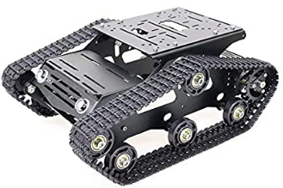
Figure 10: SZDoit: B0SP49VLS
Starting with the most expensive of the three, this SZDoit created tank chassis is the longest and tallest tank chassis of the three, weighing about 1.16 kg, and coming with a DC motor that can use 7 V to 12 V. This chassis is much taller and wider than the dimensions that our team is going for, has a high load capacity, and has an okay price. But, when we order a second one, the total price will be $160. Therefore, our team decided to look for better substitutions to choose from than this one.

3.1.1.2 B096DKCCBT

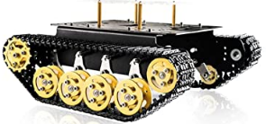
Figure 11: SZDoit: B096DKCCBT
Next, the second most pricey of the three, this also SZDoit created tank chassis is the shortest in both length and width of the three, weighing about 1.1 kg, and comes with a DC motor that can use 9 V to 12 V. Slightly off from what we want for dimensions, has a higher load capacity, and has a reasonable price for when we get a second one, totaling out at $154. At that price, this tank chassis will be really close to our budget limit. A large drawing factor for this chassis is the size of the platform provided for mounting components. The surface on this chassis is larger than that of the previous tank chassis investigated, as well as has a raised platform for additional mounting points. Compared to the B08QZB5MFR chassis, the platform on this one is raised above the treads. This allows for us to not have to accommodate for this in our design and we can attach a hull to this model directly. For these reasons, this is the tank chassis that we chose to use for our project.

3.1.1.3 B08QZB5MFR

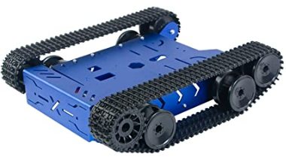
Figure 12: XiaoR GEEK: B0SQZB5MFR
Lastly, the cheapest of the three, this XiaoR GEEK created tank chassis is the widest tank chassis of the three, weighing about 1 kg, and coming with a DC motor that can only use 9 V. This chassis is near the dimensions we want, only about one and a half inches wider, and its load capacity is four kilograms. The primary drawback from this chassis was its design. Since the treads come above the platform, our team would have to design around that, building the tank with a very narrow base for the hull and expanding it out once we cleared the treads. If it was not for this fault, then this would most likely be the tank chassis our team would have selected to be used in our project, however we decided against selecting this product.

3.1.2 Batteries
With batteries being the most used voltage source in the world, we are going to use this for Photo-TANKS, over the other types of energies like solar. Since, batteries produce electricity by having electron movement inside its electrochemical cells, by having the electron move from the anode to cathode.
Since batteries are arguably the second most important part for Photo-TANKS, this will be giving us how much voltage we can use for Photo-TANKS and how much power used, current gained, and anything else we need to receive. With that, there are some specifications for what kind of batteries we need: we need at least a total 12 V, the cost needs to be at least under $60, and the cell needs to last for more than four hours. And, since there are many types of batteries, we will choose one from either non-rechargeable batteries (primary cell) or rechargeable batteries (secondary cell).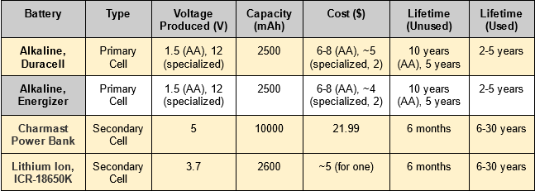 Table 5: Comparison of Batteries/Cells

3.1.2.1 Non-Rechargeable Batteries/Primary Cell
With there being many types of primary cells, all of them have the same function, as shown in the figure below.
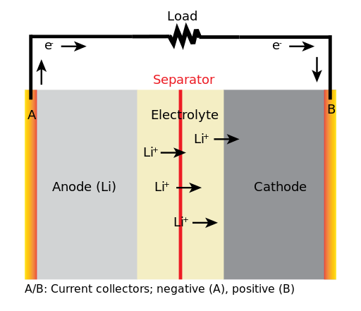
Figure 13: Battery diagram, for primary cell [Wiki1]
With Figure 14, these cells have a lifespan depending on how long they are used and how much power is consumed by electronic devices. Generally, if primary cells are not being used, their lifespan can be 10-12 years. But, as something starts using power, the primary cell will lose some of its lifespan. The more power used from devices causes the lifespan to shorten faster. By this, we can use an equation to determine a primary cell’s life time by [Digi1]:
$T=\frac{C}{A}$ (1)
Where, T is the cell’s lifetime,C is the capacity of the cell, and A is the current applied. So, if our Photo-TANKS is going to produce around 25 W, from the voltage source of the cell is 12 V, the current applied would be about 2 A. For a longer lifetime, we will want a high capacity of the cell.
There are a few companies that deal with primary cells, like Energizer and Duracell, and we can either buy a single 12 V primary cell, or have a set of the same voltage cells to make 12 V.
For the two primary cells, each having several speciality types, like ones that give max energy. And, since both companies have just about the same capacities as the other, it would just be the matter of which we want to use more.

3.1.2.2 Rechargeable Batteries/Secondary Cell
Unlike the primary cells, there are many different types of secondary cells, since they are a combination of electrode materials and electrolytes. Some examples include: lithium-ion and nickel-metal hydride. These secondary cells have a slightly different way to allow charging along with discharging energy from themselves.
For at least the lithium-ion cell, when it is in its ‘charging’ state, electrons from the cell’s anode move to the cell’s cathode, and lithium ions flow from the cell’s cathode to the anode, charging the cell. And, when the cell is in its ‘discharging’ state, electrons from the cell’s cathode move to the anode, and lithium ions flow from the cell’s anode to the cathode, essentially discharging the cell.
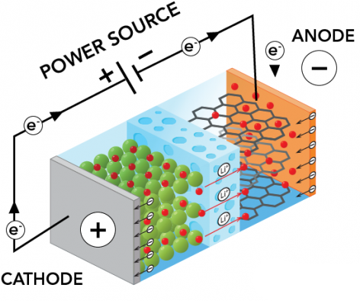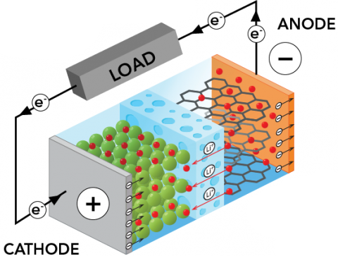
Figure 14: Secondary Cell, Charging (left) and Discharging (right) [Sci, Photo1]
The other types of secondary cells have some similar ways to charge/discharge themselves like the lithium-ion cell. Like the nickel-metal hydride, which uses an element like water in its medium to help with the charging/discharging process.
Akin to primary cells, secondary cells have a limited lifetime when they are being used. However, the lifetime of the secondary cells can be much larger than the primary cells, because of their charging/discharging process. But, after a certain amount of charge/discharge cycles, the secondary cell will start to lose performance. The secondary cell will also lose performance depending on: how long it has been charging, the depth of discharge as seen in Figure 15, and how long the secondary cell goes unused.
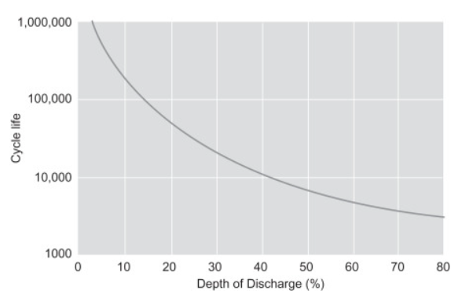
Figure 15: Depth of Discharge of a Secondary Cell [Fig 16]
For the singular secondary cell that is on Table 5, while it produces 12 V, the unused lifetime of six months and the price for it just makes it unusable for Photo-TANKS. While Photo-TANKS would not have to worry about being unused for those six months, it would be best to not use the secondary cell just based on the price. Since, we can get about twenty four primary cells for nearly half the price.

3.1.2.2.1 INIU Power Bank
The Jetson Nano 2GB Development board requires at least 4.25 V to stay in operational mode. However, the manufacturer recommends that the development board is powered by a steady 5 V power supply with at least 2A current. Based on these specifications, we have chosen a mobile power bank that is rechargeable and has a large capacity. The power bank that we have chosen is a power bank made by INIU. This battery pack has a 10000mAh capacity. It delivers a 5 V signal with a current of 3 A. In our design, we will be running two of this battery pack to double the run time of the tank. To accommodate the development board for two batteries, we will be running both batteries into a power regulator. When both batteries are connected in series, the combined voltage will be more than the development board can handle. The power regulation circuit will take the combined signal from these power banks and bring the output signal back down to a steady 5 V with 3 A current. This is exactly the power specifications that the developer recommends using to power the device.
UPDATE:
The INIU Power Bank was replaced with a Charmast 5V 3A Power Bank. Both of these power banks supplied the same voltage and current through USB-C connection, however the Charmast power bank was smaller in size. We opted for a smaller battery pack so that all of our components would fit more comfortably in the system.
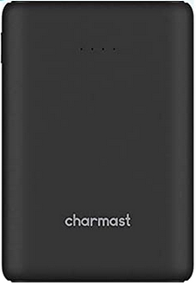
Figure 16: Charmast Power Bank

3.1.3 Motors
As a fundamental part for the Photo-TANKS, the motors allow the Photo-TANKS to move. Without them, the Photo-TANKS would just be a stationary cannon, which is not our end goal. Since we plan on making two tanks, there will be six motors, three twelve volt motors in the design for each Photo-TANKS, one motor that connects to the treads, one servo motor for the turret, and one servo motor for the barrel elevation. As such, for the motor attached to the treads there are requirements of: having a semi-low cost of either less than $100 for one or $150 for two, being able to go as fast as 75 RPM or greater, and using less than ten watts. And for the servo motors attached to the turret and barrel, they have requirements of: having an affordable cost, roughly similar or greater RPM speeds, and using about the same amount of watts as the motor connected to the treads. Based on these requirements and the fact that Photo-TANKS will be smaller due to its chassis, the motors will have to be small. There will be two types of DC motors to choose from: brushed motors, and brushless motors. By limiting the amount of motors to choose from, we will choose from three motors plus the tank chassis motor. So, in total there will be six motors to choose from for the two different motors we need. Is what we want to say, but brushless motors range from $400+, so only brushed motors will be compared.

3.1.3.1 Chassis DC Geared, Brushed Motors

Motor | Price ($) | Speed, No Torque (RPM) | Speed, Max Torque ( RPM) | Motor Size (mm) | Motor Length
MG16B-060-AB-00 | $37.03 | 213 | 160 | 17 | 38
1271-12-21 | 25.63 | 125 | 80 | 27 | 36
25 Geared Motor | - | ~150 | ~100 | 25 | 39.5
Table 6: 12 V Motor Comparison plus tank chassis motor, Connected to Treads
From Table 6, the MG16B-06-0-AB-00 is about the most average of the three chosen, being a good price, having a good amount of RPM and being rather small in size compared to the other two. Whereas, 1271-12-21 is cheaper, has lower RPM and has a bigger size than MG16B. And, 9904-120-5-2602 is the most expensive and the largest size, but has the greatest amount of RPM.
Since each of these motors are DC brushed motors, the motors rotate based on their magnetic field. When the motor is powered up, the armature inside will be pushed around, the left side of the armature will be ‘attracted’ towards the right side of the motor, the same for the right side of the armature, where it will be drawn to the left side. Until, both hits their desired side, causing them to be ‘rejected’ at that side, forcing them back to the other side, causing a full rotation, which repeats.
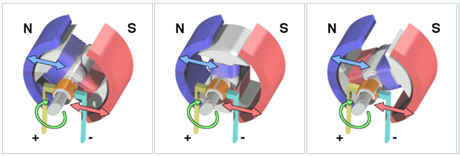
Figure 17: 12 V DC Brushed Motor Rotation [Wiki2]
And, as it starts rotating, we could find the current through the motor, and the power produced by:
$I=\frac{V_{applied}-V_{cemf}}{R_{armature}}$ (2) and, $P=I*V_{cemf}$ (3)

From Equations (2) and (3), it would be possible to theorize the power produced for the three motors chosen, from a 12 V source. We also could find the speed or torque of the motor, but since each motor specifications give what their maximum speed is at no torque and max torque, it would be possible to guess what the speed is at anything in between the zero to max torque. With this, we can start comparing the three motors, more in-depth.

3.1.3.1.1 MG16B-06-0-AB-00
Starting with the average of the three, the MG16B-06-0-AB-00 has a cheap price considering that the DC 12 V motors range from $19 to $252 (reference Newark). With the motor’s RPM being about the middle of all the DC 12 V motors from Newark, and being the smallest in size.We can see at no-load, or has roughly no torque, then the motor’s RPM max is around 213. But, when the motor gets around the max torque, which is 6 Ncm, then its RPM falls to around 160. By theorizing and using Equations (2) and (3), with a 12 V source, for the motor at no-load, the power will be roughly 80 mW to 960 mW. And, for max load, the power will be roughly 120 mW to 1.44 W. If we look back to the house of quality, we want the power used to be less than 25 W, and with this motor having the power produced being around 1.4 W, it should be fine.
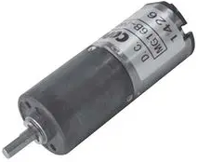
Figure 18: NIDEC COPAL ELECTRONICS: MG16B-06-0-AB-00

3.1.3.1.2 1271-12-21
From the average to the weakest of the three, 1271-12-21 has a cheaper price than MG16B, but given that 1271’s RPM is quite low, from the DC 12v Newark motors, the RPM ranges from 1.5 to 441. 1271’s size is a bit bigger than MG16B, but it is still small compared to others on Newark. Based on the max torque of this motor, which is 2.5 Ncm, the RPM falls to around 80. Which is just slightly above what we want for a motor to have, so this one is a no-go. By theorizing and using Equations (2) and (3), for a 12 V source, for the motor at no-load, the power will be roughly 20 mW to 240 mW. And for max load, the power will be roughly 50 mW to 600 mW. And, if we compare this to the house of quality, the power is significantly less than the 25 W we want to use.
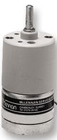
Figure 19:MCLENNAN: 1271-12-21
However, while this motor might not be used for the treads, the 1271-12-21 has the best chance of being the motor for the turret. Since it has the lowest RPM speed and price of the four motors. And, since the 25 mm geared motor has the biggest chance of being used, this motor has a similar size and length of that motor. Also, this motor is lighter, 55 g, than the other two motors, 70 g for MG16B and 125 g for 9904, giving Photo-TANKS a lesser chance of being top-heavy.

3.1.3.1.3 25mm Geared Motor
This is the motor from the tank chassis that we chose. With its size being roughly similar to 1271, and its length being similar to MG16B. It has no price tag associated since it comes along with the $76.99 tank chassis, and it has both RPM speeds over our house of quality RPM speeds by about 75 RPM for no-load and 25 RPM for max load. And, we can theorize the power made by using Equations (1) and (2), by a 12 V source. At no-load, the power produced is roughly 200 mW to 2.4 W. And at max load, the power roughly be triple of the no-load (so 600 mW to 7.2 W). Comparing this to the house of quality, 7.2 W out of 25 W is pretty significant, this motor would use and produce much more power than any of the other three motors. Even though that is the case, this motor has the highest chance of being used, since it came along with the tank chassis.

3.1.3.2 Turret Continuous Rotation Servo Motors
One of Photo-TANKS most important purposes besides reducing the time from target detection to confirmation in the military’s target acquisition process is Photo-TANKS ability to accurately recreate a real world tank. Part of achieving that effort is in making Photo-TANKS turret operate like that of its realistic counterpart by being able to rotate a full 360° independently from the direction that the tank is facing and/or traveling. In order to accomplish such a task our team realized the need for a small motor to drive a gear that would in turn spin another gear that would turn the tank’s turret. Upon research, our attention was guided to 360° continuous rotation servo motors as the desired tool for the job at hand. Proceeding, we formulated a series of requirements that we felt the correct motor for our project should meet, including: being able to control what direction the motor is rotating, being able to control how fast the motor is rotating, the motor has to be able to spin the turret fast enough to meet our requirement specification for turret rotation speed, and the motor has to be strong enough to overcome any frictional forces that would hinder it from rotating the turret or cause a stall. Cost was a constraint that we felt did not need to be heavily considered since a majority of the 360° continuous rotation servo motors on the market are priced within the range of $10 to $30. The most vital requirement that we felt the motor should meet is its ability to overcome the frictional forces to rotate the tank’s turret since our design constitutes 3-D printing the tank’s turret and body, and we are not providing any aids to rotating the turret such as rollers or bearings.

From Table 7 below, we can see that all three of the options operate at either the same, or near the same optimal working voltage. Further, all three of the options meet our requirement of being able to control the rotation direction and rotation speed of the servo motor. While all of the options are about the same price, product 900-00360 is considerably more expensive than the other two options. Taking these aspects into consideration, we can look into each one more in-depth to better understand how our team selected which servo motor to use in our project.

 | Rotation Speed (No-Load)  (RPM) | Stall Torque  (kg$⋅$cm) | Gear Material | Optimal Working Voltage (V) | Rotation Direction & Speed Control | Cost ($)
FS5103R | 62.5 | 3.2 | Plastic | 6 | ✓ | 11.95
900-00360 | 140 ± 10 | 2.2 | Plastic | 6 | ✓ | 27.99
DF15RSMG | 62.5 | 19.3 | Steel/Copper Mix | 7.4 | ✓ | 18.05
Table 7: 360° Continuous Rotation Servo Comparisons

3.1.3.2.1 FS5103R
Beginning with the most affordable servo out of the three options, product FS5103R was heavily considered as the servo of choice for our team’s project since it roughly sits in the average position of the other two options. It’s rotation speed under no-load is 62.5 RPM, or about 0.16 sec/60°, and considering that in reality the servo will have to overcome some resistive forces and be under load, we estimate that a more realistic rotation speed would be around 0.2 sec/60°. Even at this slower speed, FS5103R should be capable of meeting our proposed requirement specification that Photo-TANKS turret has to be able to rotate 30° per second. Product FS5103R has a listed optimal working voltage of 6 V, and our research found that the average working current drawn by this servo motor is around 200 mA. Plugging these values into Equation (2), equates to a power consumption of 1.2 W. This value is well within tolerable of our requirement specification of 25 W maximum power usage. What ended up deterring us from selecting this servo motor is its specified stall torque, notably due to the plastic composition of its internal gears. Specified at 3.2 kg$⋅$cm, our team was worried that the frictional forces the servo would have to overcome would be too demanding and cause a stall. That, or possibly end up breaking the internal gears, especially in the situation where the operator of Photo-TANKS would want to abruptly turn the tank’s turret at full rotation speed. However, if it turns out that our selected continuous rotation servo motor, product DF15RSMG, is too powerful then product FS5103R could be a worthy substitution.

3.1.3.2.2 900-00360
While being the most expensive servo of the three possible options our team selected, product 900-00360 did seem to bring some value to the table. Considering the situation where Photo-TANKS turret is much less challenging to rotate than our team foresees, 900-00360 could be a satisfactory option if FS5103R ended up being too slow. Having a rotation speed of about 140 RPM, 900-00360 is over twice as fast as both the other servo options. Translating this to the possible gear ratio our team uses for Photo-TANKS turret and the driving servo, having a far faster servo RPM could allow us to more accessibly achieve our requirement specification of the turret being able to rotate 30° per second. This faster rotation speed unfortunately does not come for free. Sacrificially, the stall torque of this servo motor is 1 kg$⋅$cm weaker than FS5103R, sitting at 2.2 kg$⋅$cm. Again, we were worried that this amount of torque may not be strong enough in order to rotate the tank’s turret and the servo could undergo extreme amounts of stress. The specified optimal working voltage for this servo motor is also rated at 6 V and moreover, its working current under no-load was listed to be 150 mA. Using Equation (2), our team calculated that we could expect a power draw of 0.9 W using this servo motor. Out of the three options, this servo offered the lowest amount of power consumption and easily paired with our requirement specification of 25 W maximum power usage. Similarly to the product FS5103R, 900-00360 gears are made out of plastic and substantial amounts of stress on the internal gears could end up causing a failure via the plastic breaking. For these reasons, we decided it would be best to turn our attention for selecting the correct servo motor for our project away from 900-00360.

3.1.3.2.3 DF15RSMG
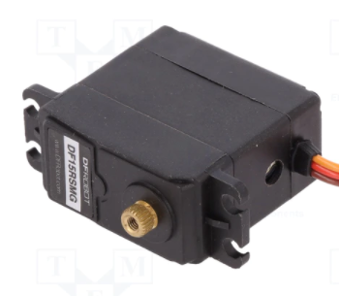
Figure 20: DF15RSMG Servo Motor
Servo DF15RSMG overall seemed to have the best combination of specifications that our team felt would accomplish the task of rotating Photo-TANKS turret efficiently and without the worry of ever having a mechanical failure. Not to mention that for its cost being under $20, we felt we were getting a great deal of quality and performance for a good price. Also having a no-load rotation speed of 62.5 RPM like the FS5103R, this servo is rather slow compared to the other option on hand. However again, accommodation with taking into regard the gear ratio used for the tank’s turret mechanism, achieving our requirement specification of 30° per second turret rotation should be well possible. DF15RSMG does have a higher optimal working voltage than the other two options at 7.4 V, and a stall current of 2 A at 7.2 V. Meaning that, using Equation (2), the maximum power draw we would see from this servo motor would be 14.4 W. This is rather high; however, given how strong this servo is, our team suspects that we would never run into such a situation and the power drawn while in working conditions would be far lower and not drastically impeding on our requirement specification of 25 W maximum power. Continuing on how strong product DF15RSMG is, the stall torque is specified to be 19.3 kg$⋅$cm, being 6x greater than FS5103R. This figure was rather impressive, largely in part by DF15RSMG use of steel and copper gears that are able to face far stronger amounts of force to drive the servo. Having a stall torque this high, our team felt that any worry of the challenge of overcoming frictional forces could be completely disregarded and that this servo motor would not ever have an issue with rotating Photo-TANKS turret. For all of these reasons, we selected product DF15RSMG as our continuous rotation servo motor to operate the turret rotation functions on Photo-TANKS.
UPDATE:
The DF15RSMG servo motors were replaced with the Greartisan 12V 50RPm Geared DC Motor. This motor can handle up to roughly 4 Kg.cm of torque at maximum revolutions per minute. If the motor is undervolted to 10RPM, the motor can handle 15 Kg.cm of torque. The motor was chosen to replace the servo motor mentioned above because it has a more rigid body. The servo motor that we used during testing was having issues with the housing flexing. This was due to it being made of plastic. When the housing flexed, the gears we designed would become unaligned properly and the turret rotation would stall. The new DC motor selected has an all steel housing preventing any flexing, this keeping the gears in place.
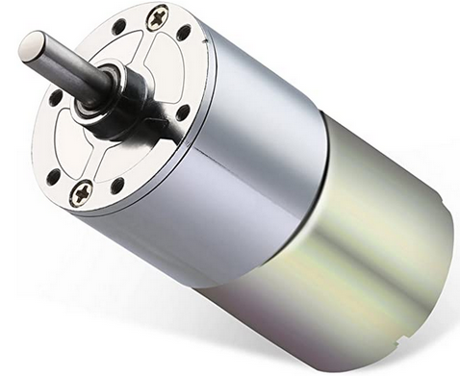
Figure 21: Greartisan 12V 50RPM Geared Motor

3.1.3.3 Barrel Elevation Servo Motors
Another part of Photo-TANKS recreation of a realistic tank is having the ability to control the elevation angle of the tank’s barrel in order to more accurately aim the tank’s cannon, or laser in our instance. By pairing barrel elevation control with a fully rotatable 360° turret, Photo-TANKS will be capable to directly identify potential targets via unique code identification and possibly engage with those targets in a wide range of movement. Furthermore, given the situation where the tank would be situated on higher elevation in order to provide Photo-TANKS with a greater view of the surroundings for observation, the operator can control the barrel depression to aim at and identify potential targets. Unlike the turret continuous rotation servo motors, our barrel elevation control requires position control, which is offered by the everyday basic servo. However, our team realized that a constraint that needed to be addressed while deciding on what servo to use is that the amount of available space within the head of the turret is limited. Especially in the area where the servo to control the barrel elevation is going to be mounted. Therefore, we focused our attention onto the market of micro-servo motors. In doing so we formulated a list of requirements the right micro-servo should meet for our project, including: dimensions that would work well with our tank design and a high level of resolution between the servo’s steps in order to maximize aiming accuracy. Like the turret servo motors, cost was again something that we felt did not need to be greatly considered since the range of most micro-servos on the market are priced at about $5 to $10. Specifications like rotation speed were also not heavily considered since all of the micro-servos we investigated had similar rotation speeds around 0.1 sec/60°. Taking everything into deliberation, our team decided that the most important requirement that we felt the best servo motor for our project would have to meet is the amount of resolution between the steps in order to maximize the aiming accuracy of the tank.

 | Stall Torque  (kg$⋅$cm) | Operating Travel (°) | Optimal Working Voltage (V) | Pulse Cycle  (ms) | Gear Material | Dimensions (mm) | Cost ($)
HXT900 | 1.6 | ± 45 | 4.8 | 20 | Nylon | 23 x 12 x 23 | 3.49
HD-1440A | 0.6 | ± 90 | 4.8 | 2.2 | Plastic | 20.2 x 8.5 x 20.2 | 6.34
MG90D | 2.1 | ± 45 | 4.8 | 1.0 | Steel/Copper Mix | 22.8 x 12.2 x 28.5 | 9.95
Table 8: Position Control Micro-Servo Comparisons

From Table 8, we can see that all three of the options operate at the same working voltage of 4.8 V. Additionally, all three of the options being compared have fairly similar dimensions, all of which would work well with our project’s design. Comparatively, the greatest difference between these three options are their respective prices and the period of their pulse cycles determining the resolution between the micro-servos steps.

3.1.3.3.1 HXT900
The HXT900 was initially our motor of choice when our team began our research into micro-servo motors. This servo is widely used and highly recommended amongst the world of hobbyists, often referred to as the ‘hobbyist’s favorite micro-servo’. Beginning with its cost set at $3.49, HXT900 is very inexpensive and was the most affordable micro-servo out of all the servos we investigated. The performance specifications for this servo were also quite impressive, at least at first. Product HXT900 specifies that its stall torque is rated at 1.6 kg$⋅$cm. Given that the only components that are integrated with the barrel in our project are the laser diode, plano-convex lens, and mounted first-person camera for Photo-TANKS operator, the total weight of the barrel should be rather light. Therefore, our team felt that with this stall torque rating, we would not run into any issue of moving the tank’s barrel. Furthermore, HXT900 offers ± 45° of operating travel which is more than enough travel distance for our desired range of elevation control for our project. Having an optimal working voltage specified as 4.8 V, product HXT900, reports show that these micro-servos draw about 250 mA under no load. Using Equation (2), this results in a power draw of 1.2 W which is well within manageable grounds of our specification requirement of 25 W maximum power usage. The only drawback that HXT900 has is its pulse cycle, specified at 20 ms. Initially, we felt that this figure would be acceptable for our resolution requirement; however, upon further research we discovered that these micro-servos have a very small, but noticeable stutter between the steps of rotation. Or in other words, we felt the resolution between the steps was not great enough in order to provide our project with the amount of barrel elevation control precision that we desired. For this reason, we realized that we needed to return to scouting out the market for available products that offer a much better specced pulse cycle to meet our requirement of having a high degree of aiming accuracy.

3.1.3.3.2 HD-1440A
Starting with this micro-servo’s cost, HD-1440A is resting at the lower end of the market, priced at $6.34. Seeming like a decent substitution to the HXT900, it offers about 10x better rotation step resolution with a pulse cycle of 2.2 ms. Additionally, this micro-servo was one of the smallest we could find on the market and has the smallest dimensions compared here. This would give our team the greatest amount of freedom in deciding exactly where the micro-servo should be mounted within the turret head of the tank. Similar to all the micro-servos compared here, product HD-1440A has an optimal working voltage of 4.8 V; however, it has a specified working current of 100 mA under no load. Therefore, using Equation (2) we can calculate that the expected power draw for this micro-servo would be about 0.48 W or well within our proposed requirement specifications. Product HD-1440A does offer a further amount of operating travel compared to the other two micro-servo motors, specified at ± 90°. While this value is acceptable for the purposes of our project, this a far greater amount of possible operating travel than we would ever need. What concerned our team was HD-1440A’s listed stall torque being rated at 0.6 kg$⋅$cm. Again, while we expect the barrel of Photo-TANKS to be rather light, our team was not comfortable with the thought of this micro-servo being potentially too weak.

3.1.3.3.3 MG90D
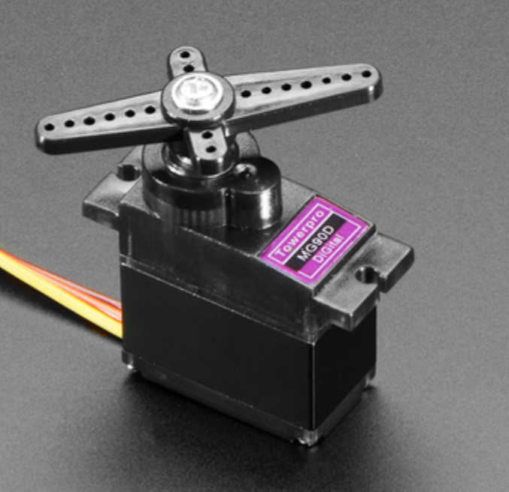
Figure 22: MG90D Servo Motor

MG90D overall accommodated for all the concerns we had regarding the other two micro-servos our team was considering. With a cost set at $9.95, this micro-servo is priced at the higher end of the scale in the market of micro-servos and is the most expensive servo compared to HXT900 and HD-1440A. Having a specified stall torque of 2.1 kg$⋅$cm, MG90D is the strongest motor out of the three. Like DF15RSMG, this micro-servo utilizes steel and copper gears to drive the motor, resulting in the ability to overcome strong resistive forces. Having a stall torque this strong, product MG90D should never have an issue modulating the elevation of the tank’s barrel. Similar to the servo HXT900, MG90D offers ± 45° of operating travel in either direction and provides plenty of possible travel space that our project would require. Again, like the other two micro-servos being compared here, product MG90D has an optimal working voltage of 4.8 V. Unlike the other two options, this micro-servo consumes much more power. Our team’s research found that MG90D’s average working current draw is around 500 mA. Taking into account Equation (2), this results in a power draw of 2.4 W while under no-load. This figure is a bit large compared to the other two micro-servos, being twice and 5x greater than HXT900 and HD-1440A respectively. Even though this micro-servo motor draws a much larger amount of power compared to the other two options, 2.4 W would still be manageable and meet our specification requirement of 25 W maximum power usage. The most notable specification listed for MG90D is its pulse cycle of 1.0 ms. Our research found that with this short of a pulse cycle, the resolution between the steps of rotation is extremely exceptional and the movements of this micro-servo are very smooth. By having great resolution between steps, our team felt comfortable that servo MG90D would meet our requirement for maximizing the aiming accuracy of the tank’s barrel. In summation, our team decided that this micro-servo motor was the best equipped to accomplish the task of controlling the barrel elevation of our project and selected it as our micro-servo of choice.

3.1.4 Laser Diode
The laser diode is very crucial to Photo-TANKS, since the laser diode is going to be utilized to identify potential targets and will be used to ‘shoot’ hostile targets. Since the laser diode is going to be placed within the barrel, the diameter of the laser diode needs to be somewhat small or less than fifteen millimeters. Along with that, the laser diode needs to: produce at least ten milliwatts of optical power, be around 633 nanometers for its wavelength, have a low maximum beam divergence of either 12° or lower, and cost less than $100.

There is not really much to compare with these laser diodes. We could find the power/current/voltage from using the power equation for the laser diode. Which has some use, since using a 12 V source, we could find the maximum current we can use for the power. Because, we should not exceed the output power/max current.

 | Wavelength (nm) | Power (mW) | Typ./Max Current (mA) | Diameter (mm) | Beam Divergence (Max) (deg) | Cost ($)
L635P5 | 635 | 5 | 30/45 | 5.6 | 10 | 25.21
HL6320G | 635 | 10 | 70/95 | 9 | 11 | 43.02
HL6322G | 635 | 15 | 85/100 | 9 | 11 | 71.96
HL63163DG | 633 | 100 | 170/230 | 5.6 | 13 | 307.32
Table 9: Laser Diode Comparisons [Thorlabs1]

3.1.4.1 L635P5
With the lowest output power of the four laser diodes, and the second cheapest of all the 633 nm - 635 nm laser diodes [Thorlabs1]. Due to its low power, 5 mW, and by using the power equation, the max current that we could use would be around 0.4167 mA. While it would be possible to get that low of a current, this diode is our best bet. Since, the max divergence is 10°, which is good, but the minimum divergence is 6°, which is the same as the laser diode HL6322G. But, this laser diode is a class 3R/3B laser, which will be safer to use for an extended period of time. This is the laser diode we have chosen.

3.1.4.2 HL6320G
This laser diode is much more applicable to use with Photo-TANKS than the previous. It has the absolute minimum of output power and a higher max current of 0.833 mA from our 12 V source. The price is alright, with it being under half of the amount we want to spend for a laser diode. And, it has an alright max divergence of 11°, while its minimum divergence is 5°. A really great choice, and an okay diameter too.

3.1.4.3 HL6322G
This laser diode is pretty much an upgrade of HL6320G. It has a higher output power, and a higher max current of 1.25 mA when we use the 12 V source, and the diameter is the same. The max divergence is the same, but the minimum divergence for this laser diode is 6° instead of 5° like HL6320G. This laser diode is a bit pricey but also a really good choice if we need the extra 5mW of output power. Out of the four laser diodes, this laser diode was chosen first, but since it is in the range of a class 3B laser, it would be generally unsafe to use for a long period of time.

3.1.4.4 HL63163DG
This laser diode has the highest output power of all the 633 nm - 635 nm laser diodes. However, just because this diode does, the price for it is triple the amount of the price we are willing to pay for. But, if we were to exclude the price, this laser diode would be great. Because of its high power, the max current is 8.33 mA with the 12 V source. Its diameter is a good size, and while its maximum divergence is 13°, the minimum divergence is 5°. So, if this laser diode was cheaper, it would have the best chance to be picked, but since it is $307.32, this laser diode will not be chosen.

3.1.5 Laser Diode Evaluation Board
Update: We needed a Laser Diode Evaluation Board that could run a current driver for the laser diode, so we got the MLDEVAL Evaluation Board. It has multiple chip support, it can be powered by 5 V source, it supports all laser diode pin setups and it has an on-board current control by potentiometer. This Evaluation Board is just to make the Laser Diode work correctly.
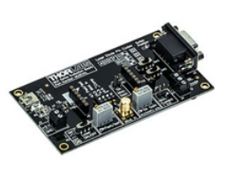
Figure 23: MLDEVAL Board

3.1.6 Constant Current Laser Diode Driver
Update: We needed a Constant Current to run the Laser Diode, so we got the MLD203CLN to run with the MLDEVAL Evaluation Board. It will also be connected to the 5 V source, with the potentiometer. And, this Current Driver has a built in protection against current spikes to protect the Laser Diode from burning out.
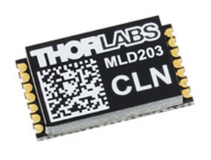
Figure 24, MLD203CLN Current Driver

3.1.7 Lens
The lens is something that Photo-TANKS is going to need so that the beam from the laser diode does not diverge after a certain amount of length and remains focused and collimated. Since the lens is going to be located within the barrel, the diameter needs to be somewhat small, in the range of 25.4 mm or less. Along with that, we want the lens to: accept the 635 nm laser diode we have chosen, have a focal length of one meter or higher, and a cost under $100.

For the lenses, we can test a few things, like we can use the Lensmaker's equation (Equation 4) to find the possible focal length that we desire for a thick lens. Or, we could calculate the effective focal length (EFL) (Equation 5) of multiple thick lenses if we need/want to go further.

$\frac{1}{f}=(n-1)[\frac{1}{R_{1}}-\frac{1}{R_{2}}+\frac{(n-1)d}{nR_{1}R_{2}}]$ (4)
$\frac{1}{EFL}=\frac{1}{f_{1}}+\frac{1}{f_{2}}-\frac{d}{f_{1}f_{2}}$ (5)

 | Type | Focal Length (mm) | Diameter (mm) | Acceptable Wavelengths | Cost ($)
LB1409 | Bi-Convex | 1000 | 25.4 | 350nm - 2μm | 22.18
LB1859 | Bi-Convex | 1000 | 50.8 | 350nm - 2μm | 36.52
LA1259 | Plano-Convex | 2500 | 25.4 | 350nm - 2μm | 19.98
LA1039 | Plano-Convex | 9 | 3 | 350nm - 2μm | 56
Table 10: Lens Comparisons [Bi-Thorlabs, Plano-Thorlabs]

3.1.7.1 The Bi-Convex Lenses
For these lenses, they have little to no use for Photo-TANKS. Since, bi-convex lenses are used when the distance of the ‘object’ and the distance of the ‘image’ are nearly the same. But, since the ‘image’ can be anywhere from the maximum focal length to right next to the ‘object’, the conjugate ratio can be fine and could also not be fine. Since, the bi-convex lens works the best when the ratio is around 0.2 to 5.

If we take the focal length of the selected Bi-convex lens and if we assume that the distance between the laser diode and lens is about twenty millimeters, then the distance for at least a 0.2 ratio would be about four millimeters and for a ratio of 5, the distance would be about one hundred millimeters. Therefore, in order for an optimal ratio, the laser diode would have to be at a distance away of about two hundred millimeters for the ratio of 5. Which is something we could do, but for only a one meter focal length, it is not worth it.

3.1.7.2 The Plano-Convex Lenses
These lenses are much more appropriate for Photo-TANKS. Since plano-convex lenses can deal with a higher and lower conjugate ratio than bi-convex lenses and since they perform a better job at focusing and collimating a beam to ensure minimum beam waist. Because of that, this type of lens is the best choice for Photo-TANKS.

At first, the LA1259 was our choice for lens, since it had a large focal length. However, upon further research we discovered we were thinking a bit backward. We found out that due to its large focal length, the lens would be able to focus and collimate the laser diode’s beam in the fashion of a laser pointer as we desired. This could be adjusted for using a system of lenses; however our team decided to change to a lens that could handle the task on its own. With a much smaller focal length in order to be close to the laser diode before the light diverges too far, we selected LA1039 as our lens of choice for our project.

3.1.8 Optical Sensors
With these, we want them to detect when the laser diode is ‘targeting’ them at low levels of optical output power. And for them to detect when a ‘hit’ occurs, when the laser pulse uses a higher optical output power. So, for these optical sensors, we want them to: accept the 635 nm wavelength from the laser diode, have a good size for their active area at or above one millimeter diameter, and have a somewhat okay responsivity of 0.5 or higher. Lastly, the total cost for how many we want needs to be lower than $200.

 | Type | Wavelength Sensitivity Max (nm) | Diameter (mm) | Dark Current (nA) | Responsivity (A/W) | Cost ($) (for 1)
TEPT5700 | Photo- Transistor | 800 | 5 | 100 | 0.95 | 0.77
EAALST05RDMA0 | Photo- Transistor | 700 | 5 | 100 | - | 0.17
FDS010 | Photo- Diode | 1100 | 1 | 0.3 | 0.44 | 48.15
FD11A | Photo- Diode | 1000 | 1.1 | 0.002 | 0.6 | 14.58
Table 11: Optical Sensors Comparisons [Vishay, Mouser, Diode-Thorlabs]

For these optical sensors, we could find the responsivity of each using either the responsivity equation for photo-diodes (Equation 6) or phototransistors (Equation 7). And we could find the photocurrent for each optical sensor, if needed (Equations 8 & 9).
$R_{Diode}=\frac{I_{Photo}}{P_{Optical}}$ (6) $R_{Trans}=\frac{(I_{Light}-I_{Dark})}{(P_{In}*A)}$ (7)
$I_{Photo-D}=n(\frac{Q*P_{Optical}}{hf})$ (8) $I_{Photo-T}=q(\frac{n*P_{In}}{hf})(\frac{μτE}{L})$ (9)

3.1.8.1 The Phototransistors
For these optical sensors, they are more useful for Photo-TANKS than the photodiodes. Mainly because the price for one can be less than a dollar, and generally come as a set of 100+, and at higher quantities, the price for one decreases, like from $0.77 for one to $0.445 for one if 100 are ordered.

While the photodiodes give their responsivity, we can calculate the responsivity for these phototransistors using Equation 7, with their A being five millimeters, and the $P_{In}$ can be up to one watt. With these, the responsivity range for TEPT5700 being 0.00479 (A/W) at one watt, to 4.79 (A/W) at one milliwatt. And for the EAALST05RDMA0, the range is 0.00198 (A/W) to 1.98 (A/W). Meaning, at a lower input power, the responsivity increases.

Of the two phototransistors, we have chosen the TEPT5700. Since it has a higher responsivity and since we do not need an overwhelming stock of phototransistors, instead of buying the minimum quantity of EAALST05RDMA0 which is 1,500, we can buy 100 of TEPT5700 for nearly one-sixth of the 1,500.

3.1.8.2 The Photodiodes
With these optical sensors, photo-diodes have less of a use for Photo-TANKS. Since, photodiodes generally have a low responsivity of 0.36 to 0.725 (A/W), a smaller active size (of the two that were chosen), and that the price for one can be above the price for many for a phototransistor. For those reasons, photodiodes will not be chosen for Photo-TANKS.

3.1.9 Multi-Color LED
The last optical component, excluding any stretch goals, that we need for Photo-TANKS. However, this optical device does not really have a huge impact on Photo-TANKS, since it will only be used to show the ‘health’ of Photo-TANKS. With that, the multi-color LED needs to: display at least three colors (Green to Yellow to Red), use less than 5 W of power, and cost less than $20.

 | Type | Wavelength (nm) | Current (mA) | Forward Voltage (V) | Viewing Angle (deg) ${2Θ}_{\frac{1}{2}}$ | Cost ($) for One
1528-2761-ND | RGB LED | R:632 G:520 B:468 | 20 | R:2 G:3.2 B:3.2 | 130 | 5.95
BL-HBGR32L-3-TRB-8 | Smart LED | R:625 G:525 B:465 | 18 | - | 120 | 7.99
Table 12: Multi-Color LED Comparisons

For the multi-color LED, there are only two things we can calculate/show off, the resistance needed for a color of the multi-color LED (Equation 10) and the power of an LED [Digi2].
$R=\frac{V_{DD}-V_{F}-V_{OL}}{I}$ (10)

3.1.9.1 1528-2761-ND
This LED is a regular RGB LED. RGB LEDs generally come with 3+ leads and can produce various colors based on the voltage source and Equation 10. The 1528-2761-ND can be used with and without a microcontroller to produce the colors. But, since we only want to use three colors: red at 632 nm, green at 520 nm, and yellow at 580 nm, a microcontroller is not really necessary for this multi-color LED. But, since we will be using a microcontroller, it will make the process of changing between colors faster.

If we were to use Equation 10, we could find that the resistances for the three colors would be, with a 12 V source: 440 Ω for red, 410 Ω for yellow, and 380 Ω for green. Which are easily accessible resistors. Or, instead of using resistors, it is possible to use pulse width modulated (PWM) signals from a microcontroller to produce those three colors. Since, we are going to use a microcontroller anyways.

3.1.9.2 BL-HBGR32L-3-TRB-8
Unlike the previous LED, the BL-HBGR32L-3-TRB-8 is a smart LED. A smart LED is a multi-color LED that has a programmable interface, where the smart LED can produce various colors using an 800 kHz $I^{2}C$ interface. Since this LED has the $I^{2}C$ interface, the LED uses less space and simplifies the code used to produce colors for the regular RGB LED. Which can be used to chain multiple smart LEDs together to display either the same color, or different colors if the next smart LED’s input is connected to the previous smart LED’s output. This multi-color LED/LED type is the one we chose.

Figure 25: Sample Image of a Smart LED [Digi2]

UPDATE:
The BL-HBGR32L-3-TRB-8 smart LEDs were removed from the design due to overcomplication in their setup as well as coding. We opted to change the designs to use simple LEDs connected in series with a small resistor and connected to a control signal wire. We had different color LEDs for friend and foe.

3.1.10 Wiring
One of the more complicated parts of building our tank is going to be the wiring. The reason that it will be complicated is because of the tank's turret. The tank's top mounted gun is a separate piece than the main body of the tank. This allows the tank to remain stationary while the turret is aiming in various directions. Without the ability to turn the turret separate from the body of the tank, the tank might not be able to aim at a target in an acceptable time. An example of this would be if the tank pulled into an area with limited turning radius. If an enemy tank appeared behind the primary tank, the primary tank would not be able to turn around and shoot it.
Since we have decided that the tank's turret must be able to rotate, we need a way to wire it properly. The standard wiring method would be to run the required wires through the hole that connects the turret and the tank's body. The wires would be fixed to the printed circuit board in the body of the tank as well as being fixed to the components in the turret. This method will work but it is not the most ideal solution. The problem with this idea is that when the tank turret is turned too many times in either direction, the wires can become tangled and or damaged. More specifically, if the tank's turret were to rotate in a single direction too many times, the wires would become twisted around each other. This would lead to the wires being ripped from their connections. Forcefully removing wires from the circuit board and or various components would most likely damage them. This would guarantee that the tank has a critical failure.
There are four potential solutions to this problem that I have found. All of these solutions come in the form of a slip ring. A slip ring is a type of wiring connector that transmits power and electrical signals from one contact to another in a rotating configuration. The four types of slip rings that we considered are the standard slip ring, pancake slip ring, mercury wetted slip ring and the wireless slip ring.

3.1.10.1 Standard Slip Ring
The standard slip ring is the most common type of slip ring. This design is the most straightforward design as well as the least expensive option. This design consists of a rotational cylindrical structure that contains metal traces and carbon brushes. The carbon brushes are built as part of the external housing of the component. The core of the device consists of metal traces that wrap around the cylinder. When fully assembled, the brushes are making constant contact with the metal traces. This allows either half of the assembly to rotate while retaining the connections established.
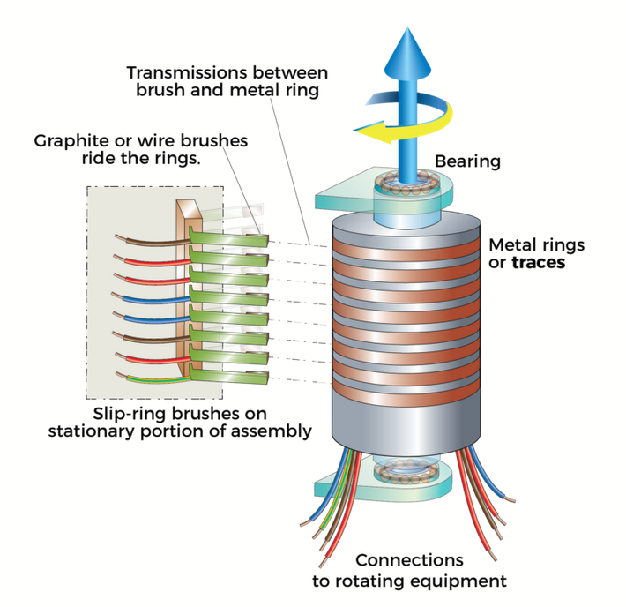
Figure 26: Standard Slip Ring

3.1.10.2 Pancake Slip Ring
The Pancake slip ring uses the same idea of contacts and brushes that the standard slip ring has. The difference is that, instead of the vertical orientation of the slip ring, the pancake slip ring has a more horizontal orientation. To be specific, the pancake slip ring is shaped like a disk. The metal traces that pick up the signals are placed on the top or bottom of the inner surface. The brushes are then placed on the opposite inner surface. While this design is very similar to the standard slip ring, it is not the most ideal configuration for our design.
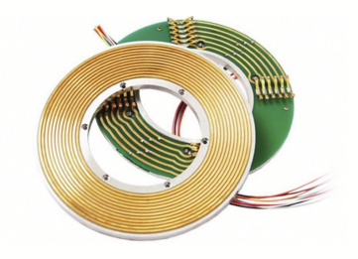
Figure 27: Pancake Slip Ring

3.1.10.3 Mercury Dipped Slip Ring
The mercury dipped slip ring is another slip ring design that has a vertical orientation. In this design, instead of using the metal brushes that we learned about in the previous designs, the slip ring uses brushes that have tips that are wetted with liquid mercury. The mercury in this scenario is molecularly bonded with each of the contacts. There are multiple advantages to this design. The first advantage is the reduction of friction. When the turret rotates, the standard metal brushes are constantly rubbing on the wire traces. This carbon on metal contact results in friction. With the wetted mercury design, the use of liquid means that the brushes are not making direct contact with the wire traces. This results in a very low amount of friction. Another advantage of this design is the high conductivity of mercury. When compared to one of the more common materials used as brushes, carbon, the conductivity of mercury is superior. The last major benefit of the mercury dipped slip ring is the reduction of electrical noise. In general, sound resonates more in solids than liquids. This means that vibration and other outside factors will affect the slip ring less. This makes for a quieter and more reliable component. Other aspects to consider with this mercury dipped design are the safety and reliability of the component. One major drawback of this design is that it cannot be safely used with any devices that involve food. This is because mercury is a heavy and toxic material. The other drawback of this design is the freezing point of mercury. Liquid mercury freezes at exactly -40 degrees celsius. Luckily, our tank design is not affected by either of these drawbacks. This makes the mercury dipped slip ring a solid choice.

3.1.10.4 Wireless Slip Ring
The wireless slip ring has the same core idea as the other designs. It connects wires from one side of the component to the other while allowing rotation. In this design, instead of using physical contacts, the power and signals are transmitted from one side to the other via magnetic fields. This type of slip ring is significantly more expensive and less efficient when it comes to how much power it can transmit. However, this design excels at being robust and reliable in rough conditions. This is because the design has a lack of mechanical parts.
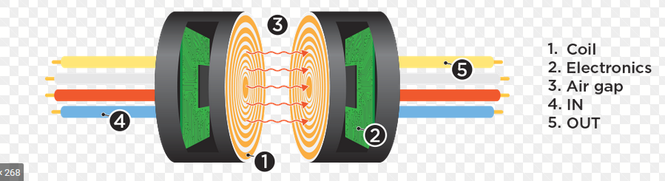
Figure 28: Wireless Slip Ring
After reviewing the various slip ring designs, we can easily eliminate some of the choices. The wireless slip ring is needlessly expensive and overcomplicated for our tank design. We will not be operating the tank in any harsh environments therefore the added reliability that comes from the lack of mechanical parts is not needed. We also will not be operating the tanks long enough to warrant spending extra money on components that will last longer. The pancake slip ring is a solid and simple solution to our wiring problem, however it will most likely not fit our special requirements. I think the design would benefit more from the vertical orientation of the standard and mercury wetted slip ring. The vertical orientation will allow us to close the openings of the tank body and tank turret to prevent unnecessary contamination. The standard slip ring design is the most budget friendly and least complicated design. We will use this slip ring design for our tank turret and body connection.
UPDATE:
There were no slip rings used in the final product. Our mechanical design allowed us to keep the two wires running from the turret housing to the main body snag free. The slip rings that were applicable for our design were incredibly expensive. We decided to extend the wires between the housings that way if there was a wire twisting issue, it would take significantly more rotations.

3.1.11 RF Transceiver and Antenna
A bluetooth transceiver is an essential part of our tanks design. The bluetooth transceiver will be in charge of sending and receiving signals from the primary cpu to the controller and back. There are multiple specifications for the bluetooth transceiver that we must check for. Some of these specifications include the protocol, serial interfaces, chip form factor and more. For our design, we want a surface mountable chip that is capable of fitting on our printed circuit board. We also want to make sure that our selected chip has the correct serial interfaces. We have not specifically picked out a primary integrated circuit, therefore we do not know what interfaces we will be using. Having said this, we should be safe as long as the transceiver we select has I2C, UART, ADV and PWM. These four serial interfaces should give us enough options to complete our objective.

3.1.11.1 Bluetooth Protocol
When choosing a RF Transceiver, one of the first things we look at is the bluetooth protocol. Depending on which protocol your device supports, you can interact with different devices. There are major differences between the protocols. We will be covering Bluetooth 4 and Bluetooth 5. The first difference between these two protocols that we want to cover is the data transmission speed. The newer protocol, Bluetooth 5, can support up to 2 Mbps. Comparing this to Bluetooth 4, which maxes out at 1 Mbps, we find that Bluetooth 5 is double the speed. When we look at the range that these two protocols are capable of, we find that Bluetooth 4 supports up to 50m outdoors and roughly 10m indoors. Bluetooth 5 supports up to 200m outdoors and 40m indoors. This means that Bluetooth 5 has an overall range that is four times better than Bluetooth 4. With the increase in range that is available from Bluetooth 5, the need for a bluetooth antenna that is separate from your transceiver is less important. The next aspect that we want to compare is the data capacity. Bluetooth 4 supports up to roughly 31 bytes in transmission capacity while Bluetooth 5 supports up to 255 bytes. This means that Bluetooth 5 will allow us to send more instructions to and from the controller simultaneously than we would be capable of doing with Bluetooth 4. The last thing that we want to compare is the compatibility of these protocols. The Bluetooth 5 protocol has backwards compatibility with previous Bluetooth protocols. The Bluetooth 4 protocol cannot interact with devices that have Bluetooth 5+. This means that if we chose an RF Transceiver that did not support Bluetooth 5, then we would not be able to use the current generation of smartphones as controllers for the tank. Overall the comparison between Bluetooth 4 and Bluetooth 5 is an easy one. We have learned that Bluetooth 5 has made significant improvements to its design giving it the clear edge over Bluetooth 4. One specific reason that I believe Bluetooth 5 is a must have over previous protocols is the increased range of the signal. Increasing the range that the tanks can be controlled from can create an additional element of excitement. This is especially true when paired with the planned heads up display camera.

3.1.11.2 Bluetooth Transceiver Comparison
This section goes over all possible Bluetooth Transceivers that Photo-TANKS might use.

3.1.11.2.1 BGM220PC22WGA2R
The BGM220PC22WGA2R is a surface mounted bluetooth transceiver made by Silicon Labs that is currently listed for $7.51 per unit. This transceiver will be mounted directly on the PCB surface. This specific RF Transceiver module has a 2.4 GHz - 2.4835 GHz frequency range. The device's protocol is Bluetooth 5.2 which is an updated version of Bluetooth 5. This means that the device has a data rate of 2 Mbps and a data range of two hundred meters outdoors and forty meters indoors. This data transmission is all done through the integrated antenna in the device. This means that we would not have to affix any external antennas to the tank to get the range specified within the devices data sheet. The device also has a 32 kB RAM internal memory size. The BGM220PC22WGA2R is a low power design that can operate on anywhere from 1.8 V - 3.8 V. The package can operate anywhere between -40 C to 85 C. This is well within any conditions that we would be running our tanks. This RF Transceiver supports multiple serial interfaces. Some of these interfaces include ADC, I2C, I2S, PWM, SPI, IrDA, UART and USART.
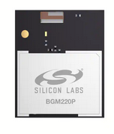
Figure 29: BGM220PC22WGA2R

3.1.11.2.2 BMD-350-A-R
The BMD-350-A-R RF Transceiver is a bluetooth transceiver made by U-Blox that is currently listed for $10.61. This RF Transceiver is designed to be surface mounted on the printed circuit board. This RF Transceiver used Bluetooth 5 connectivity. This means that the integrated antenna supports up to two hundred meters outdoors and forty meters indoors. Similar to the Silicon Labs RF Transceiver, this design is made to be ultra low power. This benefits the design because it means that we are capable of using smaller batteries while still maintaining a longer battery life. The frequency range of this device is 2.4 GHz - 2.4835 GHz. The voltage supply needed to run this device is 1.7 V - 3.7 V. This is essentially the same as the transceiver above. This device also has the same operating temperatures as the Silicon Labs RF Transceiver. One of the main differences between these two chips is the available serial interfaces. The serial interfaces that this chip supports include I2C, I2S, SPI and UART. While this chip does have a lower number of available serial interfaces. the available interfaces should be enough to complete our objectives. Examining this chip in comparison to the Silicon Labs BGM220PC22WGA2R, we can see this device has less capabilities while holding a higher price point. Choosing this device would mean that we are spending more, but getting an older Bluetooth protocol as well as less available serial interfaces. The only benefit of this device is that it has double the internal RAM memory storage that the Silicon Labs transceiver has. This device comes with 64 kBs of RAM.
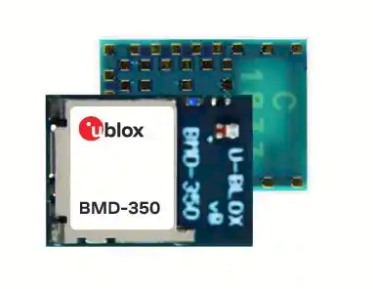
Figure 30: BMD-350-A-R

3.1.11.2.3 ENW-89854A3KF
The ENW-89854A3KF RF Transceiver is a bluetooth and wireless transceiver made by Panasonic Electronics. It currently can be bought on Digi-key Electronics for $17.45. This chip is designed to be surface mounted to a printed circuit board. The major difference between this RF transceiver and the previous models shown is that this one supports wireless internet connectivity. The RF standard that this device supports is Bluetooth and 802.15.4. To be more specific, the Bluetooth protocol that this device uses is Bluetooth 5.0. The range of this device is the standard two hundred meters outdoors and forty meters indoors that comes with Bluetooth 5 devices. This device has a significantly larger memory size in comparison to the previously discussed designs. This device sports a one megabyte internal flash memory as well as 256 kB of RAM. The serial Interfaces that this device supports are as listed: ADC, GPIO, I2C, I2S, PDM, PWM, UART and USB. The only significant serial interface that this device is lacking in comparison to the other designs is the inclusion of ISP. This would not affect our design as we will probably use I2C or UART to control our tank. This design is not considered an ultra low power design. This is probably due to the inclusion of 802.15.4. As of this moment, our design does not have any reasons to include internet connectivity to the tanks. This means that the extra cost of this device is not warranted.
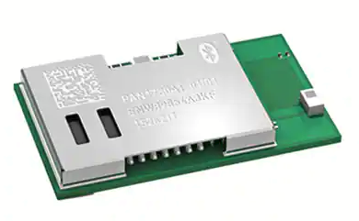
Figure 31: ENW-89854A3KF

3.1.11.3 Bluetooth Transceiver Selection
After reviewing the various RF Transceivers discussed above, the BGM220PC22WGA2R seems like the most logical choice. The first reason that this device seems like the best choice is that it has the most up to date protocol of all of the devices shown. This coupled with the fact that this device has the lowest cost makes this a good choice.

Part Number | Serial Interfaces | Bluetooth Protocol | Operational Voltage | Cost ($)
BGM220PC22WGA2R | ADC, I2C, I2S, PWM, SPI, IrDA, UART, USART | 4.2 | 1.8V - 3.8V | $7.51
BMD-350-A-R | I2C, I2S, SPI, UART | 5.0 | 1.7V - 3.7V | $10.61
ENQ-89843A3KF | ADC, GPIO, I2C, I2S, PDM, PWM, UART, USB | 5.0 | 1.7V - 3.6V | $17.45
Table 13: RF Transceiver Comparison
UPDATE:
During testing, we found that the bluetooth transceiver highlighted above was fairly difficult to connect to our system both on the physical and coding end. Our solution to this problem was to change the bluetooth transceiver for the system. Instead of using the BGM220PC22WGA2R, we opted for the HC-05 bluetooth module. This module is directly compatible with the MSP430 as well as multiple other kits such as the arduino. The connection of the device was also extremely straightforward. We needed to give the device power through the MSP430s 3.3v pin and connect another pin on the device to ground. We then connected the RXD pin on the HC-05 to the TXD pin on the MSP430. The last step was to connect the RXD pin on the MSP430 to the TXD pin on the HC-05 Module. Doing this allowed us to send and receive data between our controller and the MSP430 using UART.
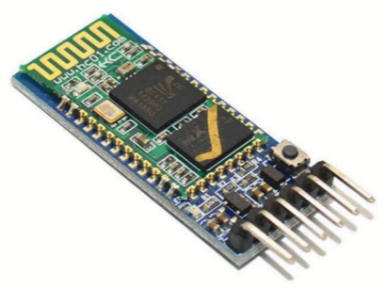
Figure 32: HC-05 Bluetooth Module

3.1.12 Graphics Processor Units
The sections below contain possible graphic processors that Photo-TANKS might use.

3.1.12.1 Jetson Nano Part Description
The Jetson Nano is a minicomputer with a Quad-core ARM A57 CPU and 4 GB 64-bit LPDDR4 25.6 GB/s memory. It has the capability to run multiple semantic networks at the same time for various applications. Said applications include object detection, speech processing, segmentation, and image classification. It comes with camera lanes which hold the ability to connect a camera of choice. From there, it uses the video encoder to turn the captured images, or videos, into ones in which we can see and format as digital files. Further, it uses the video decoder to allow us to make changes to media by converting it back to the raw images or videos. Like a regular computer, it includes a series of ports for almost any type of connectivity needed. These include HDMI, USB, Micro-USB, ethernet, and Micro SD for storage space. This platform is small but powerful, using only five watts. All these components make it perfect for the object detection on our Photo-TANKs.

3.1.12.2 Jetson Nano Competitors
The decision for which AI minicomputer we wanted to use came down to the best four single board computers on the market right now. Those are the Jetson Nano Developer Kit, Raspberry Pi 4, Google Coral Dev Board, and Intel Up Squared AI Vision X Developer Kit. These are each made by a different company being NVIDIA, Sony, Google, and Intel respectively. Although they are all similar in some respects, we wanted to take a breakdown of certain specifications that would affect the project currently and long term the most. Overall, we felt the Jetson Nano Development Kit was the best choice for us. Here is how we got to that determination.
 | Jetson Nano Developer Kit | Raspberry Pi 4 | Google Coral Dev Board | Intel Up Squared AI Vision X Developer Kit
Company | NVIDIA | Sony | Google | Intel
Cost | $60 | $45 | $130 | $419
Released | March 2019 | June 2019 | October 2020 | 2018
Processor | ARM Cortex-A57 64-bit @ 1.42 GHz | BCM2711 chip with ARM Cortex-A72 64-bit @ 1.5 GHz | Cortex A-53 64-bit @ 1.5 GHz | Atom X7-E3950 @ 1.6 GHz
Memory | LPDDR4 SDRAM | LPDDR4 SDRAM | LPDDR4 SDRAM | LPDDR4 SDRAM
GB Options | 2GB, 4GB | 1GB, 2GB, 4GB, 8GB | 1GB, 4GB | 4GB, 8GB
Wifi/Bluetooth | Capabilities | Included | Capabilities | Capabilities or Included Add on
Ports | Micro SD, HDMI, 2 ethernets, 5 USBs | 3 USBs, audio jack, 2 HDMIs, ethernet | 4 USBs, 3 audio jacks, HDMI, ethernet, micro SD | HDMI, 6 USBs, 2 ethernets
GPU | 128-core Maxwell | Broadcom VideoCore VI | Vivante GC7000 lite | Intel® HD Graphics 505
Table 14: Jetson Nano Competitors and Their Specifications

3.1.12.2.1 Raspberry Pi
One of the closest related single board computers we had to decide between was the Raspberry Pi and the Jetson Nano. With them both being released in 2019, similar in costs and most specifications, it came down to which one would be most useful for this project. Here was the breakdown we went through.
The processor in the Raspberry Pi and Jetson Nano are quite similar. The Raspberry Pi uses a BCM2711 chip and runs at 1.5 GHz compared to the Jetson Nano that uses 1.42 GHz. Also, the Raspberry Pi’s CPU is one generation newer than the Jetson Nano’s. Nonetheless, that does not take as big an effect due to how closely comparable they are overall. This was not much of a factor in our decision making.
Memory also was not a big negative factor for either minicomputer. This is because both use the LPDDR4 SDRAM, and only vary in the gigabytes they hold. The Jetson Nano comes with two options 4-GB and 2-GB, whereas the Raspberry Pi has a larger variety including 1-GB, 2-GB, 4-GB, and 8-GB. This was not a huge deal because we felt that 1-GB would be too small, and anything more than 2-GB was just not necessary for what we needed. Because both have the option for 2-GB, the memory was not a make-or-break decision.
As previously stated, the Raspberry Pi and Jetson Nano are very similar in many aspects, this includes their ports. If we did want to compare them, it would be good to know what they both have. They have USB ports, ethernet, and Wi-Fi capabilities. The Raspberry Pi has micro-HDMI ports whereas the Jetson Nano has a regular HDMI port. The Raspberry Pi also has an audio-video jack and a USB C port. This differs from the Jetson Nano that instead has MIPI lanes and a Micro-B port. Being that we only needed one USB port for this project, these were not taken into consideration for our final decision.
The last aspect that was considered and was ultimately the weighing winner is the GPU. Having a good and quick GPU can make a huge overall difference in machine learning. This is because of all the calculations that need to be run in parallel, with the better system, this is enhanced. The Jetson Nano's 128-core Maxwell GPU is simply more suitable for AI programs, which is the whole focus of our project.
Overall, although the two are similar in many aspects, the Jetson Nano was a better decision. Based on the above criteria, we can see this is primarily due to the excelling GPU. If the minicomputer was being used for something else, we may have gone with the Raspberry Pi. This would be due to the dual monitor support or faster clocking speed from the CPU. These specifications simply are not as high in importance as the GPU, for our instance. Although the Jetson Nano was a little bit pricier than the Raspberry Pi, that was a price we were willing to pay for the better GPU.

3.1.12.2.2 Google Coral
Another competitor for the Jetson Nano was the Google Coral. It is a little bit newer coming out in 2020 rather than 2019, but it is also more expensive. If we decided to take funds out of account, and solely focus on the specifications, this is what we would be considering.
The Google Coral has a Cortex A-53 processor which is a little bit smaller and more power efficient than the Jetson Nano's A-57. Overall, both processors are very similar. They are both 64-bit processors that can be used for big.LITTLE configuration or standalone. The only difference between the two, is that the Google Coral has a slightly slower processing speed than the Jetson Nano. Due to the small difference between them, though, this was not a drastic factor.
The memory capacity was a bigger factor for the Jetson Nano versus Google Coral. This is due to the Google Coral only having 1-GB of RAM option or 4-GB of RAM. As previously mentioned, we felt like 1-GB RAM just would not be enough for everything we wanted to do, and four is not needed. We decided on a minimum of 2-GB because we wanted to ensure it could keep up with the computations without crashing. We also wanted to ensure that it could quickly determine and identify the objection detection. The 4-GB just was not necessary for the extra funds. With the Google Coral not having the preferred RAM available, this was a given for the Jetson Nano.
Like the Raspberry Pi and the Jetson Nano, the Google Coral has USB ports and an ethernet port. Like the Jetson Nano it has an HDMI and Micro-B port, while the same as the Raspberry Pi, has an audio jack. It has features of both other minicomputers that we have been comparing, but realistically, we only consider the USB port for this project.
One thing that was up for debate about the Google Coral was the framework to be used. This is because it was specifically engineered to work best with TensorFlow. Of course, this makes sense because they are both made by the same developer, Google. It would run at ease with the TensorFlow Lite neural network, and this was something to take into consideration. Although the Jetson Nano is compatible with many different frameworks, including TensorFlow, it was something we had to lean towards the Google Coral for.
There are a good number of little differences between the Google Coral Dev Board and Jetson Nano Developer Kit. Taking all of these into account the Jetson Nano is simply a better single board computer for AI and machine learning. We felt like the Google Coral is a close comparison, but without the preferred RAM and the Jetson Nano having a better GPU, we made our final decision. NVIDIA has been making AI and machine learning minicomputers for a while now and felt like it was the most secure choice.

3.1.12.2.3 Intel Up Squared AI Vision X Developer Kit
The last competitor for the single board computer decision was if we should use the Intel Up Squared AI Vision X Developer Kit or the Jetson Nano Developer Kit. Intel's kit is supposed to be faster and easier to run a series of programs on than any other one on the market, but this was not the sole factor. Here are the things we considered.
We'll start with the processor. The Intel Up uses an Atom X7-E3950 processor. Like the others listed, it is a quad core. This processor is more powerful and has superior performance than the Jetson Nano's. If this was the only criteria, we may have gone with Intel's developer kit. Unfortunately, though, there were other reasons why we chose the Jetson Nano instead.
Moving onto the memory. Intel's developer kit comes with two options, 4-GB or 8-GB, neither of which we need. Being that we only need 2-GB, the other two to four would be unnecessary for the price. We will talk about that soon but seeing as we did not need as much memory, it did not feel as drastic. In this case, we would have simply gone for the Jetson Nano.
Regarding ports, Intel's developer kit has an HDMI port, Wi-Fi, and Bluetooth capabilities, three different types of USB ports, and an ethernet port. These all would be very useful in longer term usage. It is like the other two minicomputers, and the various USB ports can be found quite useful. For our project, though, it was not needed. Therefore, either the Intel kit or Jetson Nano, would have worked.
The most impactful reason we decided not to go with Intel's option is due to the price difference. The Jetson Nano is about $60, whereas the cheapest version of the Intel is almost seven times that price. Even if we all chipped in to pay for it, it would still be almost $150 per person. This was a big factor in us deciding against the Intel developer kit for this project.
It is clear to see that for something long term the Intel Up Squared AI Vision X Developer Kit would be a great investment. That is because with this you can start out in the beginning with development and continue using it all the way through to deployment. For our situation, one in which we do not know what long term projects lie ahead, and for us just starting out, the Jetson Nano was a better option. Although the Intel has a great processor and many available ports, we just could not get past the price. That is why the Jetson Nano was better than this competitor.
It is clear to see all the different pros and cons for each of the four single board computers. After going through the breakdowns and indicating specific components, it was clear to see which one would be the final decision. The Intel Up Squared AI Vision X Developer Kit had the best CPU but was too expensive. The Raspberry Pi was great all around but did not have a GPU. The Google Coral Dev Board would have been a good match, if it had the preferred RAM. The Jetson Nano Developer Kit was the best for all our specific needs. NVIDIA is a good company to go with as well, because they have been working with AI and machine learning for years now. Consistently trying to improve the learning and processing speeds with it.

3.1.13 Cameras Overview
When we consider camera specifications, we need to consider multiple aspects of the camera design. The first design specification that we will look at is power consumption. Generally, we strive for a camera that consumes as little power as possible. This is due to power issues when running multiple cameras. Ideally, we want to extend the overall operation time of the device as long as possible. With this in mind, we have two potential solutions. The first is to increase the overall capacity of the battery selected for the design. This is the most straightforward solution as there are less potential issues with running a single component. The second potential solution to the problem is to implement a secondary battery that's sole purpose is to power the cameras. Doing this means that we would have two total batteries. This would require an additional power conversion circuit to regulate the power output from the battery.
The next specification that we need to consider is the camera's shutter type. Generally, cameras come in two separate configurations. The first is the rolling shutter. Rolling shutter is when the camera captures pixels row by row. The camera sweeps down from the top and captures each row of pixels at different times. The primary issue with this configuration occurs when capturing high speed objects. If the object is moving at a high rate of speed, then as the shutter rolls down and captures each row of pixels, the image becomes distorted. This is because, due to the speed of the object that is being captured, the object is in a different location between each row capture. A good demonstration of this is an image of a helicopter. Due to the high rate of speed of the rotors, the resulting image is distorted.
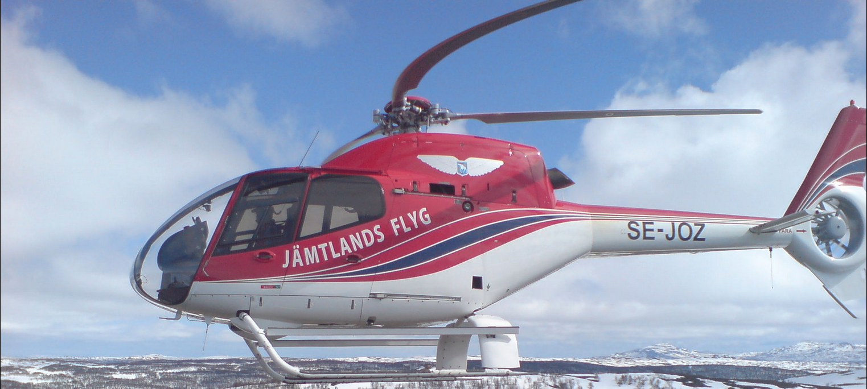
Figure 33: Rolling Shutter Distortion
As you can see in the above image, the rotors on the helicopter appear to be bent. This is not an accurate representation of the helicopter as the distorsion results in an image that doesn't represent what is actually happening. Fortunately, this will not affect our design. There are two reasons for this. The first is that the majority of the objects that our cameras are capturing are not moving faster than the shutter speed. The other reason that this does not affect our design is due to the imaging analysis software. Even though the blades are distorted, the body of the helicopter is not moving fast enough to become distorted. The body of the helicopter is ample information for the image recognition software to identify it. This means that despite the slight distortion to the image, it will not affect the desired result.
The other type of camera shutter type that we can use for our design is the global shutter. This shutter design captures all of the pixels at once. This means that regardless of the speed of the captured object, the image will remain true to real life. The negative part of this shutter type is that it drives up cost. Due to the circuitry of the camera being more complicated, these cameras cost more than the rolling shutter design. The file size of the captured images are also larger than the rolling shutter design. This means that the device requires more memory. This again drives the price higher than the rolling shutter design. Our design is going to implement multiple cameras, therefore a camera with less storage usage and cheaper costs is more ideal.
One issue that we have with the use of multiple cameras is the lack of available ports and support. Currently, the Jetson Nano development kit supports 2 stereo cameras. This means that if we want to use more than 2 cameras, we need an additional adapter. One potential solution to this is the Arducam Multi-Camera Adapter. This adaptor card allows us to connect up to 4 separate cameras to a single CSI port. The only drawback of this device is that we cannot simultaneously output imaging data from multiple cameras. To remedy this, we will capture an image with 1 camera, then capture an image with the next camera. We will do this until all of our cameras have captured an image in order. Then we can stitch the images together to make the single 360° image that we desire. If we set the capture rate of each camera high enough, and alternate captures, we can then stitch each image together and then convert it back to video format. Repeat this process and we can get a reliable 360° video feed.

3.1.13.1 360 Degree Camera
The main target identification camera / cameras will be used to observe the surrounding area to achieve our desired 360 viewing angle. This and or these cameras will be mounted on the top of the tank turret. The camera will record a 360 feed of the surrounding area and identify potential targets. It will then use the artificial intelligence software to determine the types of targets. The identification of the targets comes in multiple types. The first thing that the software would detect is whether the target is an enemy or friendly. This will be done through the analysis of the symbols and colors of the tank. After the target has been identified as friendly or foe, the software will then identify the type of target. Specifically, this means that the artificial intelligence will be able to identify the model of the vehicle.
One of the main challenges of the 360° camera setup is directional detection. This means that the camera needs to know what way is centered in relation to the barrel's camera. It is important that the 360° camera and the barrel camera are synced in direction. This is because of the 360 camera's responsibilities. The 360° camera is responsible for identifying threats in a circular radius around the tank. If the camera detects an enemy behind the tank, then the heads up display should show an indicator of a threat at the bottom of the screen. This would indicate that there is an enemy behind. The barrel camera and the 360° camera must have the same identified direction, otherwise when the 360° camera detects a target, it could mark it in the wrong spot on the heads up display.

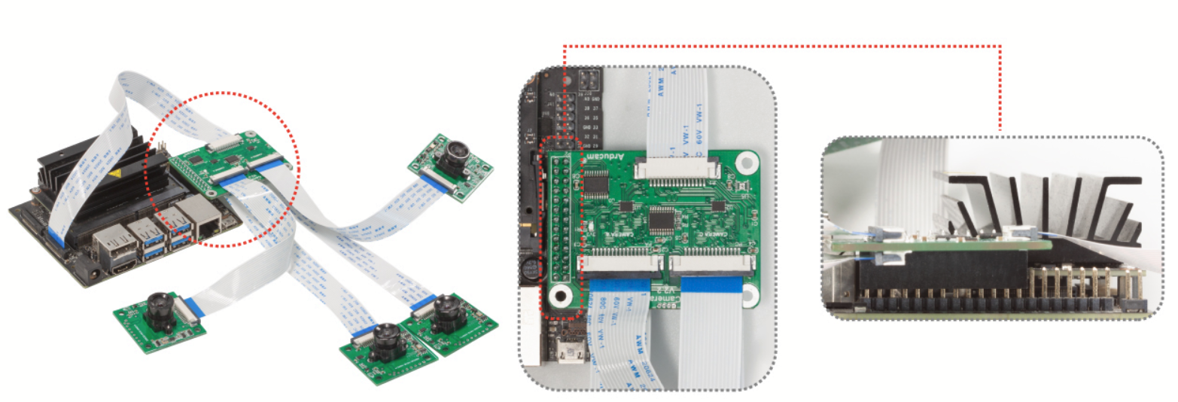
Figure 34: Arducam Multi-Camera Adapter

Outside of electrical specifications and issues that we have with the camera setup, we also have mechanical issues. The major mechanical issue that we have is the wiring of the cameras. The cameras will be connected using a combination of ribbon wires. The adapter card is made to be connected directly to the Jetson Nano development board. This means that each ribbon cable will have to be routed through a hole and into the turret housing where the cameras will be mounted. The problem comes from the rotation of the turret housing. If the turret housing were to rotate too many times in either direction, the ribbon cables could become entangled. This could result in tearing of the cables themselves and or loose and damaged connections. This would result in loss of camera functionality, which causes total functional failure. The system would still be operational due to the power cables not being damaged. However, without the camera feed, there is no image detection therefore no target identification or operator display. The solution that we have decided on to fix this problem is to limit the total number of turret rotations in any direction. If we can implement a digital stop that keeps the turret from rotating past a predefined amount, then we can avoid twisting the cable too much. The idea behind the digital check is as follows; when the turret does a full rotation to the right, the code will increment a counter. When that counter reaches a fixed value that we define, we can code it so that the turret will not be able to rotate anymore in that direction. If the turret does a full rotation in the opposite direction then the counter will be reduced by 1. This will prevent the camera from rotating too far in a clockwise and or counterclockwise direction.
UPDATE:
The multi camera adapter card for the Jetson Nano Development board was removed from the planning process during testing. This is because we found that the memory and current limitations of the development board could not handle multiple cameras while also running the image recognition software. Instead we opted to run the image recognition using solely the barrel camera.

3.1.13.2 Barrel Camera
The barrel camera will be a smaller field of view camera affixed to the barrel. This camera will be responsible for providing a live feed to the display on the controller. This feed will be analyzed by the artificial intelligence software to identify targets and decide whether the target is a friend or foe. If the Artificial Intelligence identifies the target as a threat, then the code will then use the barrel camera feed’s information in conjunction with the other cameras information to move the barrel in the direction of the potential targets. More specifically, the code will be able to identify the center mass of the target and adjust the tank barrel vertically and horizontally until the barrel is aimed at the target's center-most point. The barrel camera will be instrumental in both identifying and aiming at the target. This camera will be used to ensure that we achieve a precise shot at the target. One issue with the aiming portion of the barrel camera is the mounting point. If the barrel camera is mounted too low or too high in relation to where the barrel is actually aiming, then we will have accuracy issues. To remedy this problem, we will have to either mount the camera's focal point as close to the barrel focal point, or we will have to compensate for the difference in height. To compensate for the barrel height and camera height differences, we will have to measure the vertical difference between the two focal points. This will be a fixed value because the camera will be mounted directly to the barrel. To be more specific, when the barrel moves vertically, the barrel mounted camera will move the same distance vertically. Once we have recorded this vertical distance, we will then have to estimate the target’s distance. Using the target’s distance from the camera as well as the vertical difference between the camera's focal point, we can calculate the distance at which we will need to adjust the aiming point on the heads up display. The other possible solution to this issue is to mount the camera parallel to the barrel. This will give us a fixed value to adjust the aiming point on the heads up display. We can then tune the aiming point to a standard range that we would expect the target to be within. This would give us less overall accuracy but would provide a simpler solution to our problem.

3.1.13.2.1 Barrel Camera Options
When looking for a good camera to use for our Photo TANKs we needed something with low latency and a good resolution, that way it can easily detect the objects within view. We did not need anything too fancy and too wide angled, but also nothing too cheap because we want to ensure it sees everything it needs to. We did some research to find out which ones were compatible with the Jetson Nano, worked with MobileNet, and that had the specifications we were looking for. Below is a chart showing the breakdown of the three best choices we were deciding between. As you can see from this we were looking for something with at least eight megapixels. We were thinking of going higher, to something like 12 or 13, but issues began to arise with that. A higher range of megapixels usually means higher resolution, which in our case is really good, so that the camera/tank can easily detect what it needs to. On the other hand, though, this can become a problem because the field of view gets much larger than we need and in turn the price of the camera goes up. We did not want a standard lens, but we also did not need a fishbowl lens. We were looking more in the range of wide angle lenses. This was a trade off we did not want to make, being that we could suffice with the eight megapixels and 3280 x 2464 pixel resolution. Putting together all of our requested specifications, we decided on the IMX219-77 8MP Camera Module for Nvidia Jetson Nano.
 | Arducam NoIR IMX219-AF Programmable/Auto Focus IR Sensitive Camera Module for Nvidia Jetson Nano | Raspberry Pi Camera Module 2 | IMX219-77 8MP Camera with 77° FOV - Compatible with NVIDIA Jetson Nano/ Xavier NX
Megapixels | 8 | 8 | 8
Photosensitive Chip | Sony IMX219 | Sony IMX219 | Sony IMX219
Resolution | 3280 × 2464 pixels | 3280 × 2464 pixels | 3280 × 2464 pixels
Horizontal FOV | 65 degrees | 62.2 degrees | ---
Vertical FOV | 51 degrees | 48.8 degrees | ---
Diagonal FOV | 77.6 degrees | --- | 77 degrees
Frame Rate | 30fps@8MP, 60fps@1080p, 180fps@720p | 1080p30, 720p60 and 640 × 480p60/90 | 30fps
Price | ~$40 | $25 | ~$20
Table 15: Comparison Between Possible Camera Options

3.1.13.2.2 Raspberry Pi Camera Module 2
The first one we decided against was the Raspberry Pi Camera Module 2. For the most part, these three cameras are all very similar. They use the same photosensitive chip, have a close amount of frame rates, related field of view, and even the price of each other is not too far off. That is one of the reasons it was so difficult to choose a camera. While researching, the most common type of camera module that was used was actually this one. This is the successor to the Raspberry Pi Camera Module 1, and according to research has really lived up to its hype. The biggest issue and reason we decided against choosing this camera is because it is not directly compatible with the Jetson Nano. Of course, this is something that many people have a possible workaround for, which is purchasing an adapter connector that allows it to work with the Jetson Nano. The issue there is that it is not a guarantee. With the other programming we will be focusing on for the TANKs themselves, it was preferred not to go through additional hoops, if we were able to find another camera that is closely related. Although this was a good option if we were using the Raspberry Pi, it just was not the best match for the Jetson Nano.
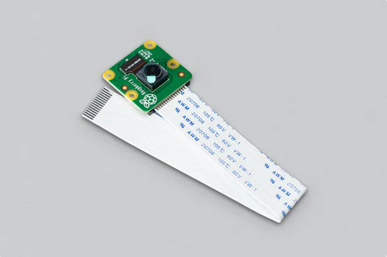
Figure 35: Raspberry Pi Camera Module 2

3.1.13.2.3 IMX219-77 8MP Camera with 77° FOV
Besides these three cameras, there were a handful of others that we were debating against. This is because there are probably hundreds of possible cameras to use for what we are needing; this is an example of one of those. Although this is not a name brand like Raspberry Pi and Adurcam, you can see it measures up nicely against the other two, and for a cheaper price than both. It still uses the same photo chip, has the same amount of megapixels and resolution, and is comparable in the field of view. At the end of the day we did decide against this one due to the various frame rates not known and tested, and the general security in choosing the other name brand ones. This goes back to wanting the best camera, but also the most seamless.
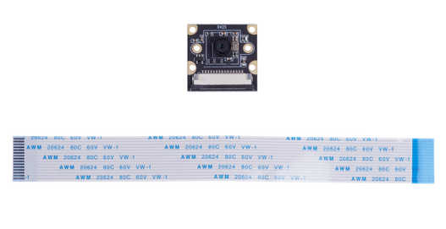
Figure 36: IMX219-77 8MP Camera with 77° FOV

3.1.13.2.4 Arducam NoIR IMX219-AF Programmable/Auto Focus IR Sensitive Camera Module
For the brand Arducam alone there are about a hundred cameras. Lucky for us, though, there were only about 30 to choose from that were compatible with the Jetson Nano. This was done by checking that they had the MIPI CSI port. Among those 30 about 15 of them would have worked fine for this project. We wanted to find that balance that was referenced earlier. Some had a field of view larger than necessary, some did not have as many pixels that we wanted, this one in the chart actually has infrared night vision. This gives us an opportunity to take our project a step further because it will be able to still detect in the dark without any further issues or delays. As you can see, from the comparisons, after going through the series of all of the possible options, the Arducam NoIR IMX219-AF Programmable/Auto Focus IR Sensitive Camera Module is overall a good choice for the specifications we were looking for and for a fair price.
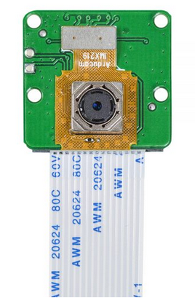
Figure 37: Arducam NoIR IMX219-AF Programmable/Auto Focus IR Sensitive Camera Module for Nvidia Jetson Nano

3.1.13.3 Top Mounted Camera Orientation / Setup
To achieve the desired 360° viewing angle that we are striving for, we have multiple camera options. This camera setup is very important to the overall functionality of the target recognition software. This is due to the potential shortcomings of each setup. We will be discussing multiple possible camera setups and how they would affect the way that we approach target detection and acquisition.

3.1.13.3.1 Single Camera Dual Fisheye Lenses
The first potential camera setup for a 360° viewing angle is a single camera oriented vertically. This vertical camera is then paired with a fisheye lens angled in such a way that you can see all the surrounding environment. There are multiple problems that we run into with this setup. The first issue that this design presents is the extreme distortion of the image. When the camera's view reflects off of the lenses, the resulting image is very different from what we would expect to see. The remedy to this solution is to use computer software to undistort and convert the frames captured by the camera into a single two dimensional image. This image can then be fed to the image analysis software to provide information for the artificial intelligence. An Example of the distorted and modified resulting images can be found in Figure 29.
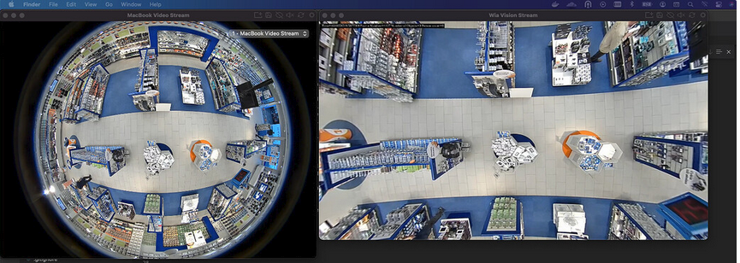
Figure 38: Single Camera FishEye Lens Distortion and Correction
As you can see, even though the captured image is undistorted using software, the image is still not an accurate representation of the real world environment. The imaging software will struggle to correctly identify objects that are not close representations of real world objects. This will severely decrease the accuracy of the imaging software. This effectively lowers our accuracy in detecting and identifying threats in the surrounding environment.
The other issue with this design is the vertical viewing angle. The single camera design would need to be mounted on top of the turret facing upwards. Due to the design of these cameras, the resulting image only shows what is in front of the lens. This means that, if the camera was mounted above the turret, then the video feed would only capture feed of everything at that level or higher. For the tank's imaging software to accurately analyze threats in the area, we need to be able to see all its surroundings. To further this point, we have prepared an illustration that clearly shows the viewing angle.
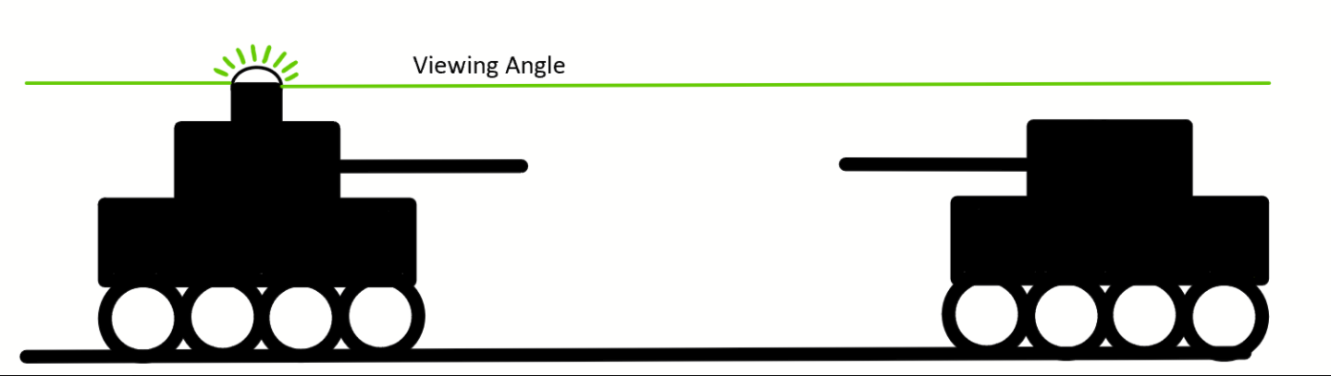
Figure 39: 360° Single Lens Viewing Angle Illustration
As you can see in the above illustration, because of the camera's viewing angle, the tank that should be identified by the imaging software is not even considered. The second tank is below the vertical field of view of the primary tank, therefore will go unnoticed unless the barrel camera is in its general direction. This is a significant flaw in this design. If the imaging design cannot locate and identify targets that are below the camera's viewing angle, the tank is left open to countless potential threats.

3.1.13.3.2 Double Wide Angle Camera Setup
The double wide angle camera setup is the second potential design that we considered. This design incorporates two camera lenses that would be placed on the left and right side of the tank. These cameras will be angled slightly towards the rear of the tank to ensure that there are no blind spots in that region. This would potentially leave a blind spot at the front of the tank as the lenses generally don't cover 180°. With this in mind, if we mount the cameras directly to the turret housing, then they will always be covering the areas around the tank that the barrel camera cannot cover. Through the process of image stitching, we can easily get a full 360° coverage of the surrounding area. This camera setup also eliminates the vertical field of view issue that the signal camera design had. This is because the cameras are pointed in a horizontal orientation. The horizontal orientation means that the imaging software can locate and identify threats at all vertical angles in front of the lenses. The only exception to this is objects that are positioned directly directly above the tank. The space directly above the tank is not as important as the other angles due to the lack of threats from above. If there was a threat directly above the tank, such as a helicopter, then the tank would not have to worry because the helicopter would not be able to fire directly down. To illustrate the viewing angle of the dual wide angle camera setup, we have provided an example figure. For the example figure, we have assumed that the wide angle cameras have a 160° vertical and horizontal viewing angle. This combined with the barrel camera will provide a full 360° horizontal view.
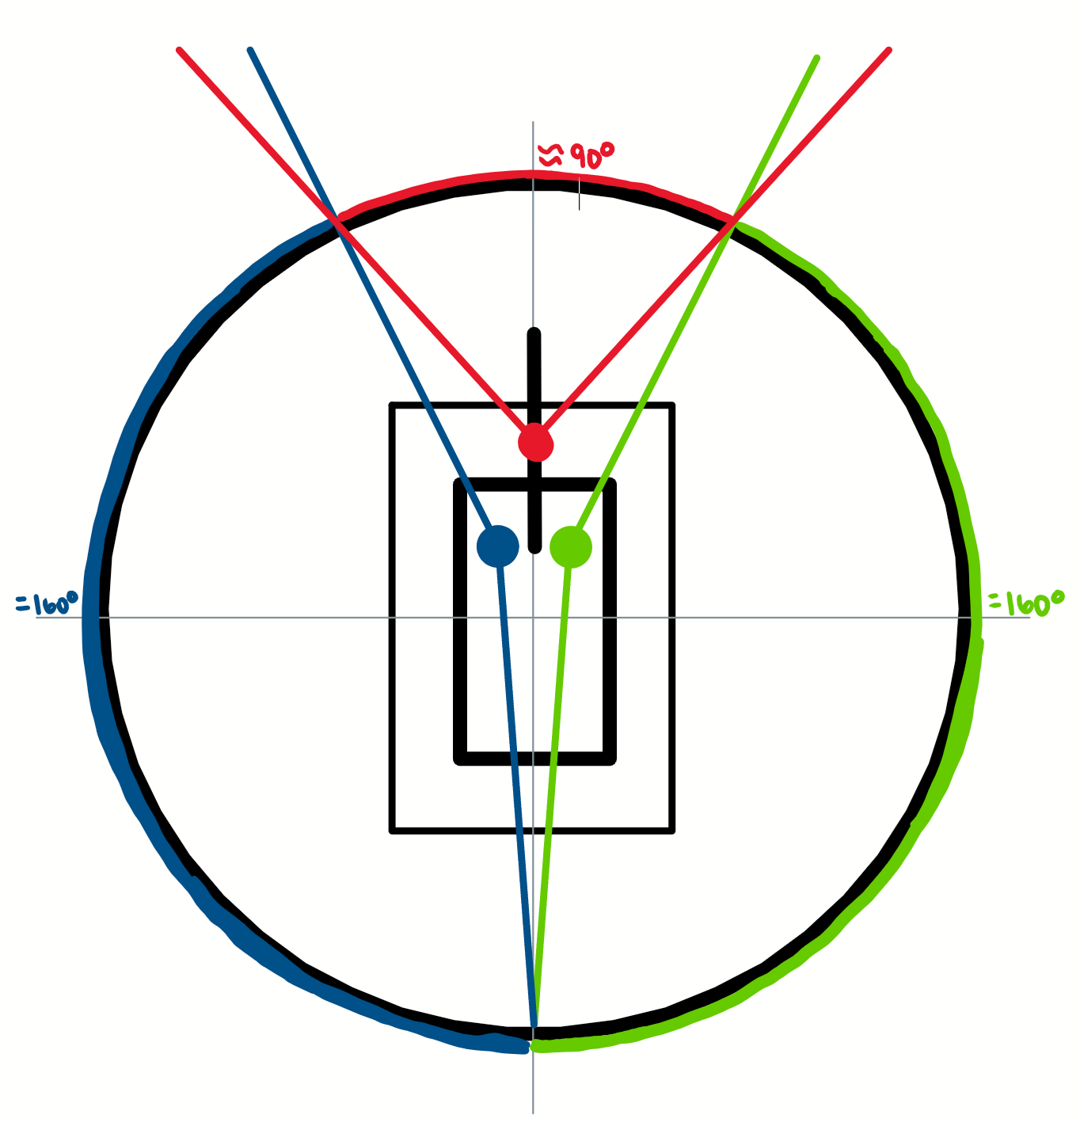
Figure 40: Example of Two wide angle Camera Setup
The example illustration is an overhead view of the tank with three separate cameras. The red camera is the barrel camera which is responsible for target identification in the direction that the tank is aimed. The green and blue cameras are the wide angle cameras that are mounted on each side. The green and blue cameras are responsible for location and target identification of all objects to the rear and sides of the tank. The total angles of each camera’s field of view do not add up to 360°. This is because the side mounted cameras are positioned slightly forward from the centerpoint. The cameras were positioned in this fashion for two reasons. The first is because we would not be able to mount both of the cameras at the center point. This would require one of the cameras to be positioned above the other. Doing this would cause one camera to have a higher field of view than the other. This is not ideal due to the fact that these images need to be stitched together to make a single 360° image. The stitching of these images will be faster and more accurate with the imaging software if the images are at the same elevation in relation to the tank body. To achieve an overall even elevation between the three cameras. We will calculate the centerpoint of the barrel camera by subtracting the minimum elevation from the maximum elevation. The barrel camera will have multiple elevations due to the fact that the barrel can aim up and down. The second reason that the side mounted cameras are moved slightly forward is because it results in a smaller required horizontal field of view for the barrel mounted camera. Having the barrel mounted camera have a smaller horizontal field of view requirement means that we can focus on choosing a device that provides a higher quality, less distorted image for the operator. Less distortion in the barrel cameras video feed should result in a more realistic and accurate experience. This will be reflected through the heads up display on the controller.

3.1.13.3.3 Triple Camera Setup
The triple camera setup follows the same concept as the dual wide angle camera setup. The major difference between the two setups is the camera’s horizontal field of views and the total number of cameras. This setup would have the barrel camera cover everything in the front of the tank. The remaining three cameras would be facing the left, right and rear end of the tank. One of the benefits of having an additional camera is that we will get a more accurate stitching effect. Generally, the more cameras that are used to capture the surrounding environment, the more overlap that is captured. This overlap makes it easier for the imaging software to create a seamless single image. The other benefit of having multiple cameras is that each camera is responsible for less area. When the horizontal field of view of the camera is decreased, the distortion caused by the camera lens is also decreased. This results in cleaner and more lifelike imaging. Reducing the requirement for overall field of view that each camera can cover means that we can focus on acquiring cameras with better overall image quality. This will also reduce the cost of each camera. Generally, cameras with an extra wide field of view are more expensive than cameras with smaller fields of view. This is because wide angle cameras are used in more niche applications than the average lens.

Design | Known issues | Need a Camera Adapter Card? | Distortion Level | Cost
360° camera | Bad Horizontal Viewing Angle | No | Extreme | Very Expensive
2 Wide Angle Cameras | Hard to Find Cameras With Wide Enough Horizontal Viewing Angle | Yes (+$40) | Slight Distortion | $25 - $65 Per Camera
3 Wide Angle Cameras | More Complicated Coding  Highest Power Consumption | Yes (+$40) | Not Much | $25 - $65 Per Camera
Table 16: Camera Setup Comparison

All Camera setups in Table 16 are designed to work in conjunction with the barrel camera.

UPDATE:
During testing, we found that the 2GB Jetson Nano Development board was struggling with current draw and memory issues when running image recognition software on one camera. Upgrading to the 4GB version of the board would have been too expensive. Considering these two issues, we decided to scrap the additional 3 wide angle cameras that would sit on the body of the tank and only use the barrel camera.

3.1.13.4 Camera Comparison
In the following section, we will review various options for each camera application. In doing this, we will be comparing various factors. These factors can be summarized into several categories. The categories are as listed; Resolution, Field of View, Connection Type and Focal Length. There are no camera options listed in this section for the double fisheye lens 360° camera. This is due to the lack of product compatible with our development board as well as the astronomical costs.

3.1.13.4.1 Waveshare IMX219-200
The Waveshare IMX219-200 is an out of the box compatible camera that is directly compatible with the Jetson Nano development board. It comes with an 8 MegaPixel sensor that displays images and video in up to 3280 x 2464. It comes with a focal length of 0.87 mm and a diagonal angle of viewing at 200°. It comes on the M12 sized board with four available screw hole attachments. It does not have rubber grommets at the mounting points so accidental shorting might be possible if metal screws are used. The camera has a power output of 3.3 V. The board that the lens is mounted to is twenty-five millimeters by twenty-four millimeters. The board comes with the standard ribbon cable connector, however the cable itself is not included. This is not a major problem because the cables that come with the cameras are usually too short for our design. The cost is roughly $34 per camera and is available at nearby distributors.
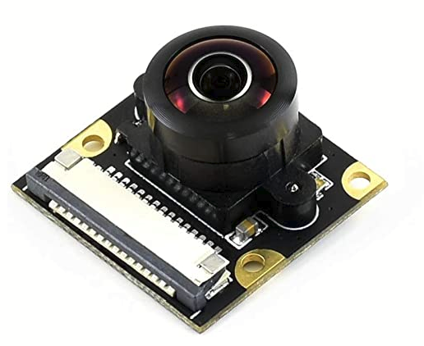
Figure 41: Waveshare IMX219-200

3.1.13.4.2 Waveshare IMX219-170
The Waveshare IMX219-170 is another out of the box compatible camera that is directly compatible with the Jetson Nano development board. It comes with an 8 MegaPixel sensor that displays images and video in up to 3280 x 2464. It comes with a focal length of 2.2 mm and a diagonal angle of viewing at 170 degrees. It comes on the M12 sized board with four available screw hole attachments. It does not have rubber grommets at the mounting points so accidental shorting might be possible if metal screws are used. The camera has a power output of 3.3 V. The board that the lens is mounted to is twenty-five millimeters by twenty-four millimeters. The board comes with the standard ribbon cable connector, however the cable itself is not included. The cost is roughly $34 per camera and is available at nearby distributors.
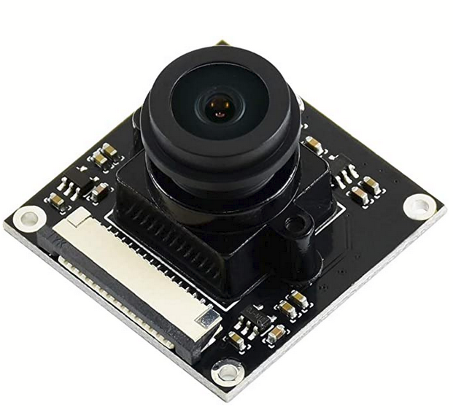
Figure 42: Waveshare IMX219-170

3.1.13.4.3 Arducam Mini HQ 12.3 MP IMX477
The Waveshare IMX477 is also an out of the box compatible camera that is directly compatible with the Jetson Nano development board. It comes with a 12.3 MegaPixel sensor that displays images and video in up to 4032 X 3040 at 30 frames per second and 1920 X 1080 at 30 frames per second. It comes with a focal length of 3.9 mm and a horizontal angle of viewing at 80°. It comes on the M12 sized board with four available screw hole attachments. It does not have rubber grommets at the mounting points so accidental shorting might be possible if metal screws are used. The board that the lens is mounted to is twenty-five millimeters by twenty-four millimeters. The board comes with the standard ribbon cable connector and cable. The cost is roughly $65 per camera and is available at nearby distributors.
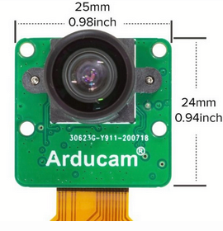
Figure 43: Arducam Mini HQ IX4777
Part Number | Focal Length  (mm) | Max Resolution | Mp Rating | Viewing Angle | Cost ($)
IMX219-200 | 0.87 | 3280 x 2464 | 8 MP | 200° (Diagonal) | 34
IMX219-170 | 2.2 | 3280 x 2464 | 8 MP | 170° (Diagonal) | 34
IX4777 | 3.9 | 4032 X 3040 | 12.3 MP | 80° (Horizontal) | 65
Table 17: Camera Comparison

3.1.14 Sound Card and Speakers
The device will be designed with speakers as a peripheral. To achieve this, we will need a sound card that is compatible with the Jetson Nano development board. Once we have a sound card that is compatible with the development board, we will hook up speakers. The speakers will be responsible for notifying the user of various things.The first thing that we will want the speaker to play sounds for is aim detection. When the tank is being aimed at, the photodiode will identify a low power laser from a laser diode and send a signal to the microcontroller. The microcontroller will then send a signal through the GPIO pin that the speaker is connected to. The speaker will play a warning sound for the user indicating that the tank is being aimed at. The second application of the speaker would be the powerup and power down sound. These sounds will play when the tank is turned on and off indicating that the tank has transitioned power states successfully. The third use for the speakers will be to create sound effects for the operation of the tank. The first sound effect we will be adding is an ambient noise simulating the tank treads moving. This sound will only play when the tank is in motion. This is to give the tank a more realistic feel. The second sound effect that we will code the tank to play is an explosion noise. This explosion noise will be played through the speakers when the tank has been hit by a high power signal from a laser diode. The photodiode will be able to differentiate between a high and lower power signal and tell the tank to play the correct audio file. The last thing that we will use the speakers for is the sound effect when the tank is firing. When the tank's artificial intelligence detects a hostile target, the high power mode on the photodiode will be available. This means that when we fire the cannon of the tank, with a high power pulse, the speakers will play a sound file that simulates a tanks cannon.

3.1.14.1 BFAB B098R78XSY Sound Card
The BFAB B098R78XSY is a USB audio sound card developed specifically to work in conjunction with the Jetson Nano development board. The usb sound card directly connects to the development board and allows for magnetic speakers to be connected to the system with a four pin speaker header. The sound card comes with a speaker header, micro usb slot, earphone jack and a volume slider. The board comes with built-in microphone and speaker support. This means that we can plug in any microphone or speaker that works with the aforementioned connections and it should operate correctly. The sound card also has the capabilities for sound activation and commands if applicable. The card also comes with the connector for the speaker header. This means that we can take any magnetic speakers that fit our design and require them into the provided header. They should then plug directly into the board and be operational. The built-in volume control on the sound card is located on the front edge of the printed circuit board. We will try to locate the board so that the volume control can be easily accessed during operation. The volume of the speakers would depend on the environment that we are testing the tanks in. If the tank is being tested outdoors or in a noisy environment, then we want to have the option to turn up the volume. Similarly, if the device is being tested in a smaller space, we want to be able to access the volume controls so the tanks operational sounds are not overbearing.

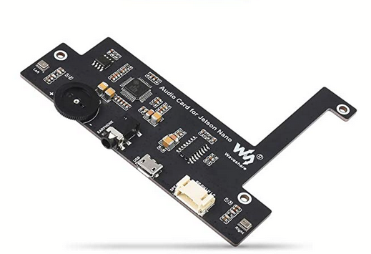
Figure 44: Jetson Nano Audio Card

3.1.14.2 Magnetic Cone Speakers
The design that we are using for our tanks audio makes use of multiple magnetic speakers. Magnetic speakers are simple speakers that contain two magnets. The first magnet is located at the base of the speaker and is permanently magnetized. The second magnet is wrapped in a coil and is not magnetized by default.The coiled magnet is attached to the cone of the speaker. When the second magnet’s coil receives a current, the magnet becomes magnetized and moves closer or farther from the permanent magnet. This results in the cone also moving closer or farther from the permanent magnet. When the cone moves in and out, the speaker is essentially pushing or pulling air. This process creates vibrations in the cone and as a result produces waves in the air. These waves are the sound that you hear from the speaker. The speaker knows what intensity of signal to send to the coiled magnet via the audio file. When the audio file contains a note with a higher frequency, the speaker will vibrate at a faster speed resulting in a higher pitched noise. If the speaker wants to play a lower pitched noise, the board will send a lower frequency signal to the coil.
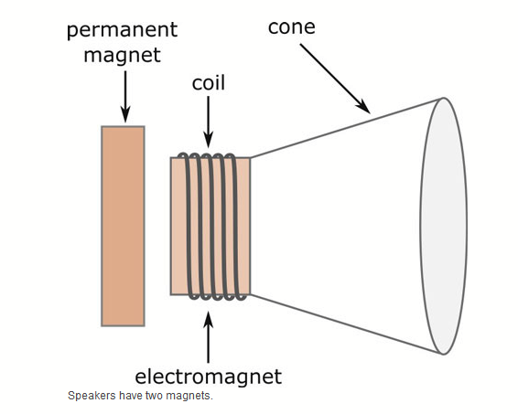
Figure 45: Magnetic Cone Speaker

3.1.14.3 Standard Flat Panel Speakers (Planar Speakers)

Flat Panel speakers are speakers that use a large flat panel made out of a single material. This large material is meant to simulate the human diaphragm. For reference, the human diaphragm is a thin muscle that expands and contracts. When the diaphragm expands, air is pulled into the lungs. When the diaphragm contracts, the diaphragm flattens resulting in air being pushed out. The flat panel speaker design is designed to emulate this process. Similarly to the human diaphragm, the speaker's panel expands and contacts resulting in air being pushed and pulled from the cavity that houses the panel. To create this movement, an audio exciter mounted to the back of the film in the center of the panel. This exciter is responsible for creating the vibrations which transfer into the panel. These vibrations are what causes the air in the speakers housing to be pushed out and pulled in. This results in the noise that we commonly hear from speakers. The panel that houses the material is more often in the shape of a square. The square shape is the most common because we want a quality sound. The sound quality is dependent on the panel's ability to handle vibrations as well as the uniformity of the vibrations throughout the panel. If the panel has strong vibrations in the center, but weak vibrations on the edges, the sound will be less quality than the sounds that would result from a panel with an even distribution of vibrations. The more uniform the vibrations are within the diaphragm, the higher quality the resulting sound will be. One of the main reasons that someone would consider a flat panel speaker over a conventional cone speaker is the depth of the design. Due to the flat nature of the diaphragm design, the speaker is much thinner than a conventional cone speaker. An example of this thin speaker design can be seen below.
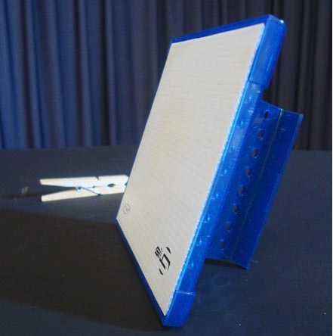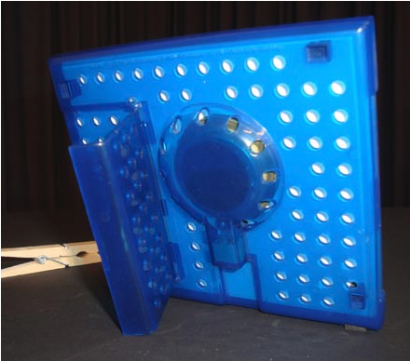
Figure 46 & 47: Planar Speaker
One drawback of the flat speaker design is that it generally has a smaller range of frequencies that it can produce in relation to the cone speaker. However, the sound quality that can be produced from a flat panel speaker is a more accurate representation of the real sound than what we would get from a cone speaker. This is because the soundwave from the flat panel speaker arrives at your ear in the form of a straight wave. This straight wave reduces the chances of the waveform becoming disorganized on the way to your ears. Another negative aspect of the flat panel design is that the sound resulting from the speaker is more unidirectional than the sound that you would get from a cone speaker.

3.1.14.4 Multi-Cell Flat Panel Speakers
Multi cell flat panel speakers follow the same theoretical design as the standard flat panel design. The major difference between the standard flat panel design and the multi-cell flat panel design is the number of audio exciters used. The multi-cell flat panel speaker builds on the idea that a more uniform vibration throughout the diaphragm results in a better quality sound. Instead of the single audio exciter, the multi-cell flat panel speaker uses two or more audio exciters affixed to the panel. The process of adding additional audio exciters and spreading them evenly across the surface of the diaphragm results in a more even vibration throughout the panel. This results in a uniform vibration across the diaphragm and a high quality sound. One of the major drawbacks of the multi-cell flat panel design comes from the use of multiple audio exciters. The audio exciters are constructed using magnets and coils made up of various metals. These metals represent the majority of the weight in the design. Due to the fact that the multi-cell flat panel speakers contain multiple of these audio exciters, the overall weight of this flat panel speaker design is much higher than the standard single audio exciter design. An example of the multi-cell flat panel design can be seen in the figure below.
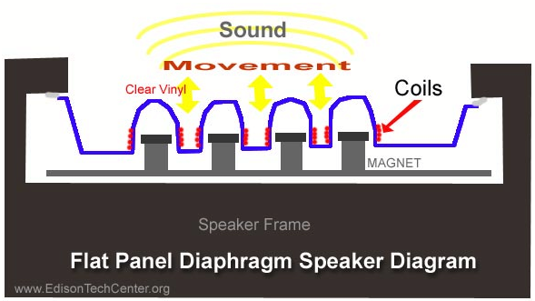
Figure 48: Multi-Cell Planar Speaker

3.1.14.5 Speaker Selection
Comparing the two major speakers designs above, we can safely conclude which design we will use. When comparing the two speaker designs, we will consider the sound quality, area of coverage, size and cost / availability.
First, we will discuss the sound quality of the flat panel and cone speakers. We have found that the flat panel speaker provides a more accurate sound than the cone speaker. This means that the sounds that are being produced are more true to the original sound that was recorded and played back. Having said that, the cone speaker design offers a wider range of frequencies that it can output. This means that the cone speaker can give deeper and higher pitched sounds in comparison to the flat speaker.
The second aspect that we will want to compare is the area that the speaker can cover. Given that the diaphragm on the flat panel speaker is only facing one direction, the resulting sound is also unidirectional. This means that, as you move horizontally in comparison to the direction the speaker is facing, the sound drastically decreases. This is especially true in an environment where sound is less likely to reflect back at you such as an outdoor space. The cone shaped speaker design has a more multidirectional audio output. This is because of the shape of the cone. The sound that is produced from the cone speaker is not only projected directly in front of the speaker, but also to the sides of the speaker. To further explain this point, the overall area that can be produced by the flat speaker is represented by 1 / R. Meanwhile the area of the sound produced by the cone speaker is represented by 1/ R^2. Assuming that each speaker has the same unidirectional range, the cone speaker covers the area of the flat speaker squared. The sound profile of each speaker type can be seen in Figure 42.
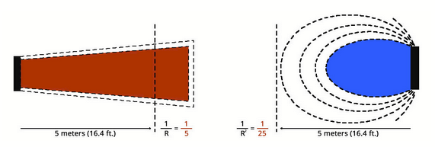
Figure 49: Planar VS Cone Speaker Speaker Coverage
The next aspect of the speaker's designs that we will compare is the size of the speaker. Generally speaking, the depth of the flat speaker is much smaller in comparison to the cone shaped speaker. To replicate the same sound, the flat speaker requires a much larger diaphragm size due to the fact that it is not utilizing available depth.
Lastly, we will look at the costs/availability of each speaker design in relation to each other. First we will look at the availability of flat panel speakers. The flat panel speaker is not nearly as common as the cone speaker design in today's market. This largely results from the fact that the cone shaped design is the market standard when it comes to speakers. This could be attributed to the fact that the flat panel speaker is only necessary when the space available for the speaker is very thin. This also pairs with the fact that the flat panel speaker is not as loud as its equivalent size cone shaped speaker. The niche form factor of the flat panel speaker results in a higher price when trying to source one. This is because there are significantly less sources creating them.
After reviewing the comparisons between the two speaker form factors, we can safely say that the cone shaped magnetic speaker is more well suited for our design. When comparing the sound quality of the cone speaker to the flat panel speaker, we see that the flat panel speaker has a more accurate sound representation. However, our design does not rely on the ability to output accurate sounds. Our design simply needs a speaker that is capable of outputting a sound that is accurate enough to be identifiable and loud enough to be heard by surrounding users and or observers. When considering area coverage, we also prefer the cone shaped magnetic design. If we consider the goal of outputting a sound that can be heard by all surrounding users and observers, then we want a speaker that can cover the most area. The cone shaped speaker outputs a more multi-directional sound which results in the audio reaching more places. This is the more ideal option for our design. Next we will cover the size of the device. Again using the previous goal, we will choose the cone shaped magnetic speaker. The cone shaped speaker can output the same decibel sound as the flat panel speaker, but in a smaller design. In this case, when we say smaller, we are referring to the radius of the speaker. The flat film speakers have a larger surface area in comparison to an equivalent cone shaped speaker. Our design is relatively large and is not lacking in internal space for the design. This means that it would be more ideal to make use of this internal space. If we chose the flat panel speaker, we would be taking up more surface area of the tank shell which would result in less space to position phototransistors. The last reason why the cone shaped magnetic design is the correct choice for our design is the cost and availability of the design. The cone shaped speaker design is the most common and most produced speaker design in the world. This means that there is no shortage of options to choose from. Having the availability to choose from cone shaped speakers of all different sizes and design specifications gives us more overall design freedom. Comparing this to the flat panel speakers, which are much more difficult to source and are very limited in design options, makes choosing the cone shaped speaker an easy choice. Below our team created a table to sum up the comparison between the two speaker types.
 | Sound Quality | Sound Coverage | Size | Cost | Availability
Cone Shaped Magnetic Speaker | Higher Decibel Compared to Similar Sized Flat Panel Speaker | Wider sound profile at equivalent range | Smaller surface area requires more depth | Cheaper | World Standard  Easily obtainable
Flat Panel Speaker | Higher Quality Sounds  Less available frequencies | Sound profile unidirectional | Thinner  Larger surface area | More expensive | Very few available  Niche design
Table 18: Speaker Technology Comparison
Now that we have discussed the differences between the two speaker design types and made a decision, we can cover the speaker that we have purchased. The speakers that we are going to be using came as a part of the package when we purchased the Jetson Nano Sound Card.The speakers we are referring to can be seen in the figure below.
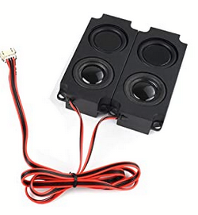
Figure 50: Jetson Nano Sound Card Speakers
The sound card comes in a kit with two small magnetic speakers. These speakers use 5 watts of power each. The resistance value of each speaker is 5 ohms. The two speakers that are included in the kit will be removed from their housings and fabricated into the shell of the tank for better sound quality. If the speakers were left inside the enclosure, the sound would reflect off of the inside of the tanks shell and the audio would be muffled. This would result in the sound from the speakers not carrying as far as it could. The speakers should work in conjunction with the sound card. Specifically, we will be able to adjust the speakers output through the volume scroll wheel on the sound card board. Additionally, we may code the controller to have the functionality to adjust the audio levels. Doing this would mean that we would not have to remove the shell of the tank to adjust the audio. Alternatively, we may also design the tank shell so that the volume wheel on the sound card is accessible without removing the shell.
UPDATE:
The Jetson Nano Speakers were scrapped from the project as we did not account for the proper spacing of the board as well as the speakers. These components would have made the device overcrowded. Another issue we were having was that the Jetson Nano was sending overcurrent warnings when we ran the image recognition software. This meant that we did not want to add any additional load to the board as it might have caused damage. Damaging this board would have resulted in overall image recognition failure and the tank would be essentially blind.

3.1.15 Speakers Input Type
There are a few different options for speakers that we could have chosen from. We could have used bluetooth speakers, auxiliary speakers, magnet speakers, or the speakers from the sound card. Now, of course we chose the speakers that come with the sound card, because they are already there and the soundcard would be programmed in. That is one of the reasons we chose that specific one. The one we would want to choose would depend on a few different things. This includes compatibility, sound quality, and the overall performance ability.

3.1.15.1 Bluetooth Speakers
There are many bluetooth speakers out there nowadays. They come in both big and small sizes, basically good for any fit for the Jetson Nano or other projects we may come across. One of the reasons we decided against the bluetooth speakers is because the Jetson Nano does not have built in capabilities for bluetooth. We would need to get an additional adapter to be able to support this type. Usually the point of bluetooth is to have the wireless feature and seemingly limitless distance from the initial point. Technically we would not get the fully wireless feature, because we would need to plug in an additional adapter. At the same time, the Jetson Nano has more than enough extra USB ports to be able to support this. At the end of the day, it was not needed, simply because the sound card already comes with the speakers.

3.1.15.2 Auxiliary Speakers
Another option for speakers are auxiliary speakers. This is again another option with many different speakers available. Since the Jetson Nano does not have audio input or output for the speaker nor microphone, this is also one of those things that we would need some kind of adapter for. We can get a USB adapter that can support the chosen auxiliary speakers and be able to use that for sound. Typically, auxiliary speakers do better than bluetooth ones, also. That being said, if it was between these two, we would choose the latter. Once again, though, the complete sound card is the best option.

3.1.16 Audio Interface Computer Connectors
Devices use the audio interface hardware to convert the received analog signals to digital audio information that the computer can read and process. These are important, because although the soundcard itself is an audio interface hardware, it is like a first level super basic one. It is not ideal for recording good quality sound, but also they can be affected by various interferences. There are different common types of audio interface connections that every computer should have at least one of. The four most common ones include USB, FireWire, PCI Express (PCIe), and Thunderbolt. Of these, the most common one is USB, and also the one we decided to use for this project. We chose this one because it is what our sound card uses. Of course, there are pros and cons to each one, and specific compatibility as well. If we had the option to choose one of the others, this is the process we would have gone through to determine it.

3.1.16.1 USB
USB is the most common type of audio interface hardware, and is produced by a number of companies. Some of these known companies include Focusrite, Yamaha, Steinberg, PreSonus, Audient, iConnectivity, Novation, and RME. There are different versions of USB with these being the main base ones: 1.0, 2.0, and 3.0. In this instance, the higher number is the better, and the lower is the original and slower. More specifically the newer ones have faster data transfer rates, and in having those we have a better audio performance. Now, although there are three different versions and there have been quicker modifications over the years, the USB is still considered slower than other connection types. To assist with this, USB is now producing other connection types, like USB-C that is supposed to give quicker transfer rates. One of the great things about USB is that it is almost universally used, so almost all devices have at least one USB hardware, giving this a good go to option if needed.

3.1.16.2 FireWire
Another audio interface hardware that is used is FireWire. FireWire is produced by some main companies including Focusrite, PreSonus, RME, and MoTU. Most computers actually do not have this output, it is a much less commonly used one, but it is, surprisingly, faster. It may be less common, but on the other hand it is usually used for higher end interfaces. Most of the time, to use FireWire hardware you also need an adapter or conversion cable to support this audio interface and connect it to the computer you are using. As a further step, depending on the computer or PC you use, you may even need to install a FireWire card. The advantage to going the extra mile to do so, is that faster and more consistent transfer rate, than USB for example. This gives an extra reliability that USB does not, especially if you are working on multiple channels at the same time.

3.1.16.3 PCIe
The PCI express interfaces are considered a dying breed and a lot more expensive, but they are still worth mentioning. These are produced by ESI, SSL, and Universal Audio. These were made to replace the PCI card, because they are now not physical. These are internal cards that get installed directly on your computer and can be bundled with extra software to make their processing power even greater. They are usually built into the original desktops and get plugged directly into the motherboard. It is like having a second sound card, essentially. Because of this, though, they cannot be used with laptops which makes their usage less necessary. Now, on the other hand, because it is in direct contact with your motherboard, the latency and some of the conversion processes are bypassed. The speed for the data transfer rate is basically instantaneous.

3.1.16.4 Thunderbolt
It is said that the thunderbolt is one of the best hardware for audio interfaces. These new top interfaces are produced by Focusrite, Universal Audio, and Apogee. This is simply because of the performance it delivers and the cost it comes at are both fair and valuable. The latency is minimal and lesser than that of USB as well, it is much faster than USB. This is becoming the new reference standard for audio interfaces. So much so that it is being used in high end interfaces, similar to FireWire. Like USB, they come in different versions, 1, 2, 3, and 4, with 4 being compatible and like the USB-C. One downside is that they are pricier, but it is for a better processing and power speed, with less interference issues. There are a lot of things to take into consideration when choosing which audio interface hardware we wanted to use, but at the end of the day, we had to use what worked with our sound card which was USB. If we were able to use any of them, we would take into account the processing speeds, the latency, and the overall price of them. Our comparison would look something like below.
 | USB | FIreWire | PCIe | Thunderbolt
Producers | Focusrite, Yamaha, Steinberg, PreSonus, Audient, iConnectivity, Novation, and RME | Focusrite, PreSonus, RME, and MoTU | ESI, SSL, and Universal Audio | Focusrite, Universal Audio, and Apogee
Versions | 1.0, 2.0, 3.0 | 400 and 800 | 1.0, 2.0, 3.0, 4.0 | 1, 2, 3, 4
Data Transfer Rate (1-4) | Slowest (4) | Slower (3) | Faster (2) | Fastest (1)
Latency (1-4) | Most (4) | More (3) | Least (1) | Lesser (2)
Prices | $200-$300 | $400-$1000 | $950-$1800 | $200-$3800
Table 19: Audio Interface Hardware Comparisons

3.1.17 Audio Output Options
The Jetson Nano does not come with any soundcard or built in audio I/O options. This means to be able to have an input or output, you have to either add on a sound card or some kind of adapter. The only two that are truly compatible and work the best with the Jetson Nano and have been tested that we could find are the USB Audio Codec for Jetson Nano Soundcard and the and the Sabrent USB External Stereo Sound Adapter. On the other hand, for a more generalized option you can use a USB to audio adapter. We decided to go with the soundcard for more direct performance. This also has a USB adapter option with it which lets us use the USB audio interface. This one gives us multiple inputs. The Audio Codec was designed specifically for the Jetson Nano by its company WaveShare. To go through the options of the specific dongle or the general adapters is below.

3.1.17.1 Sabrent USB External Stereo Sound Adapter
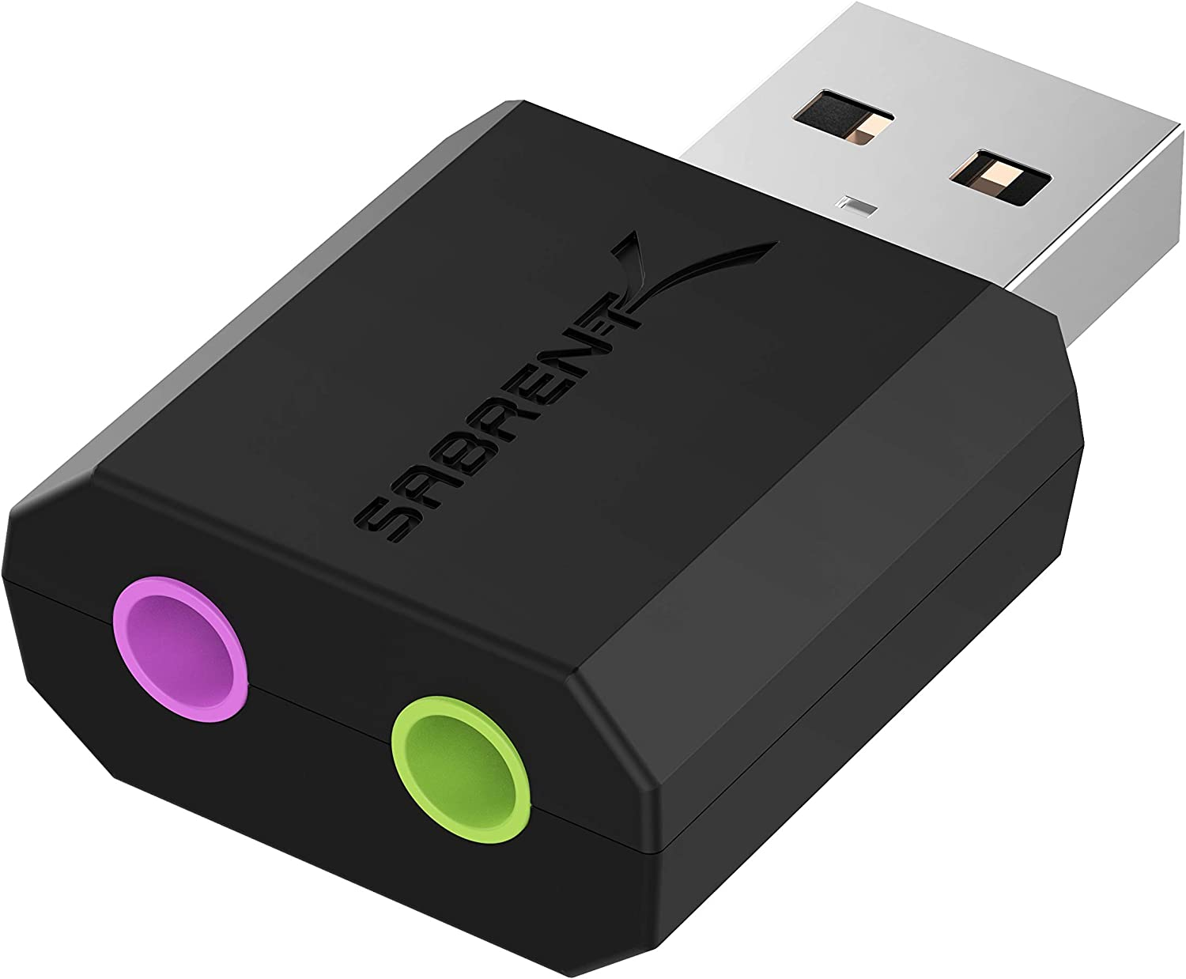
This is an External USB dongle that works with Ubuntu on the Jetson Nano. It has plug-and-play functionality so there are no extra downloads, installs, or drivers that need to be done to use it, which makes it a quick and easy setup. It has both a microphone input jack and a stereo output jack. We would not need to use the microphone input jack for this particular project, but just in case, for future references it is a nice feature. This also comes in at a nice price of approximately $9. Like the Audio Codec it is USB bus-powered so it does not require any additional power source. Although it does not use the USB 3.0 (newest version of the USB interface), it does match the sound card by using the USB 2.0. This does mean it is slower than the 3.0 alternatives. Overall, although this is a cheaper and quick fix for the audio, the USB Audio Codec for Jetson Nano Sound Card was a better overall option. It gives more features and can not beat the fact that the sound card was made for the Jetson Nano.
Figure 51: Sabrent USB External Stereo Sound Adapter

3.1.17.2 USB to Audio Adapter
This is a general term for any USB to audio adapter. In these cases you can use the faster 3.0 USB option. These can range from anywhere between $10-$20, depending on which one you decide to get. Since this is not specific to any specified brand, but just the general type of cord, the specifications really just depend on which one you choose to purchase. This is a trade off that you can specifically determine if it is worth it to you, for us we decided against it, because for approximately the same price (of $20), you can get the sound card. Which, overall, serves the same functionality and more.

3.1.17.3 USB Audio Codec for Jetson Nano Soundcard
The USB Audio Codec is a sound card made for the Jetson Nano and has a whole handful of features to make it work the best that it can be for the Nano and for this project. It does have some features that we will not necessarily be using like a built-in microphone, speech synthesis, speech dictation, speech wake up, and speech dialogue, and sound recording via the microphone. This is because we’re using the soundcard to add additional features to the aesthetics of the tank. This includes sounds for the shooting and moving. Now, even though we will not be using those features, there are a whole lot that we will be using and one of the reasons we decided on this sound card rather than the other previously mentioned adapters. These features include the speaker header, turning machine, and volume adjustment knob. It uses the SSS1692 audio chip inside it as well for better audio quality.
 | USB Audio Codec for Jetson Nano Sound Card | Sabrent USB External Stereo Sound Adapter | General USB to Audio Adapter
Plug & Play | x | x | x
Driver Free | x | x | x
USB Connector | x (2.0) | x (2.0) | x (2.0 or 3.0)
USB-Bus Powered | x | x | depends
Audio Output Jack | x | x | x
Microphone Input Jack | x | x
Stereo Speaker | x
Volume Adjustment Knob | x
Demo Codes | x
Table 20: Audio Output Option Comparisons

4 Design Constraints and Standards
This section allows the user to understand the constraints that Photo-TANKS might have, and how it can affect the designing of Photo-TANKS. Also, this section allows the user to notice the standards that Photo-TANKS might use.

4.1 Constraints
There are quite a good amount of constraints when dealing with a product, and Photo-TANKS is no different.

4.1.1 Economic Constraints
A big issue when working on a project is funding. Big companies, like Lockheed, may not have this issue most of the time, since they can fund themselves. But, for those who are not funded by a company, they have to pay out-of-pocket. Which happens to a great number of Senior Design 1&2 students. Which is something that we are going to be forced into doing. Unless, if the CREOL grant pays for some of our optical parts, then we would only have to pay for everything except for the optical devices. This, in turn, limits our testing, where instead of being able to use any part, test it, get results, and if those results are what we wanted then we use it. But, since we placed a limit of $2000, we cannot test every possibility, so we have to research every component of Photo-TANKS and attempt to figure out the best components. And, if we find out that the component we have chosen is not compatible with Photo-TANKS due to either size limitations or power limitations, then we will be forced to get another component, which would hopefully work, causing the budget to be tighter.

4.1.2 Social Constraints
A goal for Photo-TANKS was to allow armored vehicles to detect potential allied or enemy targets by using coded pulses/signal transmission. This idea is not supposed to be used for the public, but more so for the military. Currently, some armored vehicles have radar, but tanks do not have a way to check for allies or enemies, except when the other armored vehicles are nearby, where it is possible to see their tagged numbers or identification panels. So, when Photo-TANKS are made, the hardware/software used to make the coded pulses/signal transmission should be readily available for the military. Be it affordable or usable to all.

4.1.3 Environmental Constraints
Based on the fact that the environment is getting worse as the days go by, everyone, the users and the developers should respect the environment. By that, Photo-TANKS will not have any device that might affect the environment in too much of a negative way. Even though Photo-TANKS is an electrically, battery-based system, the amount of batteries it uses, and how long Photo-TANKS can last can at least prevent some environmental damage.

4.1.4 Manufacturing Constraints
One of our biggest constraints is the availability of the materials we have chosen. With the prices of various components going up due to the lack of trade, or due to the shortages of components to buy/use because of the materials to make said component is scarce. So, when deciding on the components that will make the Photo-TANKS, we need to check to see if the components are available, and if they are not currently available, when will they be? If it is a few days or week, then it would be fine with using that component, if not, then we will need to decide on another part.
Additionally, when we are creating the Photo-TANKS, certain materials, like metal, are not going to be used for the casing, since the availability might be limited/pricey or we might not have the equipment/abilities to use them. So, for the casing, we are going to 3-D print it. Which can be used to help against at least the casing’s manufacturing constraint.

4.1.5 Health & Safety Constraints
For those who will use Photo-TANKS, there are a few health and safety constraints. For example, while Photo-TANKS is running do not: touch bare electrical components with your hands under non-normal conditions, stare directly at the laser pulse from Photo-TANKS’ cannon, and allow children to use Photo-TANKS unsupervised. Plus, since Photo-TANKS is limited by a budget of $2000, the parts used might be prone to malfunctions.

When Photo-TANKS is running, make sure to not attempt any of the reasons above, since those four constraints could injure the user. For example, if the casing of Photo-TANKS is open and the electrical components are bare, touching them can produce an electrical shock, under non-normal conditions like being damped. Or, since Photo-TANKS is using a 5mW laser diode, staring at it for a brief period of time, usually less than a second, will damage an eye, causing blindness or personal injuries.

4.1.6 Sustainability Constraints
For Photo-TANKS, the goal was to have the tank to last up to four hours of continuous usage with a 12 V source, under normal conditions. These normal conditions would be inside a building without dealing with any potential damaging elements from the outside.
However, there will be times where Photo-TANKS might be used outside, where the casing of Photo-TANKS might have to deal with weather conditions, like rain or lightning. Or, the internal components have to deal with the temperature, meaning that Photo-TANKS might be forced into running during what feels like 100° Fahrenheit or somewhere of 40° Fahrenheit. So, that means that the casing of Photo-TANKS needs to be sealed, with no or very little openings, so that most weather conditions cannot affect it. And, that the inside might need some cooling or heating pads to prevent the internal components from going haywire due to temperature.

4.1.7 Time Constraints
For Photo-TANKS, time constraints will be the most important constraint we have to deal with. Since, Photo-TANKS will need to be finished by the end of Senior Design 2. That means, all the testing, designing, prototyping, and creating the final product must be done within four months, excluding any work done in Senior Design 1. All the main components need to be finished at that time before any stretch ideas are allowed to come into play. So, because of the time constraint, we might have no additional ideas or we may have too many additional ideas.

4.1.8 Ethical Constraints
There should be no cut-corners when designing Photo-TANKS. Since, cut-corners can cause faulty equipment, malfunctions, and potential dangers to young children. So, Photo-TANKS will never have any aspect that shall harm or negatively affect the user. Photo-TANKS will not have any potential toxic materials, if any, outside of the casing and the materials used will not affect the lifetime of Photo-TANKS. Also, features will not be removed from Photo-TANKS if the only reason is because of economical constraints.

4.1.9 Political Constraints
After looking at various political constraints, Photo-TANKS currently has no political constraint that is relevant to us.

4.2 Standards
There are various types of standards and regulations that we need to be aware of when designing Photo-TANKS. Like standards regarding the usage of: wireless communications, RF signals, microcontrollers. Also, there are various optical standards too.

4.2.1 Optical Standards
This subsection is for all relevant optical standards for Photo-TANKS. This might include standards for: laser diodes, lenses, photo-transistors and photo-diodes, multi-color LEDs, and cameras.

4.2.1.1 Laser Diode Standards
By the use of Laser Safety Standards, ANSI Z.136, [Lstandard], a list of laser classes is made. From class 1 to class 4, which labels the strength and potential dangers of a laser for those classes.

Class of Laser | Description
Class 1 | Lasers that are labeled as safe, under normal usage, and are generally either low power usage lasers of 0.49 mW or non-visible lasers.
Class 2 | Lasers that are considered safe only because of the ‘blink reflex’ where light is not exposed for longer than 0.25 s. Any amount of time over 0.25 s can cause eye injuries, and uses a power range of 0.5 to 1 mW.
Class 3R | Lasers that are considered safe only when handled correctly, it is best to avoid direct eye exposure. Uses a power range of 1 mW to 5 mW.
Class 3B | Lasers are generally unsafe and any exposure of the beam should be avoided including viewing/touching by the eye/skin. Uses a power range of 5 mW to 499 mW.
Class 4 | Most dangerous type of laser that can cause damage directly or indirectly and can permanently damage the eye/skin.
Table 21: Laser Classes [Lclass]
The laser diode Photo-TANKS is using has a power of five milliwatts, so the class is 3R/3B. As stated from the part selection for laser diodes, L635P5 is safer to use over the other three chosen for a longer period of time, as long as the laser diode is handled properly.
This standard is quite important, since it tells the user how strong and dangerous the laser Photo-TANKS is. And, since we have a constraint of health and safety, this should convey a potential danger that can be avoided, which will be expanded upon in the next section.

4.2.1.2 Laser Safety Standards
As a class 3R/3B laser, and based on the previous standard, ANSI Z.136, [Lstandard], there will be various protocols that are to be followed when using the laser diode. Like using eye safety glasses to prevent any eye damage in case of direct exposure of the beam from either looking at said beam or due to reflection by some sort of reflector. While damaged retinas can occur and be prevented easily, another potential threat is skin damage. If exposed to a laser’s light for an excessive amount of time can cause skin damage similar to sunburns which can be avoided by lowering the beam’s exposure to the skin.

4.2.1.3 Lens Handling and Cleaning Standards
Since lenses are quite delicate optical components, it is best to handle them with care in order to prevent any potential scattering due to fingerprints, dust, water, etc. When handling, make sure to only touch the edges with gloves on, store it in-between cloth or its storage box when not in use, and clean the lens if it ever gets dirty. If the lens is properly handled, then the lens will not need to be cleaned often and will maximize its lifetime since anything that would produce it, would not be affecting the lens. Inspections of the lens should happen before and after the use, and before and after cleaning the lens, by a magnification device. This is done to find any damages, and to see if the lens is dirty or not. If there are damages, the lens can still be used unless the damage is larger than the scratch-dig specification of the lens, then it would be time to replace the lens [Cleaning].
When cleaning the lens, there are a few procedures to clean it. First, as mentioned above, the lens should be inspected to find any damages or any contamination. Based on how severe the contamination is, there are different cleaning methods to use. Firstly, if there are just specks of dust, all that needs to happen is blowing the dust off. Not with your mouth, but some sort of dusting gas. Once the gas is obtained, hold the lens upright, have the can pointed away from the lens and slowly use said gas to blow away the specks. And, if blowing on the lens does not clean the lens, then it is possible to wash it, with distilled water and soap, and rinse off the soap with the distilled water. Afterwards, use a piece of cloth or tissue to wipe the lens until it is clean and dry [Cleaning].

4.2.2 Electrical Standards
This subsection includes any relevant electrical standards for Photo-TANKS. This might include standards for: primary cells, bluetooth, slip rings, graphics processors, sound cards and speakers.

4.2.2.1 Power Supply Standard
By the Power Supply Safety Standards, by CUI Inc, [Pstandard] this standard is a part of the whole system. For allowing components to be used for circuit classification or for shock prevention by circuit insulation.
Power Supply/Circuit Type | Description
Hazardous Voltage (HV) | The Voltage used in a circuit exceeds 42.4 VAC or 60 VDC, without a limited current circuit.
Extra-Low Voltage (ELV) | The voltage used in a circuit does not exceed 42.4 VAC or 60 VDC and is separated from any HV by at least basic insulation.
Safety Extra-Low Voltage (SELV) Circuit | A circuit that cannot reach HV levels, even when experiencing a fault. The voltage used should not exceed 42.4 VAC or 60 VDC, but if it does, it should only be for 200 ms and have a peak of 71 VAC or 120 VDC. Must be separated from HV by double insulation and must be considered safe.
Limited Current Circuit | While under a fault, the current produced should not cause HV. For frequencies under 1 kHz, the current should be under 0.7 mA AC peak or 2 mA DC, and for frequencies above 1kHz, the 0.7 mA is multiplied by the frequency, but cannot exceed 70 mA. The maximum capacitance is 0.1 μF for parts with 450 VDC/VAC. And the maximum charge is 45μC for parts with 1500 VDC/VAC.
Table 22: Power Supply/Circuit Classifications [Pstandard]
From the table above, the circuitry design that Photo-TANKS is using is ELV. Since the maximum voltage we are using should be 12 V DC, throughout the whole system. So, basic insulation must be applied from the voltage source to the circuit, the PCB used should have some protection, either by plastic or other material, to prevent faults within Photo-TANKS.

4.2.2.2 IPC Standards
The Institute for Interconnecting and Packaging Electronic Circuits (IPC) aims to standardize the production of electronic equipment. Therefore, IPC has various standards regarding PCBs. Like general documents, design/material specifications, performance, inspection, assembly and material standards. Out of most of them, Photo-TANKS will use the IPC-2220-FAM standards [FAM], which contains five different standards for designing a PCB, like the IPC-2221B [IPC1], which shows/labels a generic design for a PCB, like general requirements and component mounting through the use of soldering, which might be explained in the research/design section. Also, Photo-TANKS will use the J-STD-001 [JSTD] standard that goes even more in detail for the use of soldering for a PCB.

4.2.2.3 Soldering Standards
From the previous stated standard, J-STD-001, and the “Soldered Electrical Connections” standard from the National Aeronautics and Space Administration (NASA), there are some important steps for proper soldering for PCBs or other electrical equipment. In J-STD-001’s standard, there are three classes of products, general, service and high-performance, and several requirements for soldering. Like to name a few, all materials need to be clean, strands of the wires should not be damaged, and inspections should be performed before coating and stacking, also any defects should be reworked or scrapped, such defects can be seen in the figure below [JSTD].
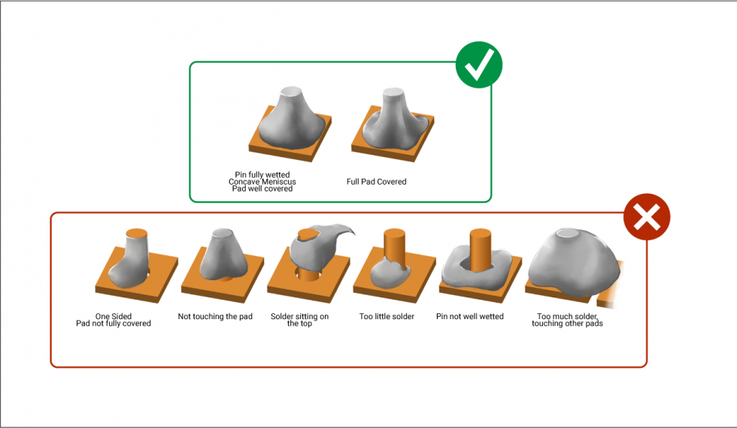
Figure 52: Soldering Rights and Wrongs [JSTD]
There are also some other important requirements like corrosion protection, correct usage of materials, part mounting requirements, and thermal protection to prevent potential risks. Some of these might not be too important for Photo-TANKS, like corrosion protection, but being able to mount parts correctly to the PCB or preventing strand damage to prevent risks or faults is necessary.

4.2.2.4 Soldering Safety Standards
Generally, when soldering, many dangers can occur. Since, the soldering iron becomes quite hot, around 400 celsius, all materials that will be soldered together must be held with some sort of clamping tool. Always keep the cleaning supply, a sponge or other water-keeping material, wet while using the soldering iron to reduce the heat of the soldering iron when not in use and while the soldering iron is not being used, place it back to its stand. And, lastly, when not in use, keep the soldering iron off and unplugged so that no one will potentially get hurt [SSafety].
When handling the soldering iron, it is important to wear eye protection, like the laser safety standards, since the solder could potentially “spit”, like when the solder breaks and could get jabbed into an eye. Always wash your hands after use of the soldering iron, use rosin or lead free solders if possible and keep any cleaning solutions nearby in dispensing bottles [SSafety].
The reason for why it would be best to use either rosin or lead free solders whenever possible is because that lead can cause serious health effects, but can generally be ignored if gloves are worn, and no skin is exposed when using the soldering iron. Whereas, for rosin, it is generated by the smoke that soldering produces, which can cause irritation in the eyes/throat, headaches, and is overall an unblockable health hazard, unless the smoke is controlled [SSafety].

4.2.2.5 IEEE 802.15.1 Standard
The Institute of Electrical and Electronic Engineers (IEEE) is a professional association that promotes electrical and technical advancement in electrical and electronic engineering. Meaning, the IEEE is responsible for making various standards for electrical-based products. Such as the 802.15 standard, [Wiki3] which specifies wireless personal area network (WPAN). More specifically, Photo-TANKS uses a standard that falls under 802.15, which will be 802.15.1, [Wiki3] that is based on bluetooth technology. This standard for bluetooth, is for portable and moving devices, which is what Photo-TANKS will be.

4.2.2.6 Bluetooth Range
Based on the 802.15.1 standard, a list of bluetooth classes is made. From class 1 to class 4, which shows the maximum output power and range of those classes.

Class of Bluetooth | Max Output Power (mW) | Range (m)
Class 1 | 100 | 100
Class 1.5 | 10 | 20
Class 2 | 2.5 | 10
Class 3 | 1 | 1
Class 4 | 0.5 | 0.5
Table 23: Bluetooth Classes, Output Power, and Range [Wiki4, Bclass]
Mentioned from earlier, we are focusing on Bluetooth 4, which can go up to fifty meters outdoors and ten meters indoors, and Bluetooth 5, which can go up to two hundred meters outdoors and forty meters indoors. The lower range indoors can be due to air conditions and the quality of the devices.

4.2.2.7 Bluetooth Frequency
Region | Frequency (GHz) | Channels
North America & Europe | 2.4 - 2.4835 | 79
Japan | 2.471 - 2.497 | 23
France | 2.4465 - 2.4835 | 23
Table 24: Bluetooth Frequency & Channels [Bfrequency]
From the table above, we can see the frequency that the Bluetooth for Photo-TANKS could connect to. From this standard for Bluetooth, Photo-TANKS would essentially be able to connect at the same frequency for the majority of the world, with exceptions to Japan, France and Spain. For that reason, Photo-TANKS will only use the frequency range of 2.4 GHz to 2.4835 GHZ.

4.2.2.8 Testing of Plastic Materials Standard
While Photo-TANKS will be using an Extra-Low Voltage (ELV) system, the casing of Photo-TANKS, the PCB, and any other thin plastics that Photo-TANKS might use can be damaged if a flammable fault occurs. So, because of that, we will be using the UL 94 standard, or “the Standard for Safety for Flammability of Plastic Materials for Parts in Devices and Appliances testing” [WikiF]. The UL 94 standard was created by the Underwriter Laboratories of the United States that essentially shows the possible method to rate flammable plastics in a system. There are two commonly used ratings for these materials, HB and V, and they are rated by a test flame. If the flame is extinguished from the material in or under a minute they could have one of the following ratings:

Rating | Amount of Time Plus if Particles are Allowed
HB | Extremely slow burning, less than 76 mm per minute to 3 mm.
V-2 | Burning stops before 30 seconds, particles allowed.
V-1 | Burning stops before 30 seconds, non-burning particles allowed.
V-0 | Burning stops before 10 seconds, non-burning particles allowed.
5VB | Burning stops before 60 seconds, no particles allowed, but holes are allowed.
5VA | Burning stops before 60 seconds, no particles nor holes are allowed.
Table 25: Rating of flame-retardant classes [WikiF]
With this table, the best rating any flammable plastic Photo-TANKS uses should be either 5VB or 5VA, but V-0 would be acceptable as well. Which is something that should be aimed for in case of a potential flammable fault happening.

5 System Design
This section encompasses both the software side of Photo-TANKS and the hardware side of Photo-TANKS.

5.1 Software Design Details
For the software aspect of the project, we will be using a Jetson Nano to compute the necessary computations needed for the promised AI recognition of ally and enemy tanks. The Nano will process the video feed then transmit the data over Bluetooth to the controller app on our smartphones to determine if it can fire its weapon system or not while processing movement and aim of the tanks’ turret system. The following sections will describe in detail what is expected of our software infrastructure.

5.1.1 MIT Application Inventor
MIT Application Inventor is a visual programming environment originally created by Google. It was later maintained by its current owner, Massachusetts Institute of Technology. It can be used by most anybody, specifically people who have never coded before. This is a huge donating factor to why we needed such an application. Since this isn’t the focus of our project, we needed something that would do what was needed without taking a lot of our time. The MIT Application Inventor works cross-platform (Android, iOS, and tablets) which also helped with our group which had different mobile platforms.
Our decision was made after looking at many pre-made applications and open-source software. We chose the MIT Application Inventor because many open-source mobile Bluetooth controllers would be missing numerous items that we needed to add to our controller. Most of the controllers that we found, would only have a joystick, two joysticks, or a set of buttons that would send data to the robot to go in certain directions. With our Photo-TANKs we needed a video feed for a camera which most open-source applications didn’t have. This would have required us to code through their language to get a function media feed. With the MIT Application Inventor, they have everything we need to make our Photo-TANKs work as desired just by dragging and dropping elements. The best part of the web application is that there isn’t code we really need to deal with. We just need to drag and drop premade code lines to get what we need up and running.
UPDATE:
We decided to change our application to a WPF application since joysticks, streaming data, and sending/receiving bluetooth data was a bit more restrictive with the MIT Application Inventor. With C#, we were able to implement everything we wanted with our controller with an ease of libraries and NuGet packages that helped reduce the amount of code needed to implement the complexity of our project. When trying to implement a joystick with MIT, there was too much lag time and the joysticks were not fluent which broke our UI standards.
Another influence on this decision was the fact that we needed more space for all the UI elements. When we initially started the application the UI elements became too small and weren’t easy to make dynamically responsive on our different phones.

5.1.2 Controller Application – Photo-TANKS’s Controller
This application is created through MIT Application Inventor. We wanted to push our focus onto the tank itself and its elements. To do this we used this software to shortcut a controller that can be used for all our needs.
Our priority was to find a software that would enable us to transmit all the data required over Bluetooth. The most important data needed was the processed live video feed from the camera that is connected to the tank. Other relevant data was the vehicle commands like the movement, firing commands, and weapon movement controls. The layout of our app should look as follows:
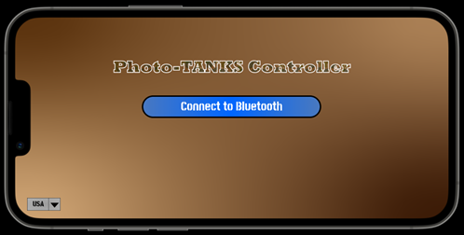
Figure 54: UI Mock-Up of Photo-TANKs Controller application’s “Connect to Bluetooth” screen
This image shows the first screen that pops up when we enter the application. There is a center button which will open a list of nearby Bluetooth devices that are located near the user. At this point, we would locate the tank in which we used to control. If you would like to change the default setting for your alliance (USA), there is a dropdown menu of the available alliances you could choose from. Select your alliance before you connect to Bluetooth to ensure you are in the alliance you desire. When selected and confirmed we end up on the main controller for the entire tank:
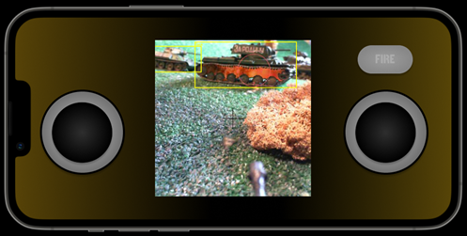
Figure 55: UI Mock-Up of Photo-TANKs Controller application’s “Main Controller Interface” screen with firing systems disabled

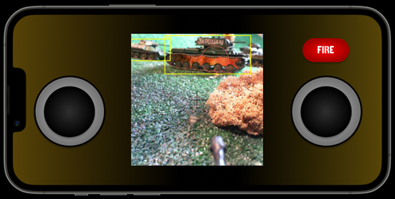
Figure 56: UI Mock-Up of Photo-TANKs Controller application’s “Main Controller Interface” screen with firing systems enabled
As you can see from the above user interface, we have two joysticks. The one on the left is used completely for the tank’s movement. It supports forward, forward-left, forward-right, right, left, backward, backward-left, and backward-right. The joystick on the right is slightly more complicated. When you slide the right joystick left or right you turn the tank’s turret counterclockwise or clockwise. If the right joystick is slid up or down the degree of the turret barrel can be increased or decreased with a max of +10° and -10°.
The image between the two joysticks is the live feed that displays the output of our AI algorithm through the Jetson Nano. If the algorithm has detected an ally in the crosshair, your weapon systems are locked and unable to fire. If the crosshair has detected an enemy, then your weapon systems are activated to fire.
The button you see above the right joystick is the firing button. This button is only active if the camera senses an enemy within its sights. When enabled the button is highlighted red to let the user know that button can be triggered. When the button is disabled, the button is grayed out until another enemy comes into the crosshair.
UPDATE:
With all the added features, we found that the MIT Application Inventor would not suffice for our needs. We decided to try a WPF application since it had painting and a way have event handlers for all our features we planned to implement. Here is a look at our application on startup. We also had to remove the firing on high because the laser driver didnt support any variations to the laser.
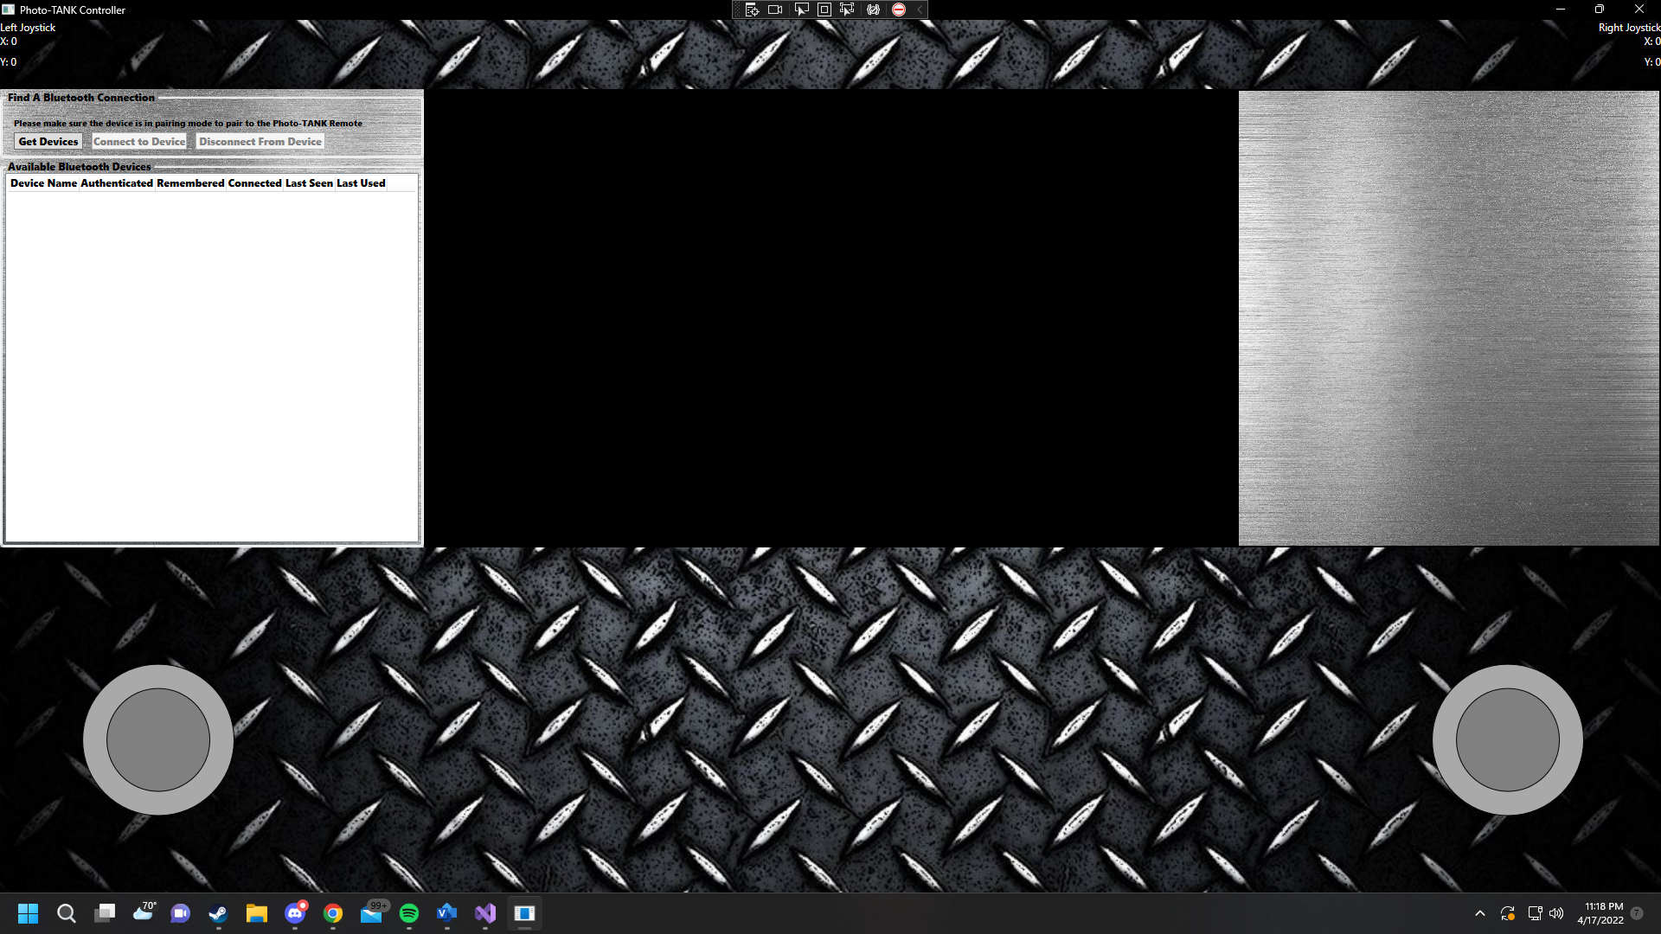
Figure 57: UI Mock-Up of Photo-TANKs Controller application’s “Main Controller Interface” screen
On startup, you can see that there is a bluetooth discovery section to our right. This is, of course, what we use to discover a device. At both top corners of the application, we have the joystick coordinates which show our joystick movements in real time to better know what data is being sent to the tank. At the bottom we have two joysticks. The left joystick controls the tread movements and the right joystick controls the turret base and barrel. Within a couple seconds after startup the controller will automatically connect to the stream from the Jetson Nano. After initialization you can go ahead and click “Get Devices” to start device discovery. When you see what you desire pop up in the ListView, go ahead and select the device and connect. When doing so, you will see a successful connection to your right stating “Data being sent/received via [Device Name]”. At this point, you may go ahead and drive the tank. It will look like this when ready.
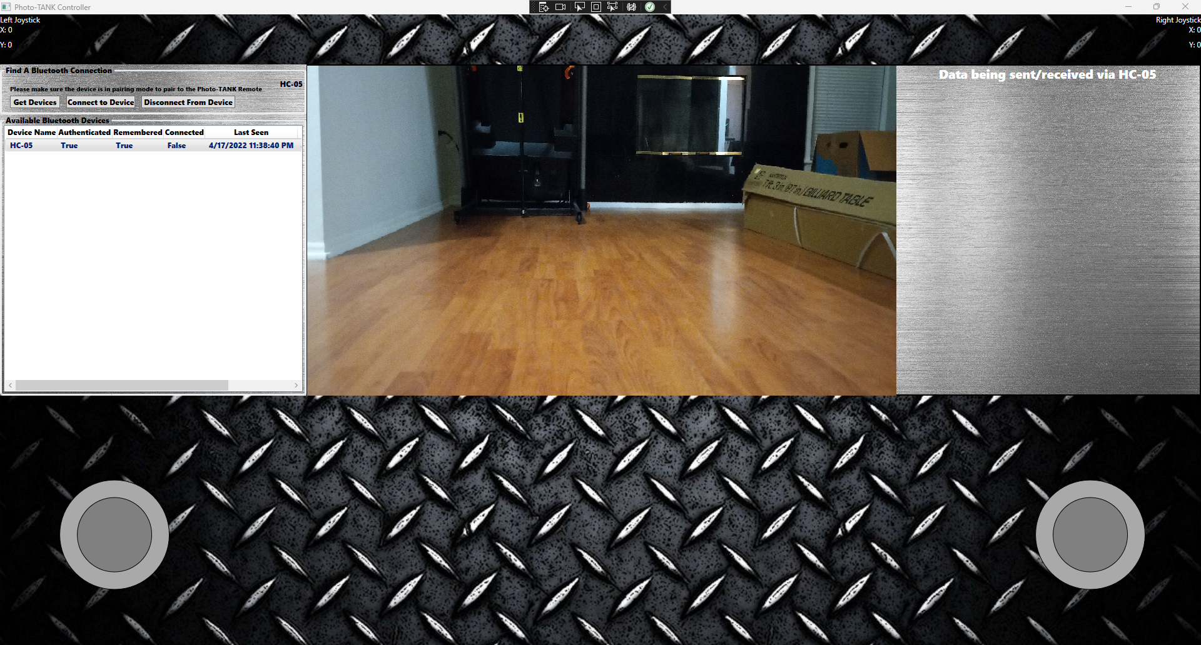
Figure 58: UI Mock-Up of Photo-TANKs Controller application’s “Main Controller Interface” screen with everything connected

5.1.3 Peripherals
The peripherals on the tank consist of the camera, speaker, and LEDs. Each of these play vital roles for our Photo-TANKs. First on the list are our LEDs. These indicate the tank vitals. We will have four LEDs per tank. Each is a different color to indicate what percentage the tank’s health is at, green for 100%, yellow for 66%, and red for 33%.
As for the speaker of the tank, this is to help simulate a more realistic tank. Every time a hit is taken there will be a sound of an explosion. When a shot is fired there will be the sound of a tank shell dispersing from the barrel. When there is movement, you will hear the tank treads moving just like a real tank.
The camera is the most important element of the entire system. This, as mentioned earlier, oversees enabling our weapon systems. It will also give us a lot of information like whether you have an enemy in your crosshair or an ally. It will give feedback on if something is a vehicle, person, or even a specific type of vehicle. At the same time of this detection, alliance is determined. Each object detection will be bound by a bounding box with the object name in the upper right of it. If you have an ally, the bounding box will be green, red would signify an enemy. All operations are done by the Jetson Nano.
UPDATE:
The speaker and LEDs had to be scrapped due to us finding extreme difficulty working with the Jetson Nano 2GB Development Kit. It turns out that 2GB of RAM was not enough to train a sufficient model. With multiple attempts of training, we couldn’t get a robust system to use for our project. Another problem we faced was the expense of trying to upgrade. When the second semester came upon us and we realized we needed to upgrade, Jetson Nano’s were going for $600. We just couldn’t afford this since we needed two of them. This was the sole purpose in why we decided to remove the LEDs and speaker since we couldn’t create two tanks to interact with one another.

5.1.4 Jetson Nano Software Implementation
This is the most important piece of our project. This will determine our allies and enemies while enabling and disabling our firing system. To do this, I need a library of classes that our AI will need to distinguish to make guesses on what something is. These classes will rely on military vehicles and personnel.
We’d like to have the more general objects to be detected as usual such as helicopters, tanks, Humvees, transport trucks, missiles, weaponry, crates, and people. These objects would then have flags which we will use flag detection as our way of determining whether something is an ally or enemy. This flag detection will be like a Boolean that when true (It is an enemy) will enable our firing systems so we could shoot the target. When it is false (It is an ally) it will disable our firing systems keeping the tank in safety mode. We plan to have set on the controller interface which alliance each tank is a part of which will be associated with each tank. These flags will be interchangeable to other common flags we have today. Flags that aren’t within our database will be displayed as “Flag not in database” which will be considered an enemy.
To do all this, we need, as mentioned earlier, our selected classes. For a robust system, we’ll need at least a thousand images for each class. To shorten our work, we’ll need to use some images from Open Images for our more general objects. Any objects that we can’t find on Open Images we’ll need to gather a thousand images to get for our training for our Photo-TANKs. Once we have gathered all our data needed, we will train our model with the given data. From here we test our tanks camera with multiple objects and see how well our model does with just this first part of the training. If there are any misdetections, we will have to gather more data for that specific object it misidentified, then retrain the model. This process will be repeated until our object detection model is almost impenetrable.
Once we have a strong model, connection to our firing systems will need to be established. To do this, we will need to connect our firing system to our Jetson Nano. Thankfully the Jetson Nano has GPIO pins in which we could connect our laser to. As mentioned before, this would only activate the laser when an enemy is within our crosshair.
UPDATE:
As mentioned previously, we had much struggle with training the Jetson Nano 2GB Development Kit. A strong model on 2GB just wasn't feasible. It turns out that we were still able to use Open Images datasets at small batches but we struggled with high losses (Average loss, average regression loss, and average classification loss).

5.1.5 Software Languages for Jetson Nano
The common software languages used for the Jetson Nano consist of Python and C++. Each programming language can achieve equivalent results which causes most of the decisions to be comfortable, efficient, and it is easy to achieve what we want. Through much research, Python is our preference. We have used python for many projects and assignments dealing with AI and Computer Vision. Although we are comfortable with C++, we haven’t used it in any AI or Computer Vision environment.

5.1.5.1 C++
C++ has been around since 1983. It was developed by a programmer known as Bjarne Stroustrup. Quickly, this programming language became famous for its speed and efficiency. Google Chrome uses this language to take advantage of its responsiveness.
There are some limitations to C++ which deter us from attempting to use such language. The main disadvantage is that this language doesn’t support garbage collection. This, depending on how big our project gets, would mean that it would take a decent amount of time to develop a convolutional neural network. With that being said, we knew this would sprout many concerns because this language has not been something that our computer engineer has been well acquainted with.
Ideally this would be the most efficient language to use for Artificial Intelligence. Sadly, due to time constraints with everything that needs to be done we wouldn’t have the time to do so.

5.1.5.2 Python
Python has been the most recent explosion of AI due to the simplicity of programming. Not only is the syntax simple but the number of libraries that are readily available for you is astonishing and they are portable across platforms like UNIX, Macintosh, and Windows. You also tend to write a lot less code to get what you need up and running. To code a simple convolutional neural network, you only need at most 50 lines of code. This has made it extremely easy to make small scripts for smaller AI projects. We considered ours decently small which has helped us decide that this may be all we need.
Other features that made it an easy selection was that it supports a lot of useful features that would make our lives easier. Unlike C++, it supported garbage collection which would put us at ease when programming without having to worry about much of anything and just full focus on getting our AI up and operational. We also thought just in case we were wrong Python could be integrated with C++ anyways if need be. Not only can it be integrated with C++ but with many other languages.

5.1.6 Jetson Nano Supported Frameworks
We decided to use TensorFlow for our deep learning framework. The most common and best ones used right now are TensorFlow, Caffe, and PyTorch. There are various pros and cons to each one, and that is what helped us determine which of them to choose. TensorFlow was created by Google and was made to replace Theano. It uses a Python API with C++ engine and NumPy to help it run faster. Caffe also uses a Python API and was made by a Berkley alum. Like TensorFlow it also uses C++ and C as well. Unfortunately, Caffe is also slowly dying due to its slow development. Lastly, we have PyTorch which, like the others, uses a Python API but with a version of Torch open-sourced by Facebook. Torch is a framework that was made to support algorithms for machine learning, which is exactly what we are needing. Knowing the basics of each one gave us a baseline starting point to decide which specifications were the best, to choose the optimal framework to use.
Caffe was the first one we decided to leave out. Although it does have image processing and has pre-made training programs that do not need coding, it didn't level up to the other two frameworks. The biggest negative factor for Caffe was that we have not worked with it very much, and if we wanted to add new GPU layers we would need to code in C++. Once Caffe was eliminated, it was down to TensorFlow and PyTorch.
PyTorch excels in large software projects and is faster than the other two frameworks. This one also has multiple modular pieces that can be combined easily. Each of the layers can be written and we can use our 128-core Maxwell GPU to run it. The only biggest downside to PyTorch is the training code must be written out mostly ourselves, which leaves more room for error in our code. Although this is a good framework, we felt that TensorFlow would work best for our object detection project.
We have worked more with TensorFlow than PyTorch, which we have not used before. It has faster compile times than older frameworks, uses a TensorBoard, and its data and models go hand in hand. Also, being that the developer, Google, made the framework and the tool, they are the closest compatible. Of course, there are some disadvantages to TensorFlow. It is slower than PyTorch, does not have as many pretrained models, and it can be prone to errors on large software projects. Further research though, we later found it works best for object detection. It is one of the most popular frameworks for machine learning. This will be shown later in a graph. In comparison to the other frameworks this was a good trade off.

5.1.7 Different types of AI Video Processing
As you may have already assumed, there isn’t just one way for AI to filter through video feed. There are multiple different techniques that could be used depending on the type of project and goal a team is trying to achieve. Here are the following AI video processing techniques.

5.1.7.1 Object Detection
The reason CNN is so important for our project is because it is the building blocks to start object detection. Object detection is not simply locating a specific object, but it is also identifying which class it belongs to, based on the programming. To program the photo-TANKs we must understand what object detection is, in detail, why it is so important, how it can be used in the real world, and the different models for it. It would be helpful to also know the difference between objection and image recognition, image processing, and the three types of segmentation (instance, semantic, and panoptic) as to not get them confused.
We decided to do object detection because it is interesting, but also can be used in real world situations. Some examples in which it can be used are video surveillance, anomaly detection, autonomous cars, tracking things or people, service robots, etc. This can advance current technology but also leads to innovative technology.
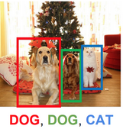
Figure 59: Object Detection of the object (animals), within an image

5.1.7.2 Image Processing
Image processing basically helps us extract information from an image or enhance an image; This is the name of the method used for it. It uses an input and an output, where the input is the image itself that you have identified, and the output is what you're identifying within the image. There is a process in which to follow to allow this to run properly. First, we must gather the data, which is the images and have them imported to CNN. Once we have that, we can allow it to change the image or simply analyze what is within it. Lastly, we get the results. This would include the changed image or the report in which we were identifying. Knowing all of this, we can properly understand that object detection is related to image processing.

5.1.7.3 Image Recognition
The goal of object detection is to be able to locate specific objects and then identify them within a video or image. This is a computer vision technique. This differs from image recognition because it is more specific and detailed. When using object detection, the program will put a box around the located object and a label on that box. Image recognition, on the other hand, only simply labels the image or video itself with the object name. Object detection basically takes image recognition to a whole other level. In doing so, it also allows for multiple objects to be identified within the same photo or video. To take that even further, it can keep track of and count the instances of those specific objects. So, to sum up, object detection is basically more precise and explicit than image recognition.
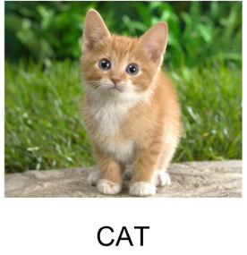
Figure 60: Image Recognition labeling the picture with the object identified within it

5.1.7.4 Segmentation
The closest related thing we have found to object detection is segmentation. Object detection is classifying specific object classes within an image, whereas segmentation is based on pixel classification. Object detection places a box around the class, but segmentation marks the pixels themselves, so it basically highlights the full shape of said class. Segmentation is a type of image processing that separates an image into different parts based on specific features. This has to do with machine learning because you can start the basis with segmentation and label the objects, then use the results for supervised and unsupervised training. There are also three different kinds of segmentation: instance segmentation, semantic segmentation, and panoptic segmentation.

5.1.7.4.1 Semantic Segmentation
Semantic segmentation takes the image as a whole, breaks it down into the individual pixels, and labels them with the corresponding class. This one is more specific than image recognition, because it does specify different classes within the image, and takes all classes into account. On the other hand, it is less specific than object detection because it does not indicate the various separate objects within the same class. Anything within the same class, would be considered one same entity. It groups them based on these categories. This type does include backgrounds, roads, etc. For example, if you have an image of a group of people standing in front of a building with trees on the side and the sky showing, semantic segmentation would break it into groups of the classes. The people would be highlighted the same color, the building would be highlighted in another color, the trees in the third color, and lastly whatever background would be another color.
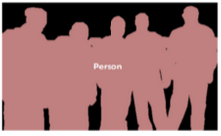
Figure 61: Semantic Segmentation of the image with the class, person, being identified

5.1.7.4.2 Instance Segmentation
This differs from semantic segmentation because instance takes it to another level. Instance segmentation is more closely related directly with object detection, but because it is more specific, it does use more memory to run. Instance segmentation does still break down the image into pixels, and does still specify the class within an image. This goes another step because it also indicates the separate objects within said class. Object detection puts a box around the separate objects, whereas instance segmentation highlights the different pixels of said objects. Now, instance segmentation does not take into consideration, backgrounds and what would be considered unaccountable regions of the photo, like semantic segmentation does. Unlike the above image, the below image identifies each person individually. In the previous example, it would identify each separate tree, person, and building, but not the sky, ground, or road.
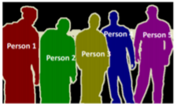
Figure 62: Instance Segmentation of the image with the class, person, being identified

5.1.7.4.3 Panoptic Segmentation
This is the last type of segmentation, and also the most specific. Panoptic basically combines both instance and semantic segmentation. This makes sense because it literally means viewing everything at once. It breaks down the pixels into the groups, clarifies individual objects for the group, and then puts it all together. It is the most detailed type of video or image processing that we will talk about. Panoptic segmentation labels the instances and the semantics of the image. This is what they call the semantic label and the instance ID. You would be able to identify the background pieces, but also how many people (or any other object) are in the image. You can even go a step further to break down and label, or number the various instances. For example, in the image below you can number each car one through four, or people one through 10.
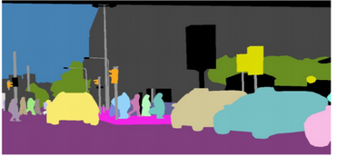
Figure 63: Panoptic Segmentation including the instance and semantic segmentation

5.1.8 Convolutional Neural Networks
To do object detection, we need a convolutional neural network (CNN). To properly choose which CNN we want to use for our project we have to understand what it is, what they do, which frameworks they work with, and why they are important. Once we learn about all of that, then we can determine which one is best used for object detection and begin implementing them.
We use CNN for image recognition by processing pixel data. It is an artificial intelligence that uses deep learning and machine learning to identify and describe what is being rendered. It does this by taking the original image (or inputted image), identifying the importance, or weight, of said image, and comparing those to other objects to determine which is of what class. CNN is usually compared to neurons of a human brain. This is because the neurons gather the external information, then work together to identify various things in our environment, within our visual view.
A CNN is more in depth than a regular neural network. This is because they have multiple layers by design, which in turn reduces processing requirements. These layers can consist of an input layer, output layer, convolutional layers in the hidden layers, and so on. In doing so, this makes the image recognition more efficient. Also, because this is considered an advancement in computer vision with deep learning that has taken time to construct and perfect, it has become natural language and image processing.
This is so important for our project with object detection because it basically puts the images through these relevant filters. The goal of them is to make our lives easier with the process while not forfeiting any data or predictions. It helps us understand the image better, depending on the size of the CNN we use. This is another aspect to keep in mind, the size. We do not want the model to be too small, in which we cannot gather enough data or specifications, because it would be less accurate. On the other hand, we do not want the model to be too large because then it can take longer to run and more energy, even though it may give more results. It is important to find a good balance for this. That is important in anything with engineering, having a good trade off. Being too large would use too much power and be unrealistic for use, but we need to have enough data to gather predictions. This will be further discussed with the models for the CNN later down.

5.1.9 CNN Models
There are four main CNN models used for object detection or image processing. That includes ResNet, MobileNet, and TinyYOLO V3. In addition to that, there are various sizes for ResNet and MobileNet, as well as the single shot detector (SSD) object detection app included on. These architectures help the program run quickly and efficiently, which is why we use them for more advanced projects, like machine learning and AI. It is also important to know which GPU they are working with. Ours is a newer version, so we need to ensure the model we decide to use can give the best output with that.

5.1.9.1 Performance of Reliable Models on Jetson Nano
We decided to go with SSD MobileNet-V2 (300 x 300). This was the quickest one, but also, after additional research, probably the most accurate as well. As you can see from the performance table comparing models and other competitors with the use of these models, provided by NVIDIA, why we chose what we did. Keep in mind, DNR (did not run):
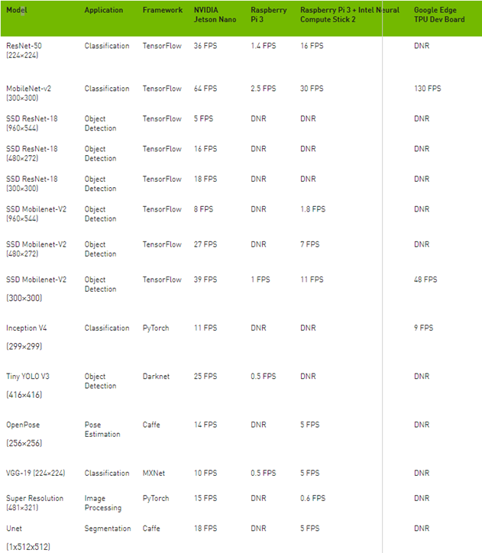
Table 26: Performance Table of Models compared to other competitors of the Jetson Nano

5.1.9.2 ResNet
This CNN was developed with deep neural networks in mind. The expectation being a lesser amount of lost data even with more layers within it. Normally (normal being with other CNN), at some point there are too many layers, in which proper communication lacks, and in turn takes longer to run and becomes less accurate. This CNN avoids that issue by ensuring there are some residuary connections between these layers. Because of this, this ResNet performs very well in any kind of project, even ones with much more fine details.
In the graph, we can see it has ResNet-50 used as the CNN alone in the first row, which is just the image classification. This one has 50 layers and uses the bottleneck design. This works so well because of the vanishing gradient effect. Using these things helps ensure that the performance of the network is optimal, even though there are many layers within it. If we look further in the graph, the SSD was only used with ResNet-18. This just means it was a smaller number of convolutional layers with the object detection as well. Although ResNet is great and accurate for extremely large projects, it is a slower CNN, as shown in the graph. Due to that, and us not needing an extremely large size, we decided against using ResNet for this project.

5.1.9.3 MobileNet
This CNN was initially proposed for TensorFlow as a computer vision model. It was made by Google and designed to be used for mobile devices or embedded systems. They are supposed to be very accurate, only use a small amount of power, and have a small margin of latency. It considers the restricted resources and constraints. For our data, we will specifically be referring to MobileNet-V2. This version is even faster and more accurate than its predecessor MobileNet-V1. It can be used for a series of machine learning projects, but we are going to focus on its usage with object detection. It starts with a 3x3 convolutional layer with 32 filters, but this CNN is a separable convolution. Basically, what this does is factor out the layers, to ensure the size and time to calculate is kept small. This is one of the things that MobileNet is known for. Doing so, helps its overall latency, and positively affects the accuracy. We felt this was the best image classification for this project, and paired with the SSD for object detection, would make it the superior option.

5.1.9.4 TinyYOLO V3
YOLO stands for You Only Look Once. It got the name because it only looks at the image one time which is considered an open-source method. This CNN works a bit differently than other object detection. In lay terms, it breaks the image into a series of bounding boxes, each that contain a confidence score regarding each class, to get the predictions.
Unlike ResNet or MobileNet, TinyYOLO does not need an additional app for object detection, it does it on its own. This CNN uses an extractor, called Darknet, that has also been made compatible with TensorFlow. YOLO is known for working very quickly and excels in more general images and artwork. Although, it is still less accurate than the SSD. This is a good object detection if used for smaller, fewer specific projects.

5.1.9.5 Single Shot Detector
The single shot detector gets the name because it uses the CNN on the image one time, and from there it can make a feature map. Although YOLO alone runs faster than SSD, SSD is slightly more accurate. This, of course, is dependent on the overall size of the object we are working with. If the object is too small the accuracy of the SSD goes down. Like YOLO it does use bounding boxes but uses that with the convolutional layers and aspect ratios.
As with anything, there are pros and cons to this method. Some positive aspects are as follows. SSD only uses one single network; this helps keep everything uniform with less latency. Also, it works well with image detection components, meaning we can use it with ResNet or MobileNet, as shown in the graph. Lastly, it has extremely good accuracy and speed in comparison to other object detection models. Not quite as fast as TinyYOLO, alone, but matched with MobileNet and the use of all the convolutional layers, it is. Between the speed and accuracy, those are two large factors that helped us come to the decision to use the SSD MobileNet-V2 model for our project.

5.1.10 Autonomous Feature
An added goal to this project is for us to make the option for fully autonomous tanks. Here is the breakdown of everything we would like the tank to be able to do on its own, based on the programming by the end of the project. Because it is initially going to be controlled with a remote control, it should learn how to move and react on its own. The tank should know how to move forward, forward-left, forward-right, right, left, backward, backward-left, and backward-right, just as we would be able to command it to do so on the phone. Additionally, it should be able to move its turret autonomously. This includes counterclockwise, clockwise, and up and down with a max of +10 and -10 degrees with precision. The tank has two tracks, a right and a left. It needs to be able to determine and learn that moving the left tread will take it one way and the right tread another way. Additionally, it needs to also know that moving both treads at the same will make it move straight forward and back. Lastly, moving them both but at different speeds can lead to turning. Taking this a step further, because we are doing object detection, it should be able to make specific moves based on what it is seeing through the camera. There are two cameras on the TANKs. There are multiple cameras on the top that are used to read any enemies and allies, and there is a tank barrel with a camera on it. This is where the object detection comes into play. Using the camera on the top, the TANK would need to first determine if they are identifying an ally or an enemy (which is the other tank). If it detects the enemy, two things should happen. First, it should attempt to maneuver itself out of range of fire, so that it does not get shot. Second, it should automatically take aim, and fire at the enemy tank. This should only be an available option to the tank when the object detection identifies the other tank in its view. Now, if it detects an ally, like a civilian, it should not engage. We aim to take this just one step further by having obstacle avoidance. Doing this will not only let the tank leave the allies alone, but also continue moving on its way around them. This would go for civilians, buildings, or anything else that seems to be in the way of the TANK.
UPDATE:
Without a robust system, we were not able to create an autonomous feature for our tanks. This became a very devastating blow to our project because we weren't able to acquire the right hardware due to how expensive the upgrades were.

5.2 Hardware Design Details
In this section, we will discuss the design specifications for the different printed circuit boards that we will be using. This includes the power circuitry, development board and bluetooth transceiver circuitry.

5.2.1 Power Flow Diagram
We designed our power design to have two identical 5 V, 3 A power banks that will be connected in series. This series connection will sum the voltages of each power bank. This can be seen in Figure 57 where the voltage of the first power bank combines with the voltage of power bank 2. This signal is then input into the TPS55288 DC - DC Converter. The signal is then regulated back to a 5 V voltage output and a 3 A current output. This newly converted power signal is then fed directly into the Nvidia Jetson Nano board via a USB type C connector. The Jetson Nano Development Board will then distribute the current to each of the necessary peripherals through the onboard GPIO pins. The power and current regulation for each peripheral will be handled internally by the development board. This will be done by changing the mode for individual pins that do not have fixed values to reflect the needed voltage. However, most of the pins will come with fixed voltages that already reflect their applications such as the camera connection.
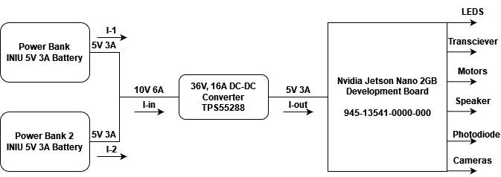
FIGURE 64: Power Flow Diagram with DC - DC Conversion

5.2.2 Webench Power Designer
Texas Instruments Webench Power Designer is an online tool designed by Texas Instruments that is used to provide power designs. The tool works by inserting your minimum and maximum source voltage and your desired minimum and maximum output voltage. You also need to specify your desired output current. You also have the option to input advance specifications for the input and output such as nominal input voltage, nominal output voltage and output voltage maximum ripple percentage. The tool then allows you to choose a design type. The four choices are Low Cost, High Efficiency,Small Footprint and Balances. If necessary, you can also input additional design parameters such as maximum component height, soft start time, minimum package size and more. Once you input all of your desired design specifications, the tool provides you with multiple designs that meet your needs.

5.2.3 DC - DC Conversion
We are using the mentioned design tool with the idea that we are using two 5V power supplies with 3 A current ratings. When selecting the design, we chose a design with the highest efficiency possible. The design we chose was to hook up the two power sources in series. This would give us an input voltage range from 5 V to 10 V. The minimum of 5 V would be when one battery pack is still supplying power, but the other battery pack is dead. Alternatively, when both power packs are supplying 5 V, we have a total of 10 V input. For the Texas Instrument Power Designer Tool, we input 5 V as the output voltage. This is because, on the part specifications page for the Jetson Nano 2 GB Development Board, the minimum required voltage to continue operation of the board is 4.25 V. If the input voltage for the development board drops below 4.25 V, the device will power down. Nvidia, the developer of the Jetson Nano, recommends that the input voltage for the board is 5 V. They also recommend that the input current of the power supply is 3 A. Therefore in the power circuit tool, we put 3 A as the output voltage.

5.2.3.1 TPS55288
For the circuits that were offered through the Texas Instruments Webench Power Designer, we chose the circuit that optimized power efficiency the most. This circuit uses the Texas Instruments TPS55288 Buck Boost Converter. The circuit topology that we chose was a buck boost design that would allow our input voltage to be 2.7 V to 36 V. This DC input signal would then be converted to a similar DC output signal with a range of 0.8 V to 22 V. This is more than enough variation in our power conversion circuit. Seeing as we only need a constant 5 V and a current anywhere between 2 A and 3 A, this circuit provides plenty of options. The circuit comes with a power efficiency rating of 97%. This means that in ideal situations, our DC to DC conversion circuit would only lose 3% of the total power during operation. The components for the design will cost us roughly $8 and take up roughly 609 ${mm}^{2}$ of printed circuit board space. Below, you can also see a part layout of the chosen circuit. All of the components that went into this design can be found in the Appendix in Table AA 4.1. The design below is split into two different images for viewing purposes. Vin in this circuit represents the series input of the two 5V power banks. Vout will be a regulated combination of the two 5V signals back into a 5V signal.
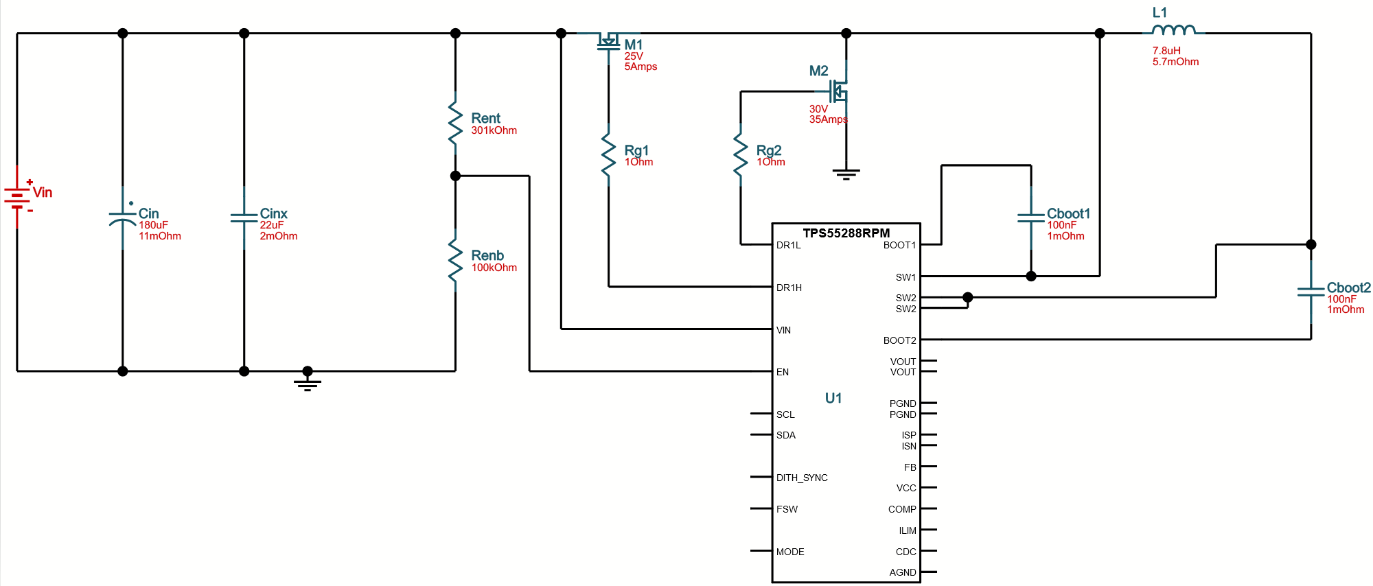
Figure 65.1: TPS55288RPM Circuit (1 of 2) (Vin = 10V, Vout = 5V, Iout = 3A)

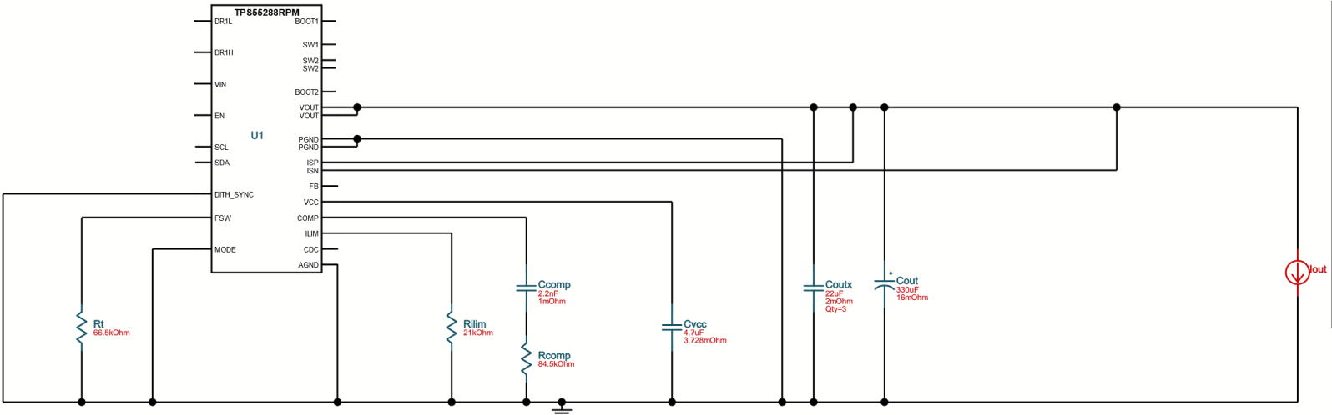
Figure 65.2: TPS55288RPM Circuit (2 of 2) (Vin = 10V, Vout = 5V, Iout = 3A)

Part Number | Description | Vin | Vout | Iout | Efficiency | BOM Count | Cost | FootPrint
TPS55288 | 36V, 16-A Buck-Boost Converter with I2C Interface | 10V | 5V | 3A | 97% | 21 | $7.86 | 609 mm^2
Table 27: DC-DC Circuit Design Parameters
UPDATE:
Due to unavailability in electrical components, we were unable to use the designed dc-dc conversion circuits shown above. Instead we designed new power conversion circuits using the LTpowerCAD II software. This software allowed us to input the parameters we desired for the design and select an appropriate circuit. It also recommended components that would work in each place in the circuit. These new circuits are shown below.
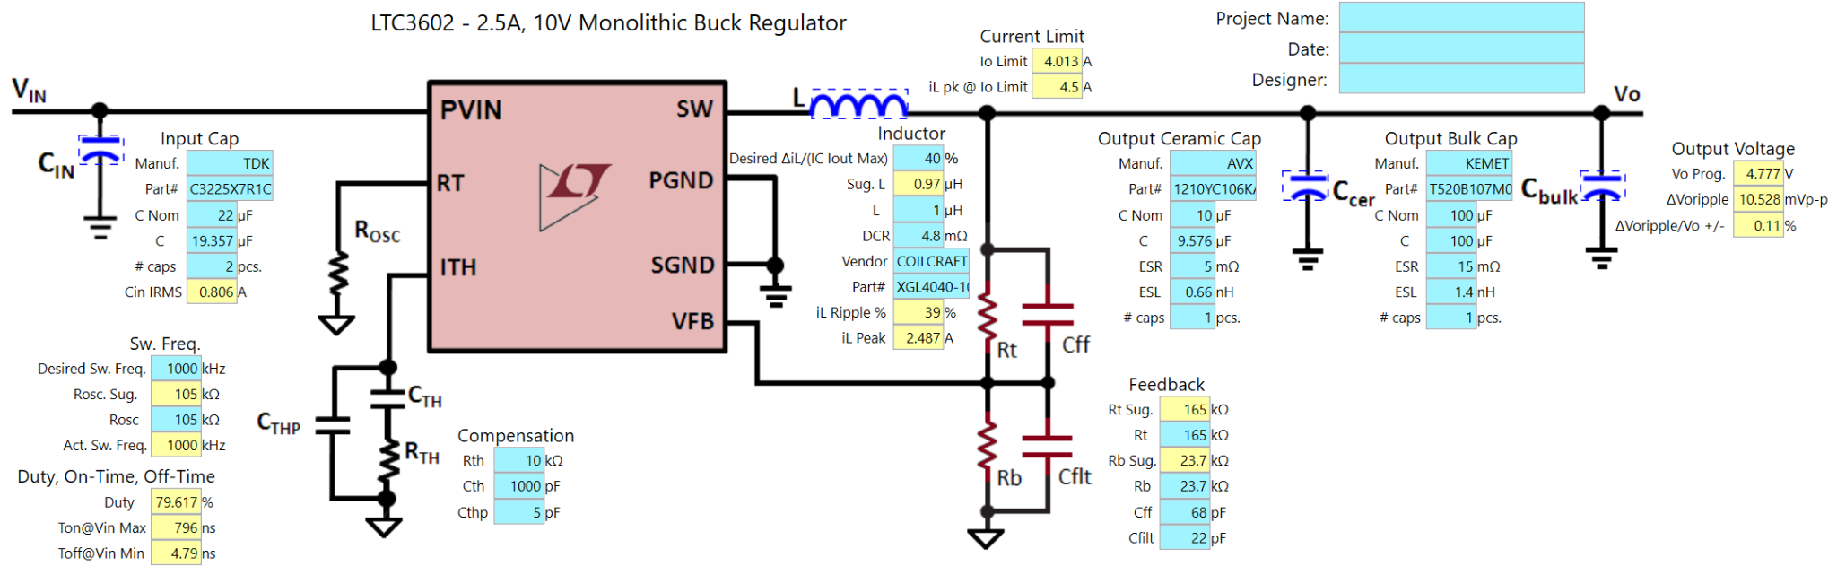
Figure 66: Barrel Elevation Power Circuit

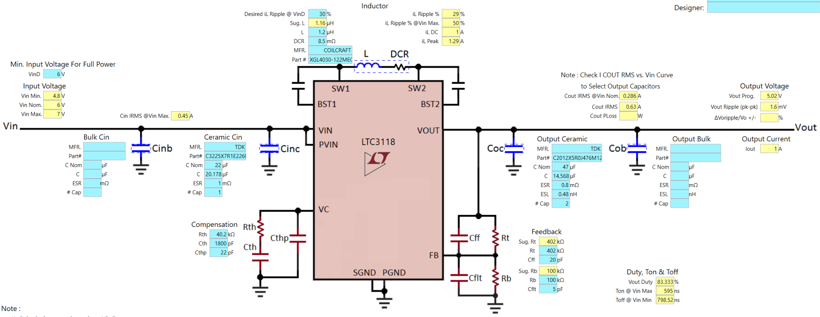
Figure 67: BMSP430 Power Circuit
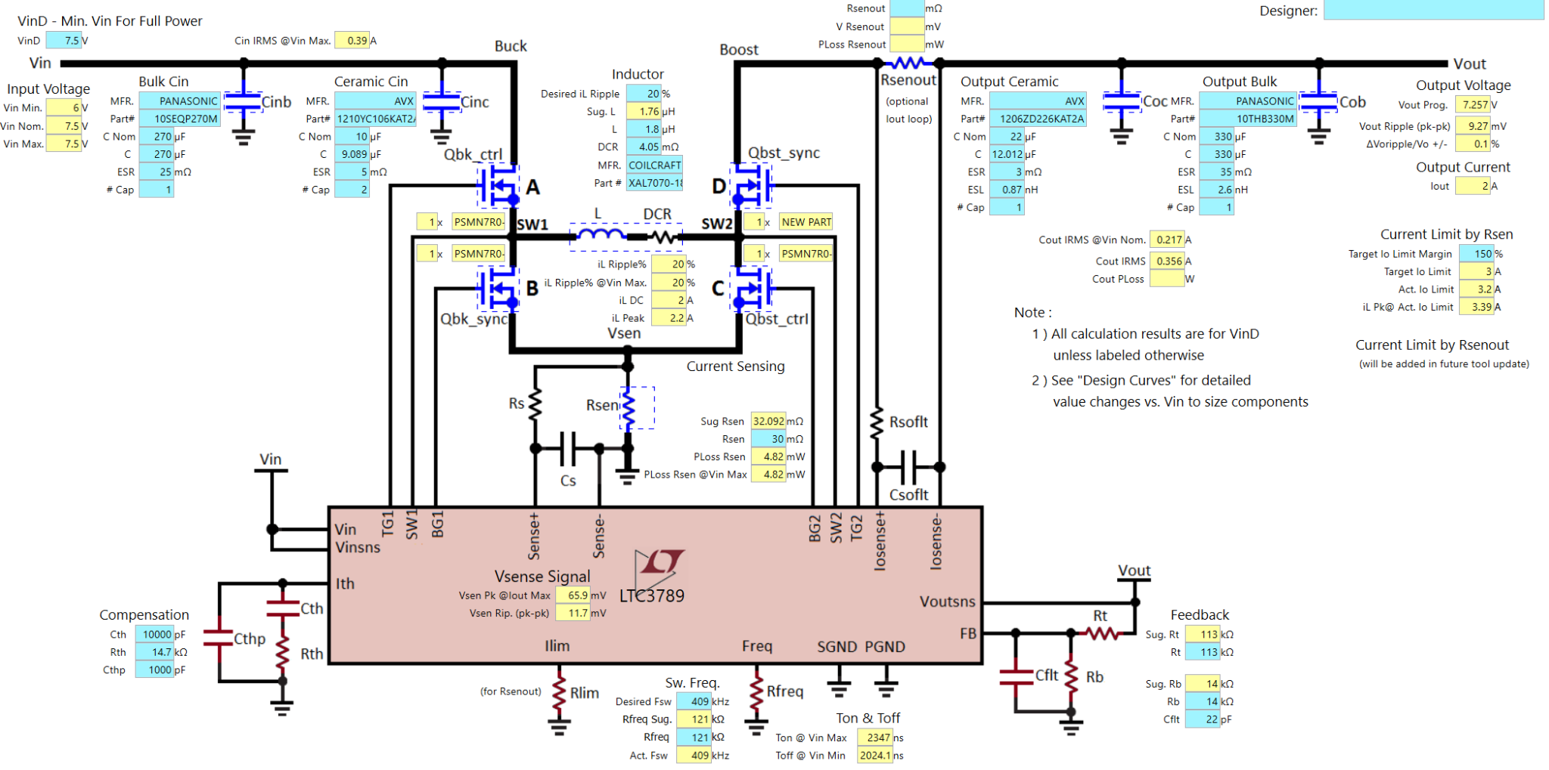
Figure 68: Turret Rotation Power Circuit
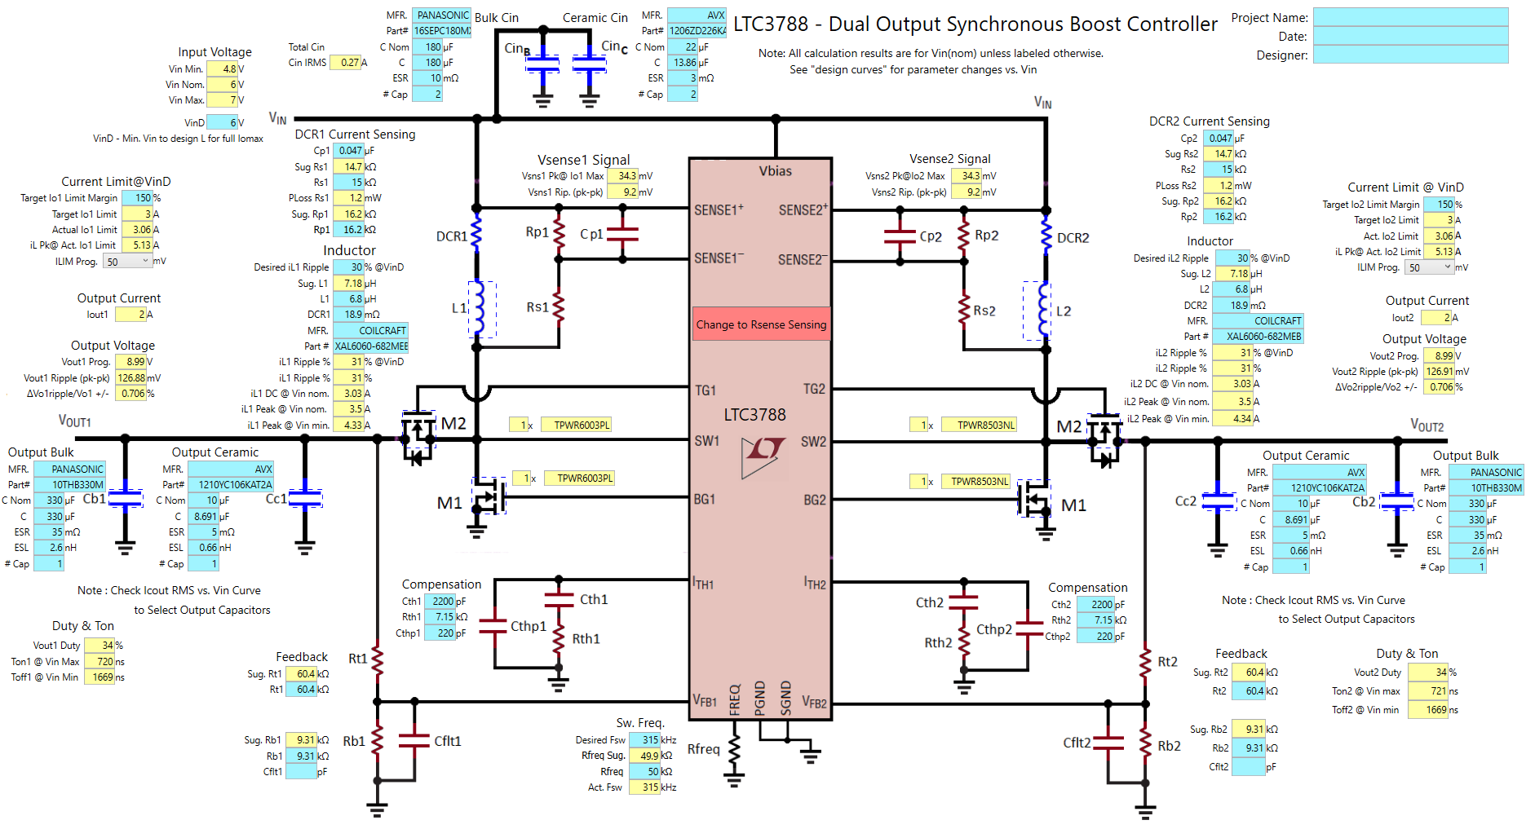
Figure 69: Tank Treads Power Circuit

Due to the Turret rotation motor being changed and some coding struggles using PWM signals from the msp430. We opted not to use these sections of the printed circuit board. Instead we powered all of the components directly from batteries. This allowed us to easily vary the voltage to certain components to achieve the ideal rotational speed of our motors. The DC motors were used in conjunction with the Qunqi L298N H-Bridge Motor Driver Controllers. These controllers were a good solution to our PWM coding issue as we vary and invert the voltages at each terminal on the controller using digital signals from the MSP430. This gave us full control of each DC motor.
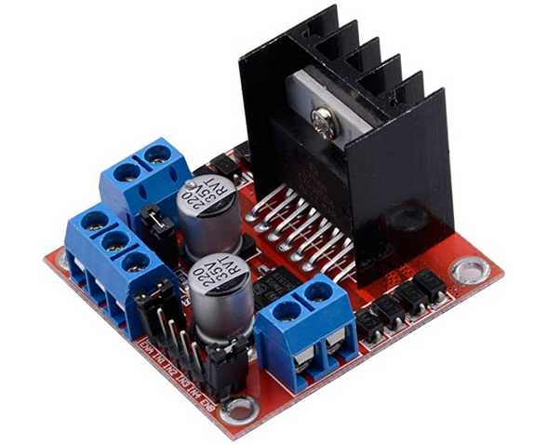
Figure 70: Qunqi H-Bridge Motor Controller

6 Testing
This section serves to provide information on features of Photo-TANKS that our team was able to prototype and test during our time in Senior Design 1. Over the evolution of our project, a considerable amount of time of the semester was dedicated to brainstorming the possibilities of features Photo-TANKS could have. Then narrowing them down into a list of attainable objectives. Following, a large remainder of time was dedicated to part research and selection, ensuring that every part selected was compatible with one another and conducting further research whenever unplanned implications hindered what our team thought could be possible. By the time that our team was in a comfortable position to begin ordering our parts to start with prototype testing, there were only a few weeks left in the semester.

Viewing Photo-TANKS as being divided into two major sections, being the target identification feature and the target acquisition feature, our team focused on prototyping the target identification feature. Within our time constraints, this feature was much more attainable to test. Comparatively, the target acquisition feature will require an extensive amount of coding and machine learning before our team can properly test for functionality and make improvements. A task our team plans to tackle over the course of Senior Design 2.

6.1 Phototransistor Testing with ADC converter on a MSP430FR6989
When trying to figure out how to communicate with our phototransistor the first thing that popped into mind was, we will need an ADC converter (Analog to Digital Converter). After this realization, we also felt the need to be able to display what we got from our readings. We figured having something simple like reading it to the console so we can verify that the process was working. To do so, we confirmed that UART (Universal Asynchronous Receiver-Transmitter) could be used. Remembering back to Embedded Systems we realized that we used a similar board with all the bells and whistles we needed to make the process work for validating our tests. This helped us conclude to use the MSP430FR6989 board.

6.1.1 MSP430FR6989 Schematic
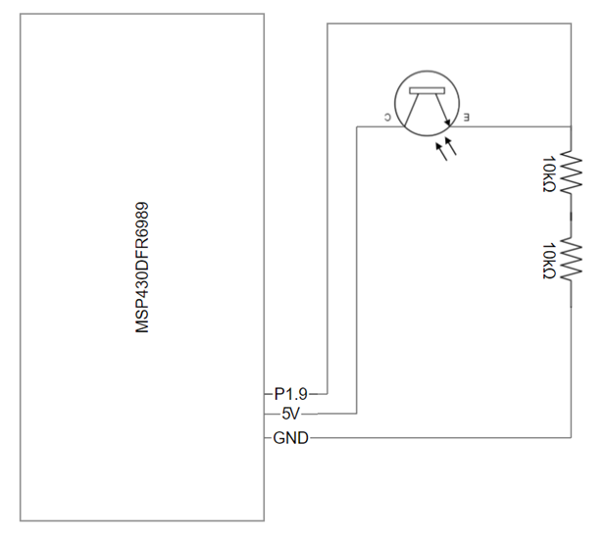
Figure 71: Phototransistor Test Design
As you can see from the above schematic design, we have P1.9 for the ADC converter to read, 5 V for power to the phototransistor, and GND for ground to complete the circuit.

6.1.2 Code for Testing
Most of the work in the code from Appendix AA3 was put into initializing our ADC and UART. Once we got those operational it was smooth sailing. As you can see from the code, we made it where we can modify the values we were expecting from the ADC converter depending on the power transmitted from the phototransistor. When sitting idle we got a reading of 0.5 V - 0.7 V, but when the laser was cranked up, we usually sat right below 3.1 V since the pin itself could only receive a maximum of 3.3 V. This code helped us get a better understanding of how much power or laser needed and how sensitive our phototransistors were.

6.2 Laser Diode and Lens Testing
The primary link of communication between the two tanks of our project is the laser diode mounted within Photo-TANKS barrel. Being the method used in order to perform the process of target identification via identification code, as well as engage in combat with the opposition. In order for the operator to be able to accurately hit the other tank’s phototransistors at any range, the laser beam from the diode needs to be well focused and remain collimated for an extended period, ideally infinity. Effectively, the beam waist of the laser diode needs to remain at a minimum for the ranges our team proposed or greater. To test this, our team utilized equipment in CREOL’s laboratory to conduct tests with lenses to find what arrangement provided the best results. Below are images and a summary from the setup that provided such that.

The setup below in Figure 65 consists of a Newport M-20X objective lens with a focal length of nine millimeters paired with a Thorlabs HL6544FM laser diode mounted in a temperature control laser diode module. The position of the objective lens was first adjusted until a clean and focused beam spot was cast onto a screen only a short distance away. Following, in order to ensure that the laser beam had a low beam waist, the screen was then relocated as far as possible away from the setup. Then, the position of the objective lens was once again adjusted until a clean and focused beam spot was cast. Now in this configuration, the laser diode’s beam was operating with little dispersion and remaining as a collimated beam of focused light.

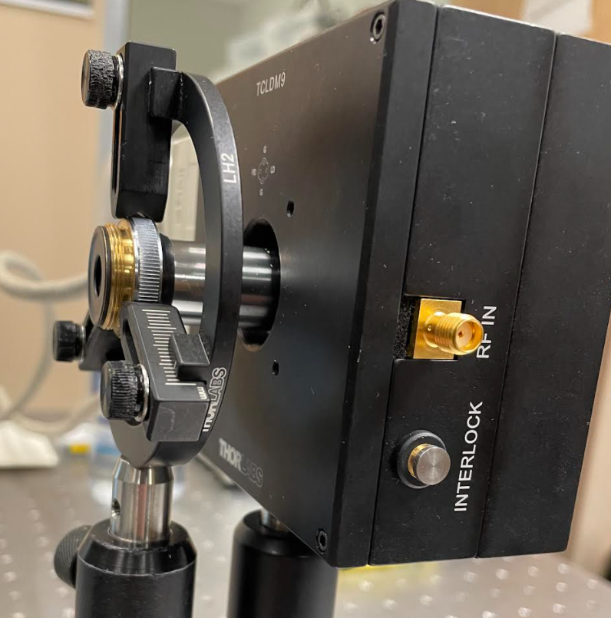
Figure 72: 20x Objective Microscope Positioned Near the Laser Diode

Following are images of the laser’s beam spot at different intervals of distance. What is to take notice is the lack of disparity between the beam spots. Effectively, this demonstrates that our laser beam is operating within a window of minimum beam waist. The maximum distance available for testing purposes was along the lines of about eleven feet. This was able to be extended to the laboratory’s wall; however, a proper measurement of this distance proved to be challenging due to equipment in the room and other people’s belongings.

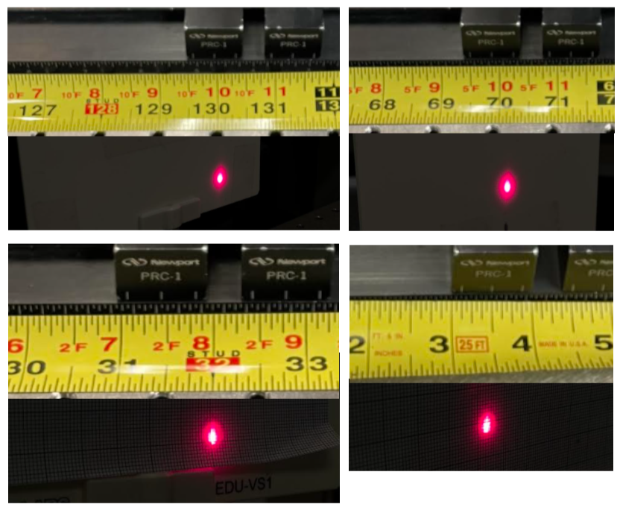
Figure 73: Beam Spot Images Compared to Relative Distance

As seen in Figure 66, the size of the beam spot remains overall unchanged compared to the distance it is at. Looking at the top left image, the laser beam spot can be seen located at 129.5 inches away from the end of the microscope objective. Comparatively, the image on the bottom right shows the beam spot located only three inches away from the end of the microscope objective. It can be seen that distances between these two points maintain a focused beam. Additionally, when the laser was cast onto the wall of the laboratory, the beam spot remained unchanged, an estimation of this distance was about fifteen feet, or 180 inches. Being that fifteen feet is nearly half of the distance our team’s proposed for the minimum beam waist to maintain, with further fine tuned adjustments in the final product of our project, a minimum beam waist equal to or greater than ten meters should be achievable. While the plano-convex lens our team selected should be capable of creating similar results as demonstrated with the 20x objective lens, we will keep it in consideration to change our course of action and order objective lenses if issues arise with our plano-convex lens.

6.3 Target Identification and Hit Detection Testing
When Photo-TANKS’s laser is operating in the low power mode, the laser beam cast is a continuous beam. Upon incidence of the phototransistors, current is produced which then can be used to produce a voltage. This voltage is interpreted by the microcontroller and the tank’s identification signal gets broadcast. Likely, when Photo-TANKS’s laser is operating in the high power mode, the laser beam casts a high power pulse. Generating a larger current from the phototransistor, the voltage interpreted by the microcontroller becomes decided as a hit.

To test this feature, our team was able to utilize the phototransistors that we selected for our project. However, due to our laser diode not being scheduled to arrive in time, we had to make due with testing the setup using the same equipment borrowed from CREOL’s laboratory. This was not much of an issue though since our phototransistors are still highly responsive to the laser diode our team had lended.

Imaged below in Figure 67 is a picture of the microcontroller and breadboard circuit used in the testing setup. Out of frame is the phototransistor being held in a mount along the optical rail. An important thing to note is the voltage across the first resistor is being measured to not exceed 3.5 V or else we would permanently damage the microcontroller. Following is an image displaying the phototransistor mounted along the optical rail and being illuminated by the laser diode.

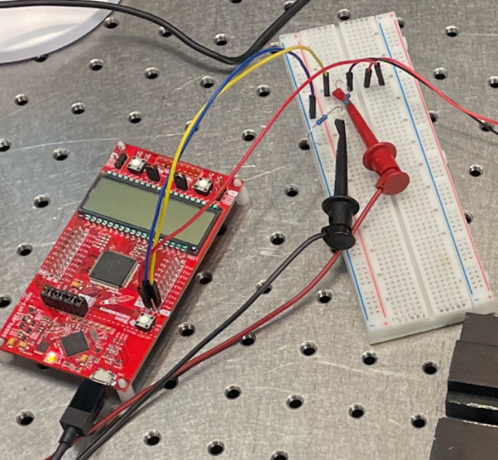
Figure 74: Microcontroller and Breadboard Circuit

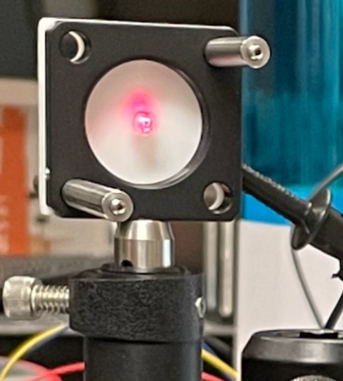
Figure 75: Mounted Phototransistor

Upon testing, it was discovered that the ranges of current needed to be input into the laser diode for identification messages to start to be transmitted occurred from 65 mA - 70 mA. Once the input current was increased beyond 70 mA, hit detection messages would begin to be displayed. The corresponding voltages across the first resistor can be seen below in Figure 69. With these results, our team noticed the need to broaden the window for identification messages to occur come the final product of our project. We want the transceiver to broadcast the vehicle identification code almost immediately and even if the phototransistor is partially illuminated. This would also allow for us to be able to edit where the threshold for hit detections to occur. As seen in Figure 69, the voltage across the resistor while the laser diode was operating at a higher power was 2.47 V. While there is still room before any damage to the microcontroller is possible, we are beginning to get close to our boundary of 3.5 V.

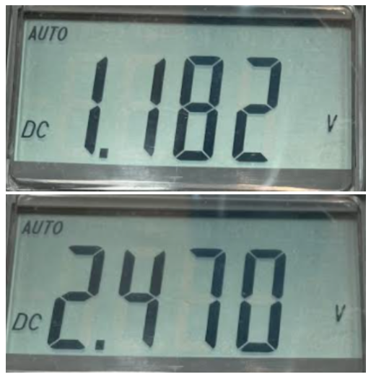
Figure 76: Voltage Across First Resistor, Low Power (top), High Power (bottom)

Lastly, imaged below are the terminal outputs while the laser diode was incident upon the phototransistor while operating in low power, and in high power.

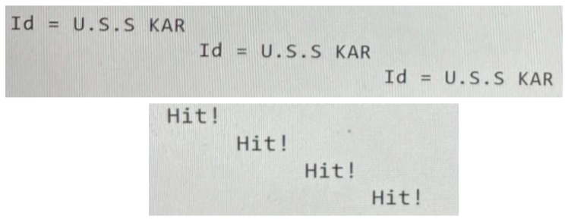
Figure 77: Terminal Outputs While Operating in Low Power (top) and High Power (bottom)

7 Administration
This section contains the estimated and total cost of two Photo-TANKS, the work distributions between each of the members, the projected milestones for at least Sd1, and the current progress of Photo-TANKS.

7.1 Estimated Project Budget
Below is a table showing off nearly all the parts and quantity of parts. Also it shows the cost of Photo-TANKS, both estimated and total.
Description | Quantity | Estimated Cost | Total Cost (Estimated) | Total Cost (Actual)
Tank Treads | 2 | $75 | $150 | $150
Microcontrollers | 2 | $15 | $30 | ~$40
Slip-ring | 2 | - | ~$20 | ~$20
LEDs | 2 | $6 | $12 | $16
Lens | 2 | $5 | $10 | $40
Phototransistors | 30 | $1 | $30 | $14.70
Motors | 6 | $20 | $120 | $60
Cameras | 4 | $40 | $80 | ~$198
PCB | 2 | $50 | $100 | ~$100
Sound Card & Speaker | 2 | - | $25.79 | $25.79
Bluetooth transceiver | 2 | $12 | $24 | $15.02
Jetson Nano 2GB | 2 | $60 | $120 | $120
Total Cost |  | $284 | $656 | $799.51
Table 28: Photo-TANKS Cost Analysis
The current cost analysis is based on how many components we believe we need to complete our current core objectives. These components do not reflect the components needed to satisfy our stretch goals. Our ideal budget for two tanks is $2000, or $1000 for one tank. Currently all the core objectives priced out, we are well below our decided limit. Some additional components that would be added to achieve our stretch goals would be LiDAR sensors and 360° cameras to aid in the LiDAR detection system. Table 27 does not include basic components like the batteries from Section 3, and electronic components like resistors or capacitors.
Update: After some changes, like deciding to only use one tank and getting/using other parts, we have decided to add a second table, with the new components chosen, their prices, amount needed, and the overall total.

Items | Quantity | Cost |  | Items | Quantity | Cost
Turret Motor | 1 | $14.99 |  | Tank Treads | 2* | $150
Barrel Motor | 1 | $9.95 |  | Laser Diode | 1 | $25.21
Motor Driver Controller | 2 | $13.98 |  | Constant  Current Driver | 1 | $38.95
Charmast Power Pack | 1 | $19.49 |  | Evaluation Board for Laser Diode | 1 | $136.43
ICR-18650K | 2 | $10 |  | Lens | 1 | $63.55
Alkaline-Batteries | 20* | $18 |  | Phototransistors | 30* | $14.70
Barrel Cameras | 1 | $80
PCB | 1 | $100
Bluetooth transceiver | 1 | $7.51
Jetson Nano 2GB | 1 | $60
Total Cost |  | $333.92 |  | Total Cost |  | $428.84
FInal Cost |  |  |  | $762.76
Table 29, Final cost of End of Project
We needed to change some parts throughout this project, so we needed a new table to compare what we first thought we needed to what we truly needed in the end.

7.2 Work Distribution
The tasks below have been divided up based on what type of engineer each member is, and based on what each member wanted to do. The tasks have been color-coded for each member plus the group itself. While each task is labeled for one person, other members are allowed to help out in order to fulfill the requirements for Photo-TANKS.
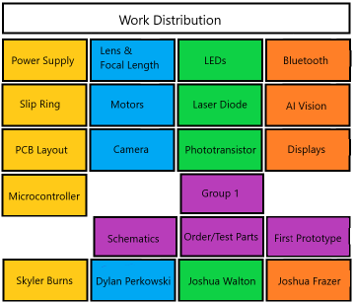
Figure 78: Task Assignment Chart

7.3 Project Milestones
Below is a table that shows the current progress of Photo-TANKS. Which helps to see everything that has been done for Photo-TANKS and once everything is ordered and tested, then the prototyping can happen.
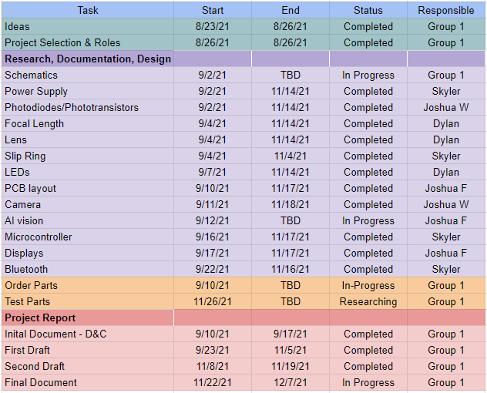
Table 30: Project Milestones, Senior Design 1
Update: Going into Senior Design 2, we needed new milestones, and ample time to complete it. Is what we want to say, but what really happened was finishing everything in a week, and finishing right before it was due, most of the time.
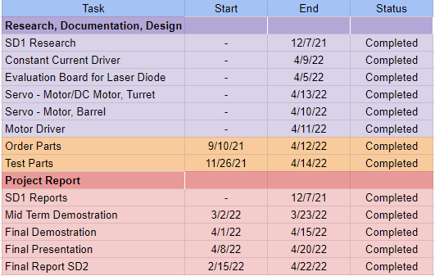
Table 31, Final Milestones, Senior Design 2

7.4 Progress
As for the requirements presented by Senior Design 1, our team is up-to-date with our progress and have completed any necessary planning, research, and part selection. We have carried out some prototype testing with equipment we have available and with parts that we have ordered. Successfully, we were able to create a working prototype for Photo-TANKS unique vehicle identification code feature as well as a hit detection system. Further, we were able to conduct testing research for the laser diode and lens setup. What lies ahead for us is Senior Design 2 where the entirety of our project will take shape and be completed.
Update: Currently, Photo-TANKS is finished, it can move the treads, body, and barrel. Also, it can detect objects with predefined images and through the use of the Laser Diode and Phototransistors we could identify allies and enemies but not fully. What we wanted to do was use unique codes for the tanks, but we only did one tank so the unique codes are not really needed, so it became a proof-of-concept.
Some of the other ideas we had just could not work, like AI functions, better object detection due to low memory of the Jetson Nano. We wanted to have two tanks, but due to financial decisions and breaking/burning out some of the parts, we had to only make one.

7.5 Owner’s Manual
Update: When using Photo-TANKS, there is not that much for controlling it or changing out some parts, with exception of the parts inside the shell. For changing parts, the outside ones are easy, it is just taking them off the stand then replacing them, both the various components and the batteries.
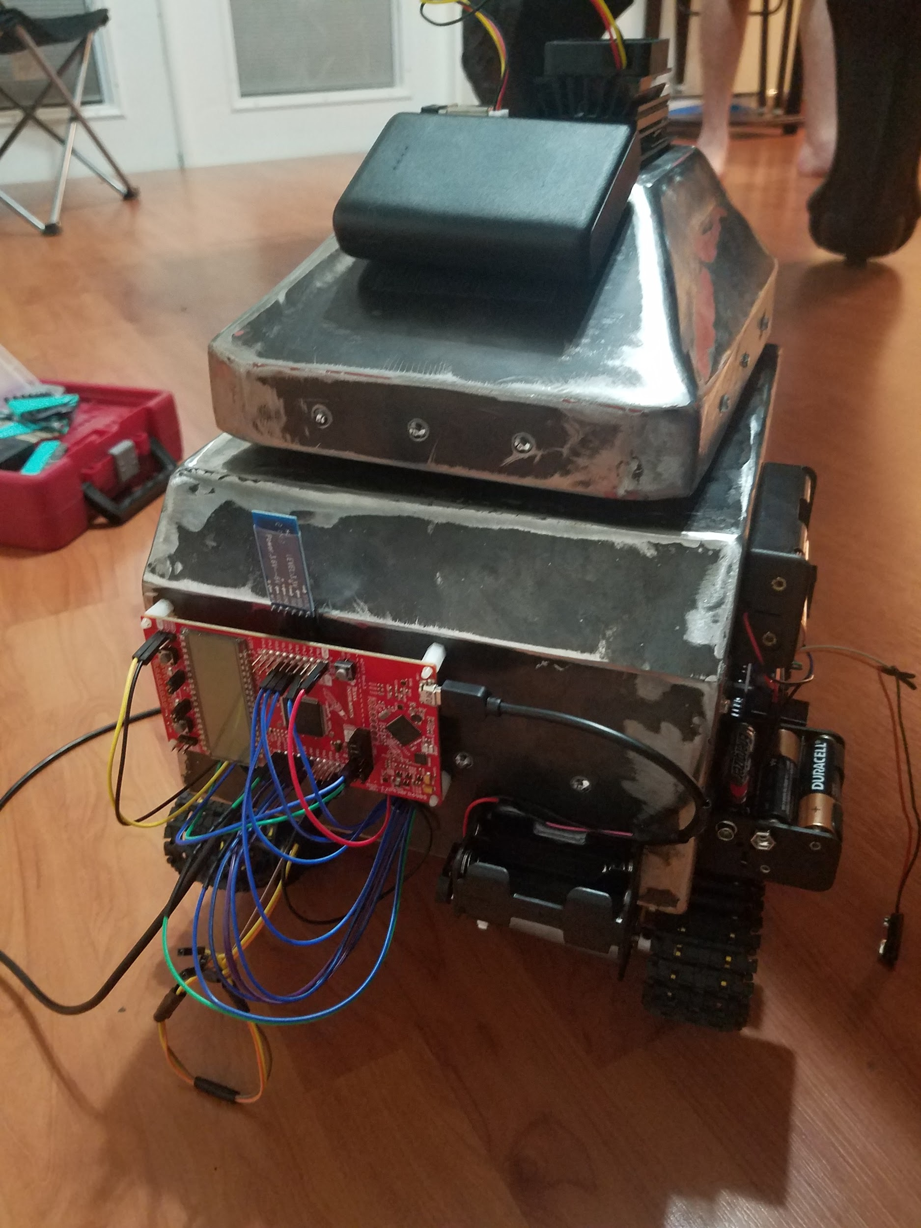
Figure 79, Outside of Photo-TANKS
For the inside parts, there are wires connecting from the breadboard we used, to various components in the body and turret, so it would be best to not disconnect any wires. If something in the turret needs to be replaced, the treads should be removed, the connectors should also be removed via unscrewing them, the motor connected to the connectors should also be removed before attempting to change anything in the turret, and any wires should not be messed with. For the body, just disconnect the treads, the connectors and the inside motor should be fine, unless they are the problem and remove them properly as previously mentioned.
Controlling Photo-TANKS is easy, you connect the Jetson Nano to a/your specific IP address (if you are using the code that our Computer Science Engineer made), then you would be able to move the tank’s treads with the left joystick, move the turret by using the x-axis of the right joystick and move the barrel with the y-axis of the right joystick. You would be able to see and detect objects if a camera is equipped with the Jetson Nano, and fire the laser at high power if the firing mechanic worked.

8 Conclusion
Blossoming from the idea of tank laser tag, to growing into a proof of concept design for target identification and acquisition for real world military application, Photo-TANKS has gone through quite a journey. And the path it took along that evolution seemed to come quite naturally and fluidly. From the beginning our team had an equal amount of excitement for the project and inspiration to turn it into something greater was rather trouble-free. Given the time period we live in and how advanced modern technology is, one would think that the military would already have deployed systems similar to Photo-TANKS. While there are technologies in existence for target acquisition systems as discussed in Ai/ATR, to our surprise, no unclassified information seems to point at these systems being used extensively in the field. Likely, it was to our team’s surprise that the United States military discontinued the use of the BCIS. Understandably, the price for each unit was quite expensive, but no unclassified information seems to point at any system that replaced it. While our team knew that we would not exactly be able to develop an entire system that could be used for the military given our time and budget constraints, we had the desire to design and build something that could prove to be of use.

Even though Photo-TANKS evolution came fairly naturally, there were still a handful of challenges our team had to overcome. Originally, we were a little overambitious with our aspirations. It was rather easy to be, because while we were conducting research it felt like every time we turned over a new stone we would find new inspiration for another feature for our project. Overtime though we honed in on our core goals and objectives and really gained some traction. Making sure every component was compatible with one another was the next big challenge. While some of the hardware was not too difficult to make sure of that, such as matching the spectral responsivity of our phototransistors with our laser diode, other components were not as simple. Since our team plans on using the Jetson Nano AI Kit for the brains of our artificial intelligence, we had to make sure that anything connected with that would work. This really limited our market of parts available and sometimes we had to make sacrifices because the better part was just too expensive. The largest challenge our team had to overcome showed up when we discovered the difficulties of using a singular 360° camera for our target acquisition system. Limited by cameras available that were compatible with the Jetson Nano, the ones available on the market were extremely expensive. Essentially, our team had to go back to the drawing board and completely redesign that system. A task that turned out to be far more challenging said than done. The solution of using multiple cameras was clear, but how was the question. No one on our team was familiar with how video stitching worked or how it could be done. Not to mention that the video needed to be a live feed with as minimal latency as possible for the AI to make decisions from and relay that information to Photo-TANKS operator. We almost thought we had to change from using the Jetson Nano and end up having to redesign other features because it was not explicit whether or not we could connect that many cameras to it. In the end we persevered though, finding an adapter that we could use for the Jetson Nano and figuring out a way that we can teach the AI where the camera’s boundaries overlap without the need for stitching.

Not to mention all the possible constraints and standards that our team has to follow for Photo-TANKS so that we can lessen the potential faults from being on a time limit, budget limit, etc. And, preventing other potential faults that might occur by soldering correctly, following proper laser safety and lens handling, etc.

At the end of the day, our team selected this project because we wanted to challenge ourselves and put the skills we have been learning in our respective disciplines to the test. Each one of us wants to prove our knowledge, but most importantly each one of us wants to design and build a project that we are proud of. Photo-TANKS is just that. The journey of Senior Design 1 has put us through our paces, it has made us think critically and like true engineers, learn how to overcome challenges, and has broadened our knowledge into other disciplines. But we have had a great time doing it and we are beyond excited to bring Photo-TANKS into life during Senior Design 2 next semester.

Update: From the start of Senior Design 1 to the end of Senior Design 2, Photo-TANKS changed very much. At first, we wanted AI controlled tanks, two tanks that could essentially fight each other by laser usage from the Laser Diode and Phototransistors. We wanted a health system, sounds, controlled firing system, and so much more. But, due to time limitations, financing, and only having one Computer Engineer, we had to scrap a good amount to at least make something in the end.

The completed version of Photo-TANKS is something that we are proud about, but sometimes we wished we were able to add some of the scrapped content. The sound system would have been great for cosmetics, health for if we had two tanks and for the “game” that we wanted to do, and the controlled firing system also for the “game”.

This project was a great decision to show off all of our skills, since it had a great variation of all 3 Majors we are in plus Mechanical Engineering. And it showed who would take charge the further we went into the semester. Photo-TANKS was great, but there are many flaws. We believe that if another group was allowed to continue to work on this, it could get to even higher heights.

Appendix A: References

AA1: Main Tank Specifications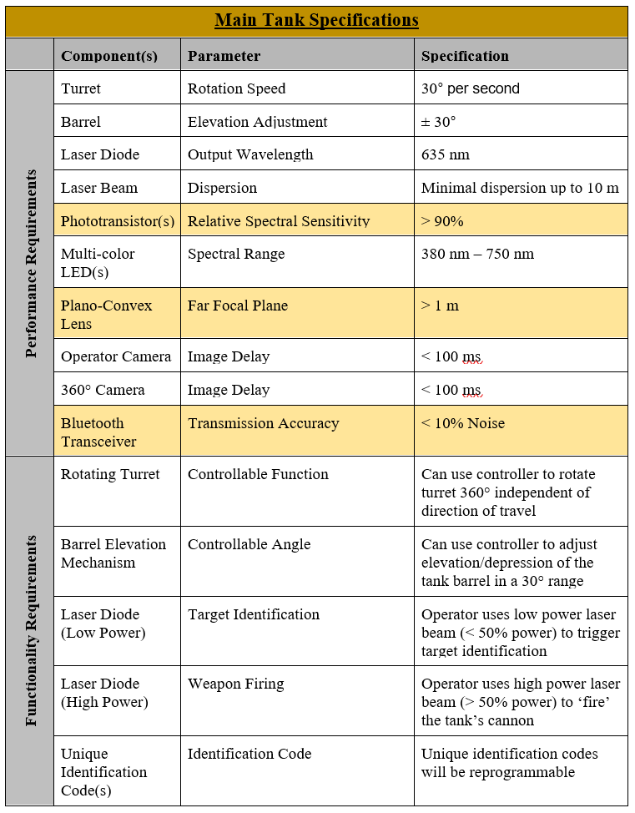
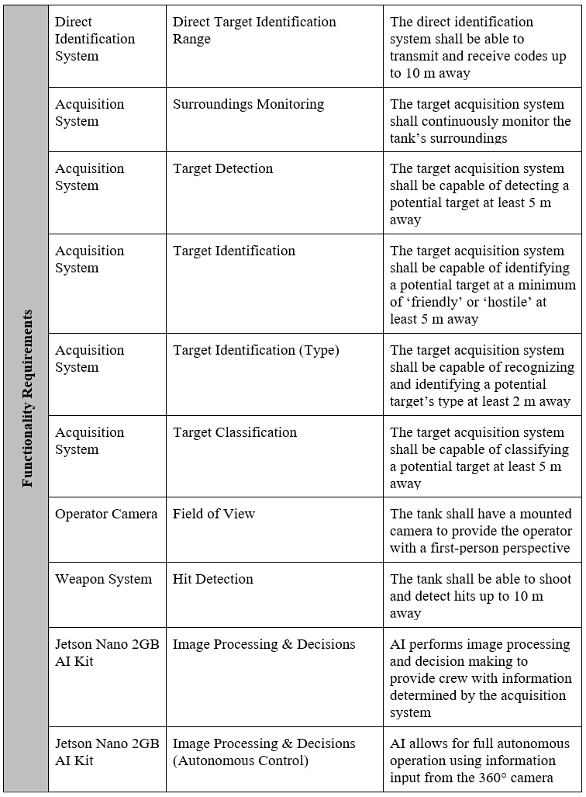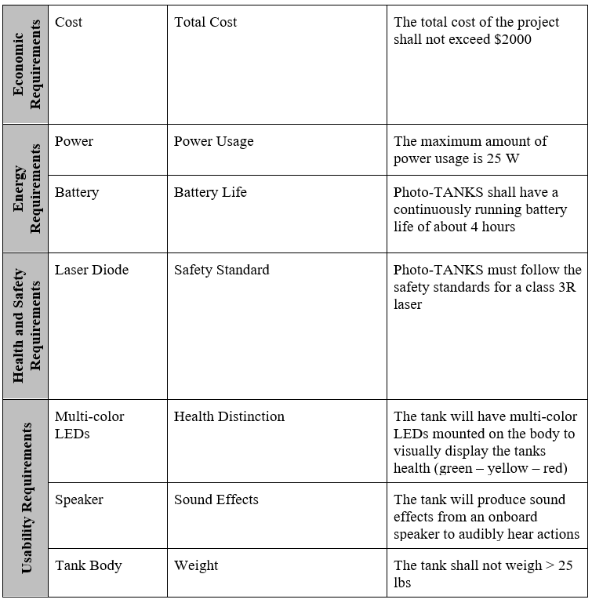

Table AA 1: Main Tank Specifications

AA2: Controller Specifications
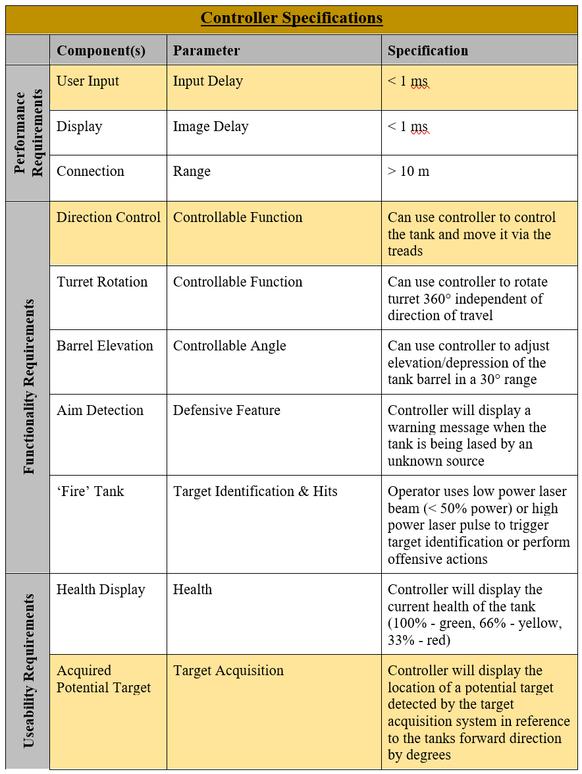
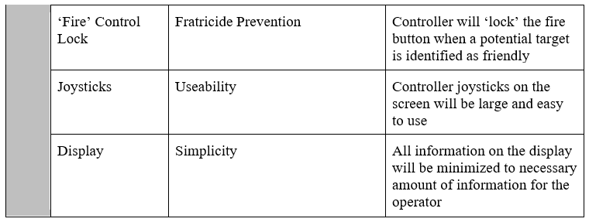
Table AA 2: Controller Specifications

AA3: Prototype Identification and Hit Code

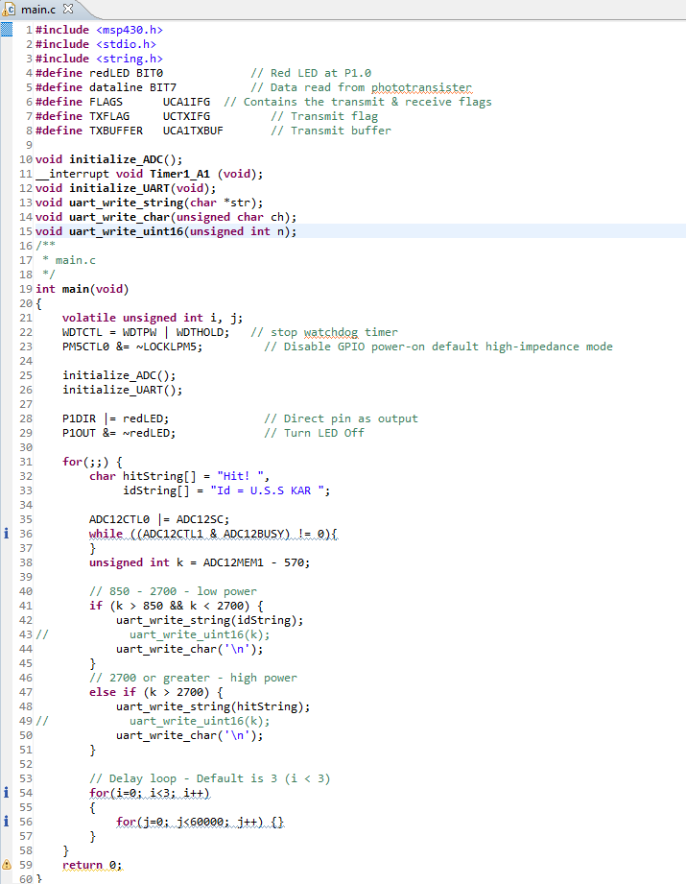
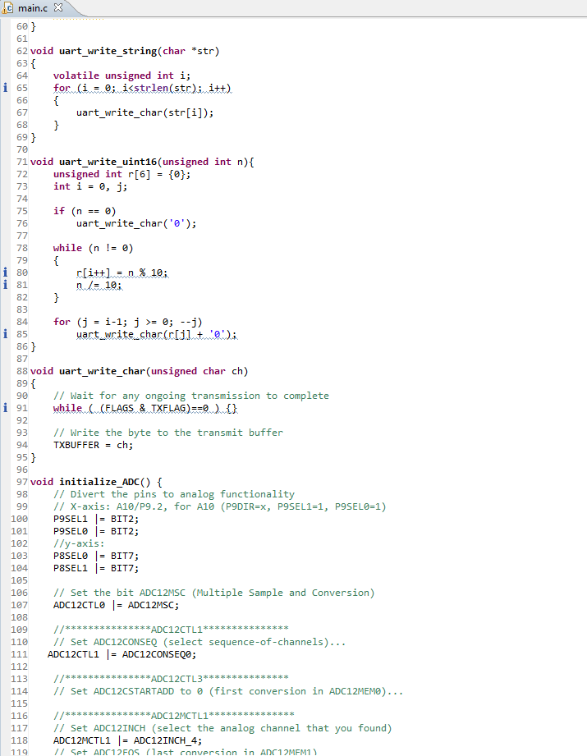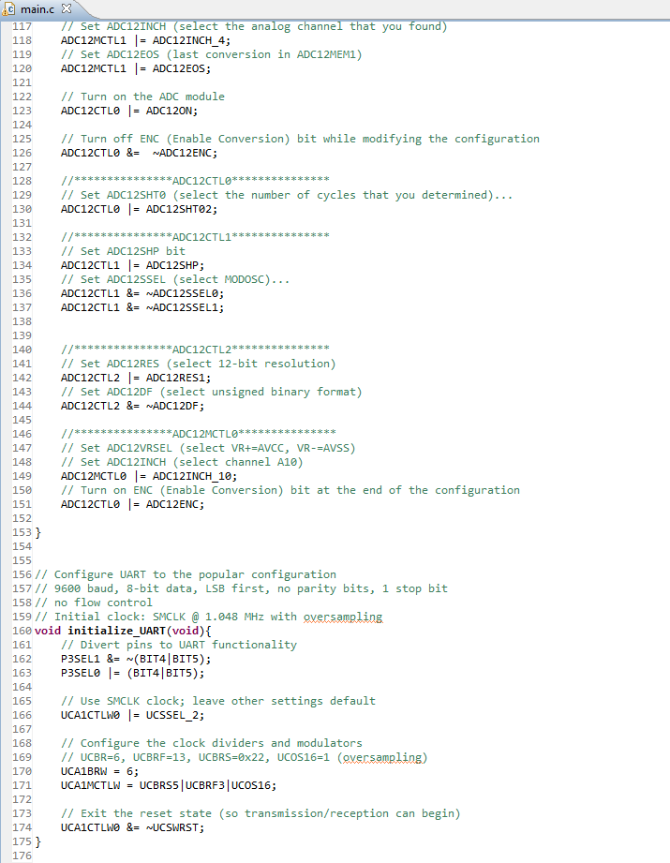
Figure AA 3: Prototype Identification and Hit Code

AA4: DC-DC Circuit BOM and Parameters

Part ID | Manufacturer | Part Number | Quantity | Total Price ($) | Attributes
Renb | Vishay-Dale | CRCW0402100KFKED | 1 | 0.01 | Resistance = 100 kΩ  Tolerance = 1.0%  Power = 63 mW
Rt | Vishay-Dale | CRCW040266K5FKED | 1 | 0.01 | Resistance = 66.5 kΩ  Tolerance = 1.0%  Power = 63 mW
Coutx | MuRata | GRM32ER61C226ME20L | 3 | 1.65 | Cap = 22 µF  Total Derated Cap = 62 µF  VDC = 16 V  ESR = 2 mΩ  Package = 1210
Rg1 | Vishay-Dale | CRCW06031R00FKEA | 1 | 0.01 | Resistance = 1 Ω  Tolerance = 1.0%  Power = 100 mW
Cin | Panasonic | 16SVPE180M | 1 | 0.5 | Cap = 180 µF  Total Derated Cap = 180 µF  VDC = 16 V  ESR = 11 mΩ  Package = 6.3x9.9
Ccomp | MuRata | GRM155R71C222KA01D | 1 | 0.01 | Cap = 2.2 nF  Total Derated Cap = 2.2 nF  VDC = 16 V  ESR = 1 mΩ  Package = 0402
Cboot2 | Taiyo Yuden | EMK107B7104KA-T | 1 | 0.01 | Cap = 100 nF  Total Derated Cap = 100 nF  VDC = 16 V  ESR = 1 mΩ  Package = 0603
Rent | Vishay-Dale | CRCW0402301KFKED | 1 | 0.01 | Resistance = 301 kΩ  Tolerance = 1.0%  Power = 63 mW
U1 | Texas Instruments | TPS55288RPMR | 1 | 2.52 | See Table AA 4.2
Rcomp | Vishay-Dale | CRCW040284K5FKED | 1 | 0.01 | Resistance = 84.5 kΩ  Tolerance = 1.0%  Power = 63 mW
M2 | Texas Instruments | CSD17577Q3A | 1 | 0.19 | VdsMax = 30 V  IdsMax = 35 Amps
Cinx | MuRata | GRM32ER61C226ME20L | 1 | 0.55 | Cap = 22 µF  Total Derated Cap = 21 µF  VDC = 16 V  ESR = 2 mΩ  Package = 1210
Rg2 | Vishay-Dale | CRCW06031R00FKEA | 1 | 0.01 | Resistance = 1 Ω  Tolerance = 1.0%  Power = 100 mW
Cout | Panasonic | 16SVP330M | 1 | 0.4 | Cap = 330 µF  Total Derated Cap = 330 µF  VDC = 16 V  ESR = 16 mΩ  Package = 10x12.6
M1 | Texas Instruments | CSD16301Q2 | 1 | 0.13 | VdsMax = 25 V  IdsMax = 5 Amps
Cvcc | TDK | C1608X6S1C475K080AC | 1 | 0.08 | Cap = 4.7 µF  Total Derated Cap = 4.7 µF  VDC = 16 V  ESR = 3.73 mΩ  Package = 0603
L1 | Coiltronics | HC1-7R8-R | 1 | 1.74 | L = 7.8 µH  DCR = 5.7 mΩ  IDC = 6.7 A
Rilim | Vishay-Dale | CRCW040221K0FKED | 1 | 0.01 | Resistance = 21 kΩ  Tolerance = 1.0%  Power = 63 mW
Cboot1 | Taiyo Yuden | EMK107B7104KA-T | 1 | 0.01 | Cap = 100 nF  Total Derated Cap = 100 nF  VDC = 16 V  ESR = 1 mΩ  Package = 0603
Table AA 4.1: BOM LIST FOR DC-DC BUCK CONVERTER
 |  | MIN | MAX
VOLTAGE RANGE AT TERMINALS | VIN, SW1 | -0.3V | 40V
 | DRH1, BOOT1 | SW1-0.3V | SW1+6V
 | VSS, DRL1, SCL, SDA, ILIM, FSW, COMP, FB/INT, MODE, CDC, DITH/SYNC | -0.3V | 6V
 | VOUT, SW2, ISP, ISN | -0.3V | 25V
 | ISP, ISN | VOUT-6V | VOUT+6V
 | EN | -0.3V | 20V
 | BOOT2 | SW2-0.3 | SW2+6
 | DRL1, SCL, SDA, ILIM, FSW, COMP, FB/INT, MODE, CDC, DITH/SYNC | -0.3V | VCC+0.3V
T_J | OPERATING JUNCTION, T_J | -40C | 150C
T_STG | STORAGE TEMPERATURE | -65C | 150C
Table AA 4.2: ABSOLUTE MAXIMUM RATINGS for TPS55288

Appendix B: Permissions
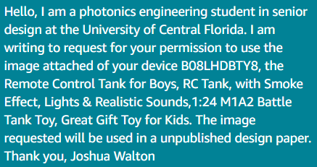
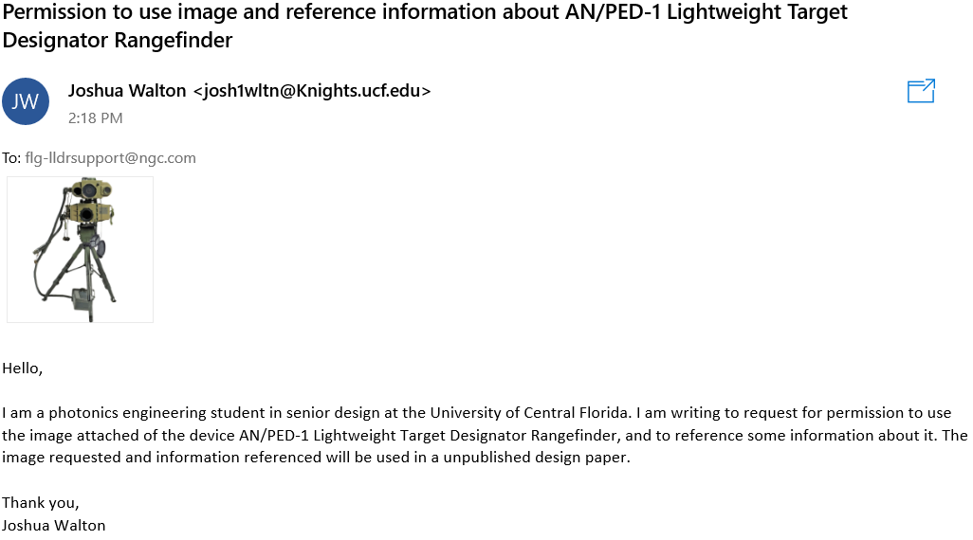
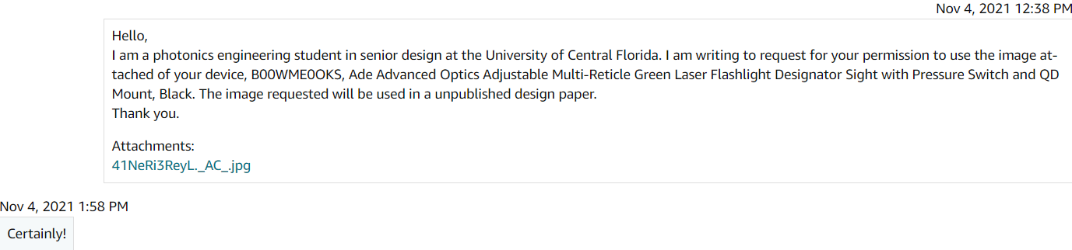
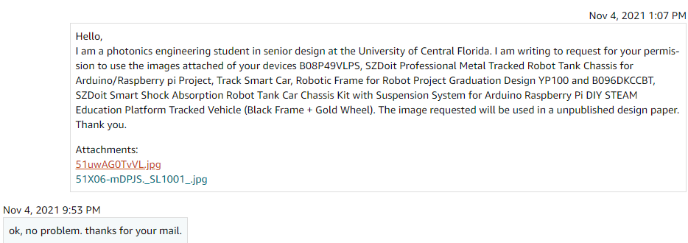
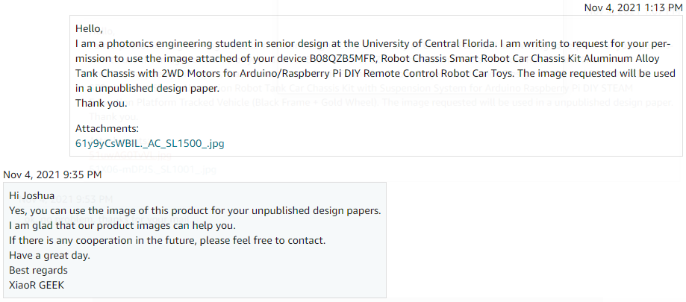
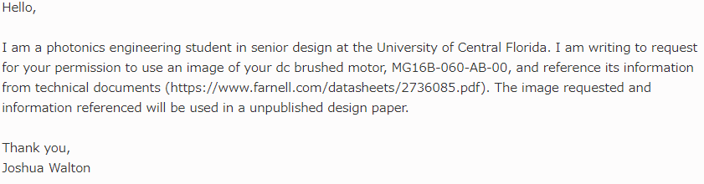
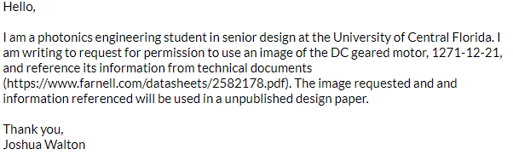

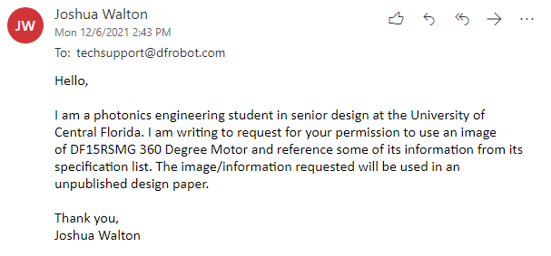

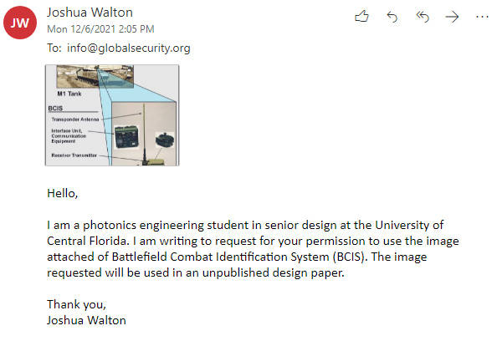
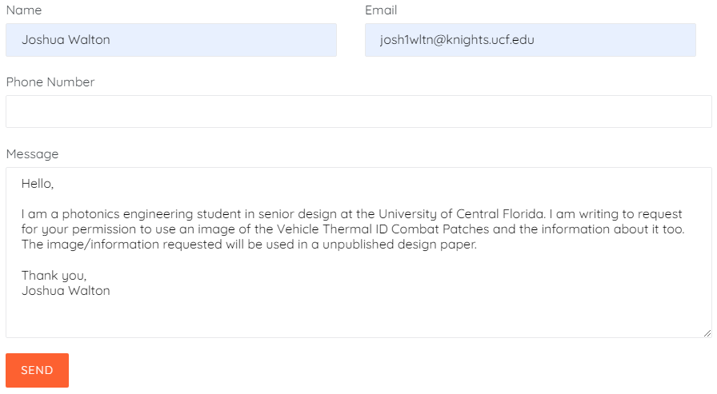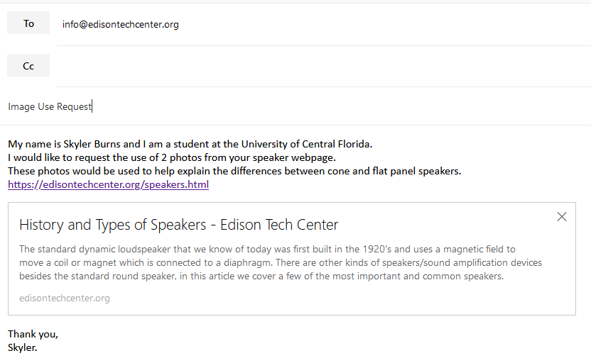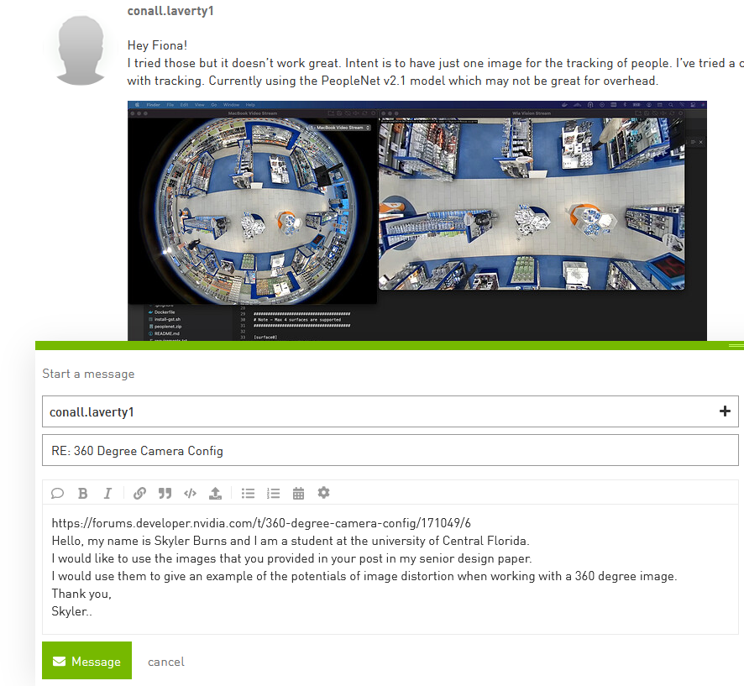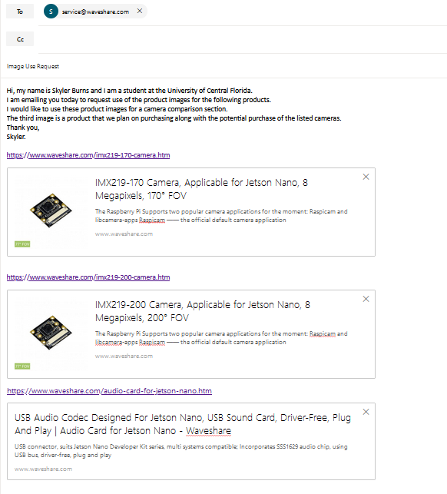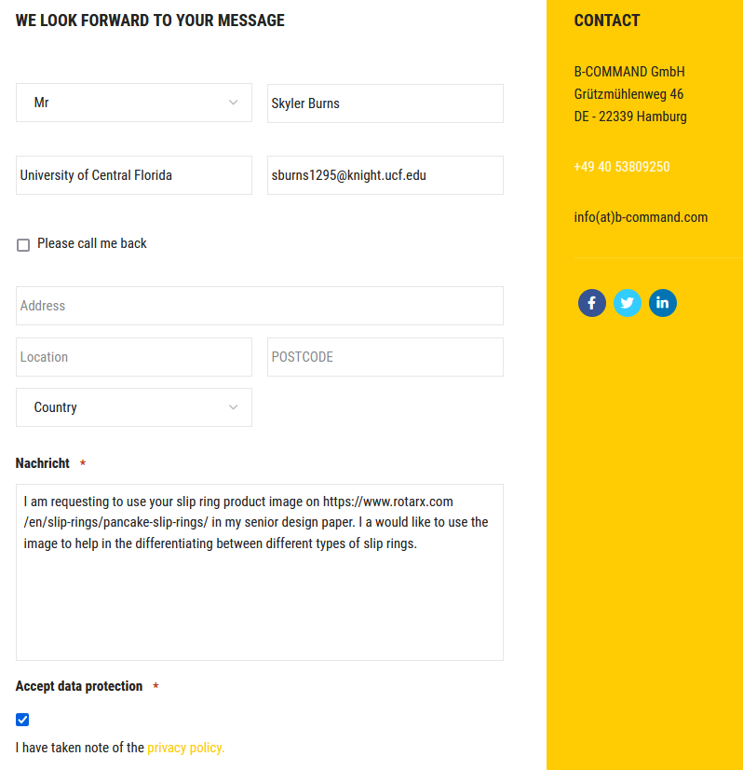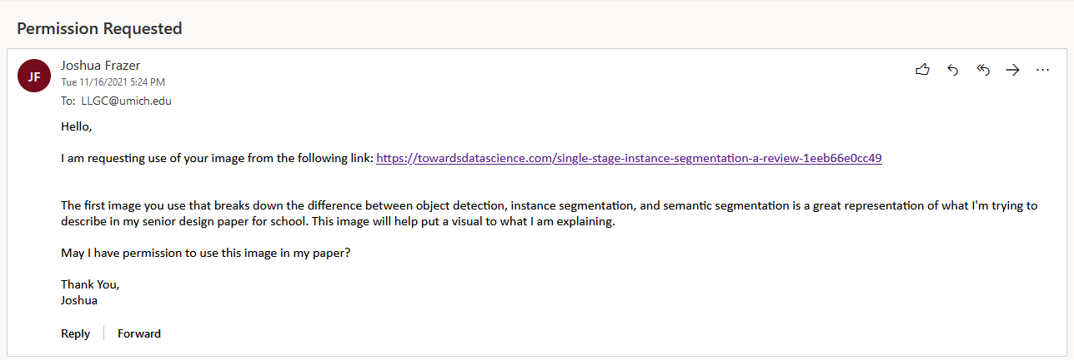
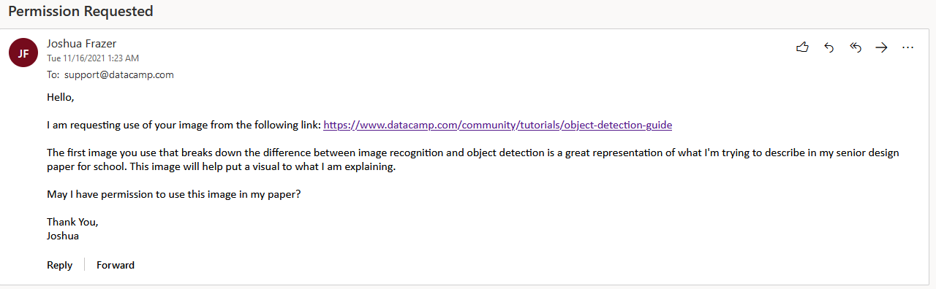
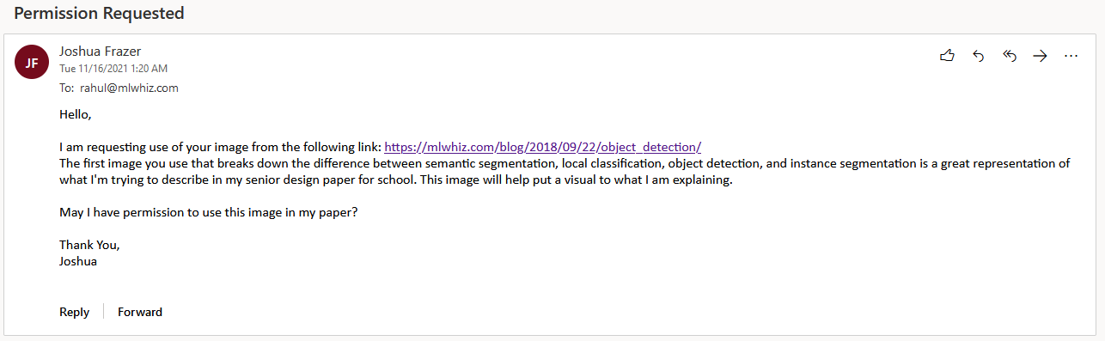
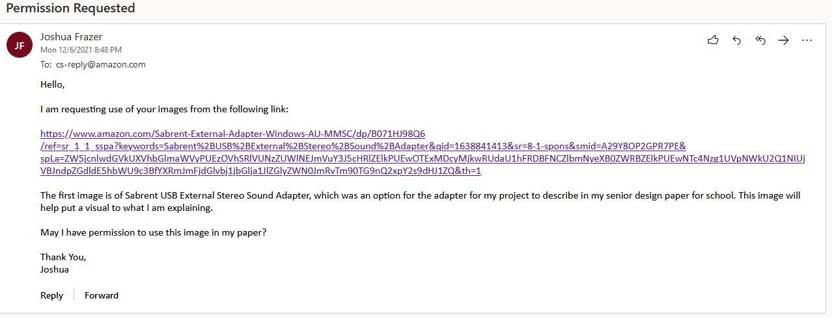
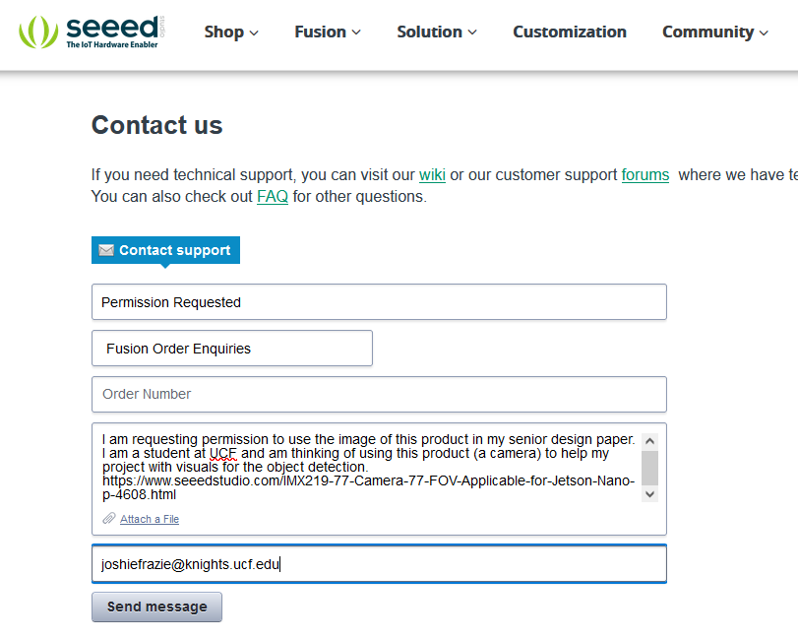
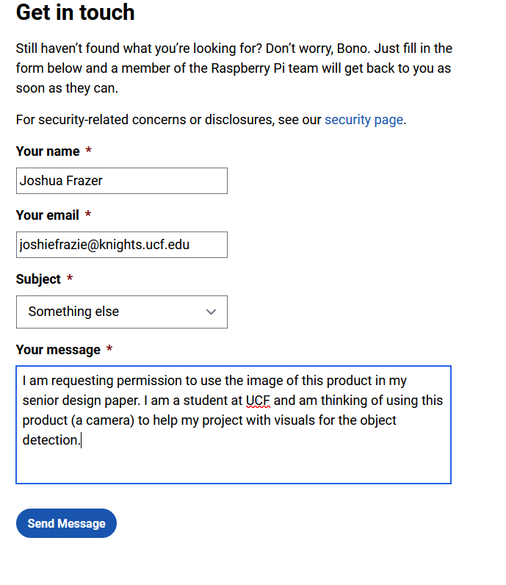

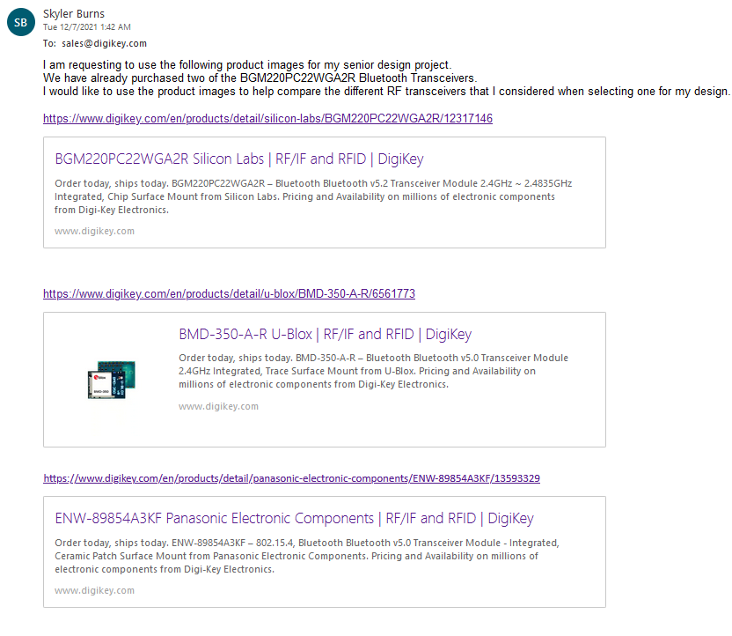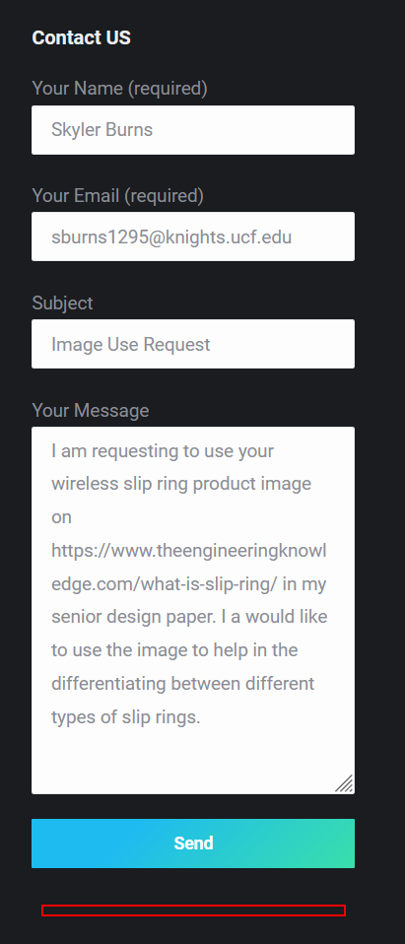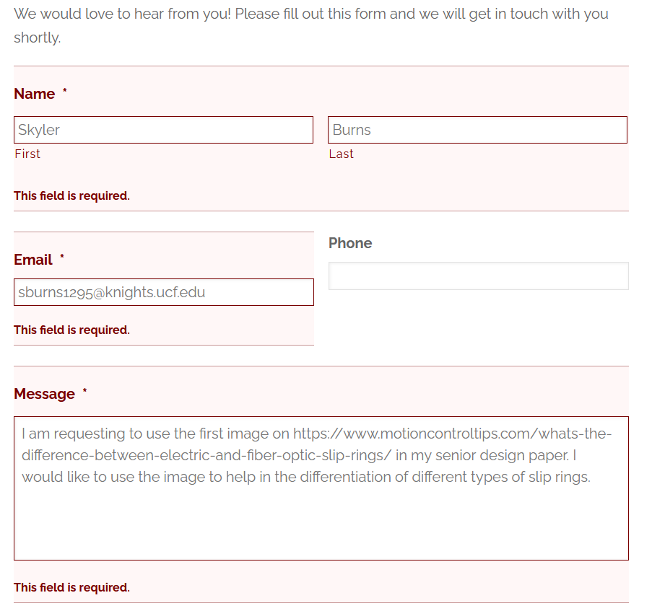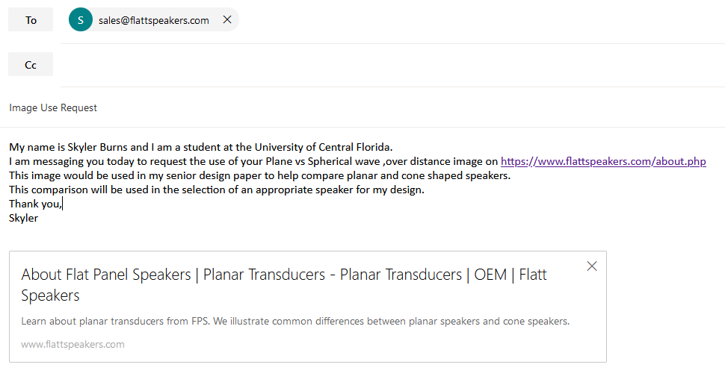
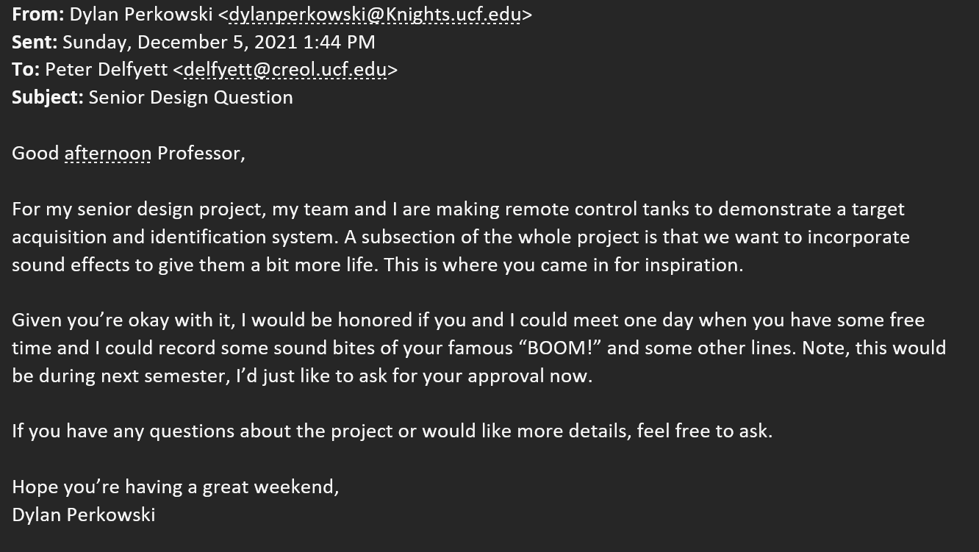
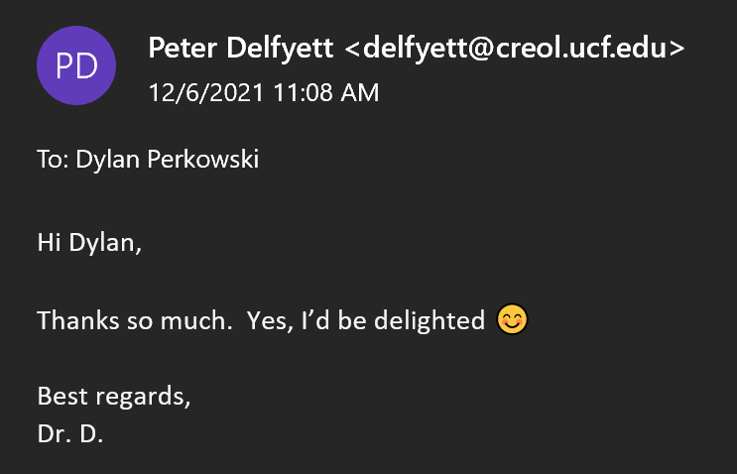

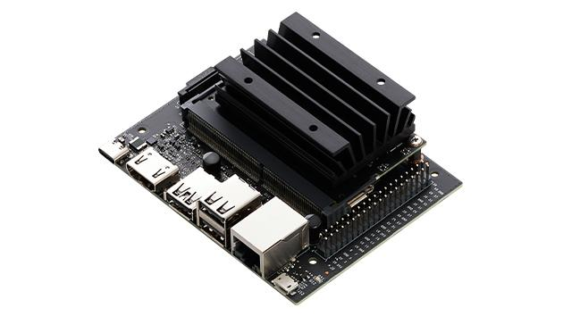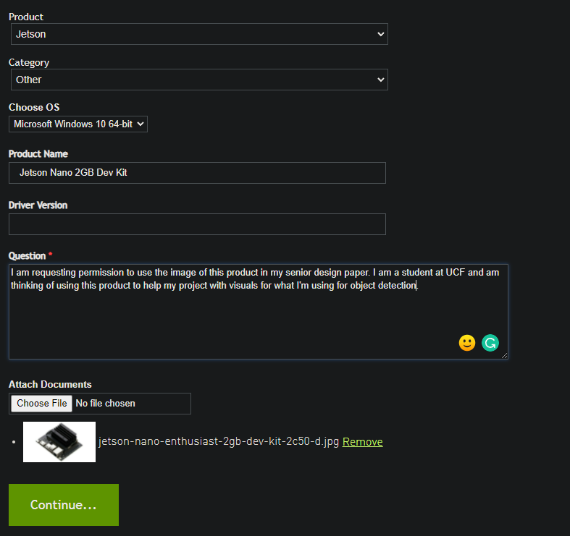

Appendix C: Citations
[1] Military Target Acquisition & ID.Target Acquisition. URL:https://www.globalsecurity.org/military/library/policy/army/fm/17-12-8/ch3.htm
[2] USA Today, Afghan, What happened to US military equipment left behind in Afghanistan? August 30, 2021. URL:https://www.usatoday.com/story/news/world/2021/08/30/what-military-equipment-left-behind-afghanistan-us/5658895001/
[3] Forbes, Afghan, Taliban Won’t Gain Much From U.S. Military Equipment Left In Afghanistan. September 8, 2021. URL:https://www.forbes.com/sites/vikrammittal/2021/09/08/afghanistan-graveyard-of-equipment/?sh=6a3688d96a52
[4] US Export Value, U.S. Arms Transfers Increased by 2.8 Percent in FY 2020 to $175.08 Billion. January 20, 2021 URL:https://www.state.gov/u-s-arms-transfers-increased-by-2-8-percent-in-fy-2020-to-175-08-billion/
[5] US Export Market Share, TRENDS IN INTERNATIONAL ARMS TRANSFERS, 2020. March 2021. URL:https://sipri.org/sites/default/files/2021-03/fs_2103_at_2020.pdf
[6] US Export Market $; Exports from: US, From 2019-2020 https://armstrade.sipri.org/armstrade/page/values.php
[7] Afghan National Army Vehicles; Transfers of major arms to Afghanistan between 2001 and 2020. September 3, 2021. URL:https://www.sipri.org/commentary/topical-backgrounder/2021/transfers-major-arms-afghanistan-between-2001-and-2020
[8] BCIS Overview, The Battlefield Combat Identification System: A Task Force XXI Response to the Problem of Direct Fire Fratricide. January-February 1998. URL:https://www.hsdl.org/?view&did=439685
[9] BCIS Effectiveness, Assessing the effectiveness of the battlefield combat identification system. June 1999, URL:https://calhoun.nps.edu/handle/10945/13509
[10] BCIS & Other Tech More Information, Desert Setting Tough on Combat ID Systems. August 1, 2003. URL:https://www.nationaldefensemagazine.org/articles/2003/8/1/2003august-desert-setting-tough-on-combat-id-systems
[11] BCIS Downfall, Marines Focus on Portable ID Gear to Reduce Fratricide. November 2003. URL:https://web.archive.org/web/20110107143934/http://www.navyleague.org/sea_power/nov_03_23.php
[12] Ai/ATR, Review of current aided/automatic target acquisition technology for military target acquisition tasks. March 1, 2011. URL:https://www.spiedigitallibrary.org/journals/optical-engineering/volume-50/issue-07/072001/Review-of-current-aided-automatic-target-acquisition-technology-for-military/10.1117/1.3601879.full?SSO=1&tab=ArticleLink
[13] CIP, Combat Identification Panels. August 6, 1999. URL:https://man.fas.org/dod-101/sys/land/cip.htm
[14] Abrams/Bradley Stats, OPERATION DESERT STORM: Early Performance Assessment of Bradley and Abrams. January 1992. URL:https://www.gao.gov/assets/nsiad-92-94.pdf
[BCIS] John Pike, Battlefield Combat Identification System (BCIS). July 7, 2011. URL: https://www.globalsecurity.org/military/systems/ground/bcis-pics.htm
[Wiki] Wikipedia, Aircraft Registration. July 15, 2021. URL:https://en.wikipedia.org/wiki/Aircraft_registration
[Wiki0] Wikipedia, Hull Number. September 30, 2021. URL:https://en.wikipedia.org/wiki/Hull_number
[CIP] Security Pro USA, Combat ID Patches. URL:https://www.securityprousa.com/pages/combat-id-patches
[Wiki1] Sdk16420, General discharging Li battery diagram. May 8, 2015. URL:https://commons.wikimedia.org/wiki/File:General_discharging_Li_battery_diagram.svg
[Digi1] Qoitech, Battery Life Calculator. URL:https://www.digikey.com/en/resources/conversion-calculators/conversion-calculator-battery-life
[Sci] Becky Chapman, How does a lithium-Ion battery work? September 23, 2019. URL:https://letstalkscience.ca/educational-resources/stem-in-context/how-does-a-lithium-ion-battery-work
[Photo1] ser_igor, Li-ion battery diagram stock illustration. July 31, 2017. URL:https://www.istockphoto.com/vector/li-ion-battery-diagram-gm825367806-133778177
[Fig 16] Meysam Qadrdan, Cycle life of Li-ion batteries. 2018. URL:https://www.sciencedirect.com/topics/engineering/cycle-life
[Wiki2] Wapcaplet, Brushed DC electric motor. April 9, 2004. URL:https://en.wikipedia.org/wiki/Brushed_DC_electric_motor
[Thorlabs1] Thorlabs, Visible Laser Diodes. URL:https://www.thorlabs.com/newgrouppage9.cfm?objectgroup_id=7
[Bi-Thorlabs] Thorlabs, N-BK7 Bi-convex Lenses, Uncoated. URL:https://www.thorlabs.com/newgrouppage9.cfm?objectgroup_id=4847
[Plano-Thorlabs] Thorlabs, N-BK7 Plano-convex Lenses, Uncoated. URL:https://www.thorlabs.com/newgrouppage9.cfm?objectgroup_id=112
[Vishay] Vishay, TEPT5700 Product Information. June 25, 2014. URL:https://www.vishay.com/photo-detectors/list/product-81321/
[Mouser] Mouser, Everlight EAALST05RDMA0. July 14, 2014. URL:https://www.mouser.com/ProductDetail/Everlight/EAALST05RDMA0?qs=hE2b9RNHrswnaSeTkgLkzg%3D%3D
[Diode-Thorlabs] Thorlabs, Photodiodes. URL:https://www.thorlabs.com/newgrouppage9.cfm?objectgroup_id=285
[Digi2] Bill Giovino, How to drive Multicolor LEDs. March 12, 2019. URL:https://www.digikey.com/en/articles/how-to-drive-multicolor-leds
[Lstandard] ANSI, American National Standard for Safe Use of Lasers. March 16, 2007. URL:https://eliceirilab.org/sites/default/files/2017-04/American%20National%20Standard%20for%20Safe%20Use%20of%20Lasers.pdf
[Lclass] Laser Safety Facts. URL:https://www.lasersafetyfacts.com/laserclasses.html
[Cleaning] Thorlabs, Optics Handling and Care Tutorial. URL:https://www.thorlabs.com/newgrouppage9.cfm?objectgroup_id=9025
[Pstandard] CUI Inc. POWER SUPPLY SAFETY STANDARDS, AGENCIES, AND MARKS. September 2020. URL:https://www.cui.com/catalog/resource/power-supply-safety-standards-agencies-and-marks
[FAM] IPC, IPC-2220-FAM: Design Standards for Printed Boards. November 20, 2012. URL:https://shop.ipc.org/general-electronics/standards/2220-fk-0-english
[IPC1] IPC, IPC-2221B Generic Standard on Printed Board Design. November 20, 2012. URL:https://shop.ipc.org/general-electronics/standards/2221-0-b-english#:~:text=IPC%2D2221B%20is%20the%20foundation,%2C%20double%2Dsided%20or%20multilayer.
[JSTD] Rasika, IPC J-STD-001 Standard Soldering Requirements. September 23, 2021. URL:https://www.protoexpress.com/blog/ipc-j-std-001-standard-soldering-requirements/
[SSafety] University of Cambridge, Soldering Safety. URL:https://safety.eng.cam.ac.uk/safe-working/copy_of_soldering-safety
[Wiki3] Wikipedia, IEE 802.15. November 21, 2021. URL:https://en.wikipedia.org/wiki/IEEE_802.15
[Wiki4] Wikipedia, Bluetooth. December 3, 2021. URL:https://en.wikipedia.org/wiki/Bluetooth
[Bclass] StarTech, What is a Bluetooth class and what is a Bluetooth profile? URL:https://www.startech.com/en-us/faq/bluetooth-adapters-classes-and-profiles
[Bfrequency] RF Wireless World, Bluetooth Frequency Allocations/Frequency Bands. 2012. URL:https://www.rfwireless-world.com/Tutorials/Bluetooth-frequency-allocations.html
[WikiF] Wikipedia, UL 94. December 1, 2021. URL:https://en.wikipedia.org/wiki/UL_94

Agarwal, Rahul. “Object Detection: An End to End Theoretical Perspective.” ML Whiz, MLWHIZ, 22 Sept. 2018, https://mlwhiz.com/blog/2018/09/22/object_detection/ .
Anbarjafari, Gholamreza. “Digital Image Processing.” Sisu@UT, https://sisu.ut.ee/imageprocessing/book/1 .
“Arducam Noir IMX219-AF Programmable/Auto Focus IR Sensitive Camera Module for Nvidia Jetson Nano.” Arducam, Arducam, 11 Sept. 2021, https://www.arducam.com/product/b0189-arducam-noir-imx219-af-programmable-auto-focus-ir-sensitive-camera-module-nvidia-jetson-nano/ .
“Audio Interface Buying Guide.” Sweetwater, Sweetwater, https://www.sweetwater.com/insync/audio-interface-buying-guide/#Choosing-the-right-I-O-configuration .
Chane, Marina. “Classification of Medical Images: the Most Efficient CNN Architectures.” IMAIOS, IMAIOS SAS, 3 Jan. 2021, https://www.imaios.com/en/Company/blog/Classification-of-medical-images-the-most-efficient-CNN-architectures .
Choudhury, Ambika. “Top 8 Algorithms for Object Detection.” Analytics India Magazine, 16 June 2020, https://analyticsindiamag.com/top-8-algorithms-for-object-detection/ .
Cunningham, Andrew. “Arm Goes 64-Bit with New Cortex-A53 and Cortex-A57 Designs.” ARS Technica, Conde Nast, 30 Oct. 2012, https://www.google.com/amp/s/arstechnica.com/information-technology/2012/10/arm-goes-64-bit-with-new-cortex-a53-and-cortex-a57-designs/%3famp=1 .
Dan, and Jameson. “Object Detection Guide.” Fritz AI, https://www.fritz.ai/object-detection/ .
Das, Arnab Kumar. “Nvidia Jetson Nano vs Raspberry Pi 4 Benchmark.” Arnab Kumar Das, Arnab Kumar Das, 12 Feb. 2021, https://www.arnabkumardas.com/topics/benchmark/nvidia-jetson-nano-vs-raspberry-pi-4-benchmark/ .
Demchenko, Maryna. “Ai Programming: 5 Most Popular AI Programming Languages.” NCube, 7 Oct. 2021, https://ncube.com/blog/ai-programming-languages .
“Dev Board Datasheet.” Coral, Google, https://coral.ai/docs/dev-board/datasheet/#features .
“The Essential Guide to Audio Interfaces.” MusicTech, 29 Aug. 2017, https://musictech.com/guides/essential-guide/essential-guide-audio-interfaces/?amp=1 .
Hollemans, Matthijs. “New Mobile Neural Network Architectures.” Machine Think, M.I. Hollemans, 8 Apr. 2020, https://machinethink.net/blog/mobile-architectures/ .
Hollemans, Matthijs. “Real-Time Object Detection with YOLO.” Machine Think, M.I. Hollemans, 20 May 2017, https://machinethink.net/blog/object-detection-with-yolo/ .
Hulstaert, Lars. “A Beginner's Guide to Object Detection.” DataCamp Community, DataCamp Inc, 19 Apr. 2018, https://www.datacamp.com/community/tutorials/object-detection-guide .
“Image Segmentation Techniques [Step by Step Implementation].” UpGrad Blog, 29 Nov. 2021, https://www.upgrad.com/blog/image-segmentation-techniques/ .
“IMX219-77 8MP Camera with 77° FOV - Compatible with Nvidia Jetson Nano/ Xavier NX.” Seeed Studio, Seeed Technology Co.,Ltd, https://www.seeedstudio.com/IMX219-77-Camera-77-FOV-Applicable-for-Jetson-Nano-p-4608.html .
“Jetson Nano Brings AI Computing to Everyone.” NVIDIA Developer Blog, 14 Oct. 2020, https://developer.nvidia.com/blog/jetson-nano-ai-computing/ .
“Jetson Nano Developer Kit.” NVIDIA Developer, 14 Apr. 2021, https://developer.nvidia.com/embedded/jetson-nano-developer-kit .
Jonathan. “Audio Interface Inputs and Outputs Explained.” Reboot Recording, 9 Sept. 2019, https://rebootrecording.com/audio-interface-io-explained/amp/ .
Kumar, Vaibhav. “Mobilenet vs RESNET50 - Two CNN Transfer Learning Light Frameworks.” Analytics India Magazine, 21 June 2020, https://analyticsindiamag.com/mobilenet-vs-resnet50-two-cnn-transfer-learning-light-frameworks/ .
Liu, Patrick Langechuan. “Single Stage Instance Segmentation - A Review.” Medium, Towards Data Science, 28 Apr. 2020, https://towardsdatascience.com/single-stage-instance-segmentation-a-review-1eeb66e0cc49 .
Michelle. “[Tech Update] Benchmark Testing of up Squared, Raspberry Pi 4 & Jetson Nano.” UP Bridge the Gap, UP Board, 27 Oct. 2020, https://up-board.org/tech-update-benchmark-testing-of-up-squared-raspberry-pi-4-jetson-nano .
Nicholson, Chris. “Comparison of Ai Frameworks.” Pathmind, Pathmind Inc, https://wiki.pathmind.com/comparison-frameworks-dl4j-tensorflow-pytorch .
“Raspberry Pi Documentation.” Raspberry Pi , Raspberry Pi Ltd , https://www.raspberrypi.com/documentation/accessories/camera.html .
Rodriguez, Jesus. “The Evolution of Google's MobileNet Architectures to Improve Computer Vision Models.” Medium, DataSeries, 16 Feb. 2021, https://medium.com/dataseries/the-evolution-of-googles-mobilenet-architectures-to-improve-computer-vision-models-ffb483ffcc0a .
Saha, Sumit. “A Comprehensive Guide to Convolutional Neural Networks - the eli5 Way.” Medium, Towards Data Science, 17 Dec. 2018, https://towardsdatascience.com/a-comprehensive-guide-to-convolutional-neural-networks-the-eli5-way-3bd2b1164a53 .
Shiledarbaxi, Nikita. “Guide to Panoptic Segmentation - A Semantic + Instance Segmentation Approach.” Analytics India Magazine, 5 Feb. 2021, https://analyticsindiamag.com/guide-to-panoptic-segmentation-a-semantic-instance-segmentation-approach/ .
Singhal, Nitin. “Semantic vs Instance vs Panoptic Segmentation.” LinkedIn, LinkedIn, 24 Apr. 2021, https://www.linkedin.com/pulse/nitin-singhal .
Suryavansh, Manu. “Google Coral Edge TPU Board vs Nvidia Jetson Nano Dev Board - Hardware Comparison.” Medium, Towards Data Science, 19 Apr. 2019, https://towardsdatascience.com/google-coral-edge-tpu-board-vs-nvidia-jetson-nano-dev-board-hardware-comparison-31660a8bda88 .
Tan, Cherie. “Jetson Nano vs Raspberry Pi 4: The Differences.” All3DP, 14 Jan. 2021, https://m.all3dp.com/2/raspberry-pi-vs-jetson-nano-differences/ .
“Up Squared Ai Vision X Developer Kit (8 GB) Series.” UP Bridge the Gap, https://up-shop.org/up-squared-ai-vision-x-developer-kit-8-gb-series.html .
“Up Squared Ai Vision X Developer Kit.” Intel, Intel Corporation, https://www.intel.com/content/www/us/en/developer/topic-technology/edge-5g/hardware/up-squared-ai-vision-dev-kit.html .
“USB Audio Codec for Jetson Nano, USB Sound Card, Driver-Free, Plug and Play.” Waveshare, https://www.waveshare.com/audio-card-for-jetson-nano.htm
“What Is the Main Difference between Yolo and SSD?” Technostacks Infotech, 20 Sept. 2018, https://technostacks.com/blog/yolo-vs-ssd .
Wu, Elaine. “How to Choose Cameras for Nvidia Jetson Nano and Jetson Xavier NX for Machine Vision.” Latest Open Tech From Seeed, 3 June 2020, https://www.seeedstudio.com/blog/2020/06/03/how-to-choose-cameras-for-nvidia-jetson-nano-and-jetson-xavier-nx-for-machine-vision/ .

[Texas Instruments] Texas Instruments, 36V, 16A buck-boost converter with PPS control. URL:https://www.ti.com/product/TPS55288

[Texas Instruments] Texas Instruments, Webench Power Designer.
URL:https://webench.ti.com/power-designer/switching-regulator

[Texas Instruments] Texas Instruments, Webench Power Designer TPS55288RPM.
URL:https://webench.ti.com/power-designer/switching-regulator/customize/7?noparams=0

[INIU] Amazon, INIU POWER BANK, 10000mAh, 5V, 3A
URL:https://www.amazon.com/gp/product/B07H6LB4J4/ref=as_li_ss_tl?ie=UTF8&linkCode=sl1&tag=jbstore074-20&linkId=28aad75b99de8dc39f7a8ee2fc5a15aa&language=en_US

[Android Central] Android Central, Spotlight on Bluetooth
URL:https://www.androidcentral.com/bluetooth-5-it-actually-better-and-do-you-need-it

[Flat Speakers] Flat Speakers, Planar vs Cone
URL:https://www.flattspeakers.com/about.php

[Waveshare] USB Audio Codec for Jetson Nano
URL:https://www.waveshare.com/audio-card-for-jetson-nano.htm

[BiCool] Amazon, USB Codec USB Sound Card for Jetson Developer Kit
URL:https://www.amazon.com/Developer-Connector-Microphone-Recording-Driver-Free/dp/B08YXV48HL?th=1

[Edison Tech Center] Edison Tech Center, History and Types of Loudspeakers
URL:https://edisontechcenter.org/speakers.html

[Dummies] Dummies, How a Speaker Works
URL:https://www.dummies.com/article/technology/electronics/general-electronics/how-a-speaker-works-223728

[RobotShop] RobotShop, Arducam Mini HW 12.3MP IXM477 Camera w/M12 Mount Lens for Jetson Nano and Xavier
URL:https://www.robotshop.com/en/arducam-mini-hq-123mp-imx477-camera-w-m12-mount-lens-jetson-nano-xavier.html

[Waveshare1] IMX219-170 Camera, 170° FOV, Applicable for Jetson Nano
URL:https://www.waveshare.com/imx219-170-camera.htm

[Waveshare2] IMX219-200 Camera, 200° FOV, Applicable for Jetson Nano
URL:https://www.waveshare.com/imx219-200-camera.htm
[NVIDIA] Nvidia Forums, How to connect more than one camera to jetson nano
URL:https://forums.developer.nvidia.com/t/360-degree-camera-config/171049

[ARDUCAM] Arducam, Arducam Multi Camera Adapter Module V2.2 for Raspberry Pi 4 B, 3B+, Pi 3, Pi 2, Model A/B/B+, Work with 5MP OV5647 / 8MP IMX219 / 12MP IMX477 Cameras
URL:https://www.arducam.com/product/multi-camera-v2-1-adapter-raspberry-pi/
[WIKI] Wikipedia, Rolling Shutter
URL:https://en.wikipedia.org/wiki/Rolling_shutter

[DIGIKEY] DIGIKEY, BGM220PC22WGA2R WIRELESS GECKO BLUETOOTH PCB MOD
URL:https://www.digikey.com/en/products/detail/silicon-labs/BGM220PC22WGA2R/12317146

[DIGIKEY1] DIGIKEY, BMD-350-A-R MOD BLE 5.0 NORDIC NRF52832 SOC
URL:https://www.digikey.com/en/products/detail/u-blox/BMD-350-A-R/6561773

[DIGIKEY2] DIGIKEY, ENW-89854A3KF BLUETOOTH 5.0 MODULE PAN1780AT S
URL:https://www.digikey.com/en/products/detail/panasonic-electronic-components/ENW-89854A3KF/13593329

[JINPAT] AMAZON, 5 circuit pancake slip rings with gold-gold contact
URL:https://www.amazon.com/JINPAT-Circuits-Pancake-Gold-Gold-Temperature/dp/B07D5BM736

[EngineeringKnowledge] The EngineeringKnowledge, What is Slip Ring, Types Working, Applications
URL:https://www.theengineeringknowledge.com/what-is-slip-ring/

[EngineeringKnowledge] What’s the difference between electric and fiber-optic slip rings?
URL:https://www.motioncontroltips.com/whats-the-difference-between-electric-and-fiber-optic-slip-rings/

[RotarX] RotorX, RotarX Pancake Slip Rings for Power and Signal Transmission
URL:https://www.rotarx.com/en/slip-rings/pancake-slip-rings/

